**Classroom Management (EDU 305)**

**Table of Contents:**

|  |  |  |
| --- | --- | --- |
| Lesson 01 | Introduction to Classroom Management (Topic 1 to 6) | 2 |
| Lesson 02 | Classroom Control (Topic 7 to 11) | 6 |
| Lesson 03 | Physical Seating & Classroom Management (Topic 12 to 18) | 9 |
| Lesson 04 | Overt Management Approaches (Topic 19 to 24) | 13 |
| Lesson 05 | Overt & Covert Management Approaches (Topic 25 to 29) | 15 |
| Lesson 06 | Role of Teacher in Managing the Classroom - 1 (Topic 30 to 35) | 18 |
| Lesson 07 | Effective Management (Topic 36 to 41) | 22 |
| Lesson 08 | Models of Classroom Management (Topic 42 to 46) | 25 |
| Lesson 09 | Plan to Implement the Models with Students (Topic 47 to 53) | 27 |
| Lesson 10 | Teacher's Effectiveness Training (Topic 54 to 59) | 31 |
| Lesson 11 | Classroom Management Strategies - 1 (Topic 60 to 65) | 34 |
| Lesson 12 | Classroom Management Strategies - 2 (Topic 66 to 72) | 37 |
| Lesson 13 | Physical Dimensions of a Classroom - 1 (Topic 73 to 78) | 41 |
| Lesson 14 | Physical Dimensions of a Classroom - 2 (Topic 79 to 84) | 45 |
| Lesson 15 | Activities for Managing Learning & Discipline - 1 (Topic 85 to 90) | 47 |
| Lesson 16 | Activities for Managing Learning & Discipline - 2 (Topic 91 to 97) | 50 |
| Lesson 17 | Curriculum Instruction and Classroom Management - 1 (Topic 98 to 102) | 55 |
| Lesson 18 | Techniques to Assist Learning (Topic 103 to 108) | 58 |
| Lesson 19 | Role of Teacher in Managing the Classroom - 2 (Topic 109 to 114) | 62 |
| Lesson 20 | Role of Teacher in Managing the Classroom - 3 (Topic 115 to 120) | 66 |
| Lesson 21 | Philosophies of How to Manage Large Class (Topic 121 to 126) | 69 |
| Lesson 22 | Large Classes (Topic 127 to 131) | 72 |
| Lesson 23 | Strategies to Maintain Discipline (Topic 132 to 138) | 74 |
| Lesson 24 | Teaching with Limited Resources & Motivating Student (Topic 139 to 144) | 77 |
| Lesson 25 | Systematic Procedure for Record Keeping (Topic 145 to 150) | 80 |
| Lesson 26 | Establishing Caring Connections - 1 (Topic 151 to 156) | 83 |
| Lesson 27 | Establishing Caring Connections - 2 (Topic 157 to 162) | 86 |
| Lesson 28 | Teachers Attributes in Teaching Social Skills (Topic 163 to 168) | 88 |
| Lesson 29 | Incentives in the Classroom (Topic 169 to 174) | 91 |
| Lesson 30 | Practice for Model for Rewards (Topic 175 to 180) | 93 |
| Lesson 31 | Effective Behavioural Support Systems (Topic 181 to 186) | 96 |
| Lesson 32 | School Discipline (Topic 187 to 192) | 98 |
| Lesson 33 | School-wide Preventive Discipline Practices (Topic 193 to 198) | 100 |
| Lesson 34 | Classroom Discipline- 1 (Topic 199 to 204) | 102 |
| Lesson 35 | Classroom Discipline- 2 (Topic 205 to 210) | 104 |
| Lesson 36 | Specific Discipline Programmes (Topic 211 to 216) | 106 |
| Lesson 37 | Bullying (Topic 217 to 222) | 109 |
| Lesson 38 | Bullying Preventive Programmes (Topic 223 to 228) | 112 |
| Lesson 39 | Social Intervention Strategies to Control Bullying (Topic 229 to 234) | 114 |
| Lesson 40 | Parent-Teacher Partnerships & CM (Topic 235 to 240) | 117 |
| Lesson 41 | Violence & Classroom Management (Topic 241 to 246) | 120 |
| Lesson 42 | Planning To Control Violence (Topic 247 to 252) | 122 |
| Lesson 43 | Teaching Positive Behaviours (Topic 253 to 258) | 124 |
| Lesson 44 | Developing Social Competence Among Students (Topic 259 to 264) | 126 |
| Lesson 45 | Social Competence (Topic 265 to 270) | 128 |

**Lesson 01**

**INTRODUCTION TO CLASSROOM MANAGEMENT**

**Topic- 001:**

Classroom management is a very important part of the professional development of teachers. A teachers’ duty is not only to teach the class but also to handle the management issues in classroom for effective teaching and learning process.

In this lecture, the following topics of classroom management are discussed:

* Elements of classroom management
* Classroom management approaches and strategies
* Models of classroom management
* Teacher’s role in classroom management
* Classroom management and the curriculum
* Discipline
* Bullying and social-emotional learning

**Topic – 002: Definition of Classroom Management:**

Classroom management embodies:

* Effective teaching of content (classroom management problems arise because a teacher is sometimes not sure of what she is teaching)
* Powerful teaching strategies (It is extremely important to use effective teaching strategies so that less classroom management problems arise. Sometimes, the problems in classroom arise because teachers do not know the teaching strategies)
* An organizational structure to support productive learning (the seating arrangement of classroom, are students sitting in rows or groups?)
* Effective use of social-emotional domains of learning
* The most successful teachers approach management as a process of establishing and maintaining effective learning environments

**Topic – 003: Key Elements of Classroom Management:**

1. **School wide discipline through curriculum:** classroom discipline is not possible without school wide discipline, so it is very important to make classroom management a part of curriculum.
2. **Classroom discipline:** Both the teacher and students must know how to behave in classroom environment. School discipline is such an element that the teachers must teach it to the students at the very start of their schooling. It is only possible through curriculum and school wide discipline.
3. **Classroom based rules:** Classroom discipline is made through classroom rules. There are certain rules for both students and the teachers to follow in classroom. We set some boundaries and we need to respect the rules in order to learn in the classroom.
4. **Identification of needs of students:** It is very important for the teacher to identify the needs of the students. Management issues in classroom arise because sometimes teachers do not know the student needs. Teacher must know students interests and their individual needs. It is very important for the teacher to have age appropriate and need based rules in classroom so that students can follow them easily.
5. **Involvement of major stakeholders:** All stakeholders who are involved in the education of a student must be made aware of the phenomenon of classroom management. The major stakeholders are students themselves, teachers, parents, school administration, principals, coordinators, classroom community.
6. **Importance to social-emotional learning**
7. **Physical seating in the classroom:** Are students sitting in rows, groups or pairs?
8. **Role modeling by teachers and caregivers:** Students learn from the teachers so it is important to have proper behaviors in the classroom so both the teachers and the students have good reputation.

**Topic – 004: Curriculum and Classroom Management:**

There is a deep link between curriculum and classroom management. In order to have effective management, this has to be integrated in the curriculum.

**Curriculum:**

Curriculum basically is a plan of action for the entire school. The curriculum consists of the ongoing experiences of children under the guidance of the school. It represents a special environment for helping children achieve self realization through active participation within the school.

**The link between curriculum and classroom:**

**Classroom management needs a school wide commitment. This commitment can only come through an active integration of classroom management principles within the school curricula.**

It is very important to prefer classroom management when the classroom objectives and goals are planned. So that both the teacher and students come to know that classroom management is a vital organ of the classroom proceedings. It has to be communicated through the lesson plans, teacher behavior, setting up appropriate rules in the classroom. School wide commitment involves all the stakeholders i.e. students themselves, teacher, parents, school administration, principals, coordinators, classroom community etc who determine that without classroom management, lesson planning and teaching is not possible.

It is important to integrate classroom management with school curricula because without this the effective classroom handling is not possible. All stakeholders must realize the importance of classroom management.

**Topic – 005: Classroom Management and the Hidden Curriculum:**

Hidden curriculum is that part of the curriculum that while not written will certainly be learnt by the students. It is all the messages the school sends about:

* What is important
* What behaviours are appropriate (what behaviour must be manifested in classroom and which is strictly prohibited? Not only in the classroom but also outside the classroom. Behaviours are very important that is why these are conveyed through the hidden curriculum without being actively spoken by the teachers.)
* Who is valued through a variety of more quiet communications? (Hidden curriculum is mainly communicated through values and norms that a school already has. It is also communicated through the behaviour patterns of teachers, principals, administrators and other senior students)
* Appropriate behaviour
* Expected code of conduct
* Adherence to core values and norms should be actively demonstrated throughout school without being preached and should be part of the school culture.

So, it is important for the school community to show appropriate behaviours so that students can learn them and same behaviours must be portrayed in classroom so that less management problems arise.

**Topic – 006: Social Emotional Learning and Classroom Management:**

There are four important dimensions for teaching that a teacher must consider:

1. Content knowledge
2. Pedagogical knowledge
3. Classroom management
4. Social emotional management

Successful teaching and learning environment is not possible unless these four operate at the same time.

**What is social-emotional learning?**

Social emotional learning deals with the domain of ‘affective education’ and refers to:

* Social networking
* Communal feelings
* Sharing and caring connections students have in schools

**Social emotional learning makes students:**

* More pro-social (pro-social means that they are more helpful to others, listen to others, take care of others etc.)
* Empathetic (Empathy means that you care and feel for others)
* Concerned towards others in classroom

A socially and emotionally aware student will be highly sensitive to the needs of others; hence less classroom management issues will arise.

**Lesson 02**

**CLASSROOM CONTROL**

**Topic – 007:**

Classroom control is a very important element of classroom management. Without classroom control, there can be no classroom management. Teachers are the biggest sources to maintain class control.

**Teachers need to be:**

* **Authoritative:** students must feel the presence of the teacher. Teacher must be in full control, which is what is called being authoritative in the class.
* **In command:** A teacher must know how to follow her lesson plan. How students must behave during lesson. How the activities in classroom will be possible? Mastery on the content, pedagogy and management makes the teacher in command.
* **Organized:** It is extremely important for the teacher to be organized in the classroom.

**Students need to:**

* **Act responsibly:** Hidden curriculum teaches the students how to behave in the classroom. What rules he should follow without asking? So, responsibility comes from following the hidden curriculum that is manifested through the behaviour patterns of the different stakeholders in the school.
* **Follow rules:** Students need to follow rules which are mutually constructed by the students and teachers. Once they are mutually constructed then they need to be followed. So that an effective classroom control is possible.
* **Respect teachers:** Students need to respect their teachers that come from the hidden curriculum. Without respecting the teacher in the classroom there can be no classroom control.
* **Take care of peers**

**Topic – 008: Governance of Rules:**

It is considered a highly important element of classroom management. Teaching and learning is a rule governed activity. Students and teachers must stick to certain rules in order to have effective teaching and learning in the classroom.

* Rules should be a strong part of school policy
* Rules should be adhered to strictly
* Warnings and penalties must incur on failure to abide by rules.

**Rules should:**

* Be for every stakeholder.
* Be properly documented.
* Be en-cultured also through the hidden curriculum.

**Topic – 009: Responsibilities of Stake holders:**

Stakeholders are the people who have direct association with the schooling of a child. These include parents; a great part of child’s upbringing is reflected in school. It is very important make parents aware of school policies and expectations of school. Second is Head of School; Head of the school determine rules together with the other stakeholders. He is a role model for the school. Third stakeholder is the teacher; teacher must work together with parents and head of the school to make classroom management policies and rules so that students can be educated effectively. Student is also an important stakeholder; students (he/she) should act responsibly in the class and should make sure that he/she gets the best from the classroom. He must follow the rules so that effective learning can go on in the classroom.

**All stakeholders are obligated to:**

* Abide by rules and regulations
* Maintain discipline
* Build rapport
* Identify problems and solutions

**Topic – 010: Identification of Needs of Problem Students:**

**Who identifies the need?**

* Parents
* Teachers
* Administrators
* Peers
* Support staff
* Community

**How does the school handle the problem?**

* Appropriate policies in place
* Adhere to policies and rules after the problem is identified
* Problems communicated to key informants
* Timely action
* Assurance that the problem is obliterated

**Topic – 011: Counselling Services in Schools:**

Counselling services is the key element of classroom management, but unfortunately there are many schools where there are no counselling services. Counselling services are needed to identify the behavioural problems.

**Identification of behavioural problems:**

* Rapidly occurring behavioural problems need to be identified in schools and adequate steps must be taken to overcome those problems.
* Behavioural issues need to be categorized from least to most harmful.

**Counselling services:**

* Behavioural issues that are most harmful need professional support services.
* Counselling needs to be institutionalized in schools to address acute behavioural problems as teachers cannot deal with all kinds of behavioural issues.

**Behaviours that may require counselling:**

* Students who insult others
* Students who tease others
* Students who abuse others
* Students who bully or harass others
* Students who lie
* Students who steal
* Students who are aggressive
* Students who lack confidence
* Students who are victims of bullying

**Lesson 03**

**PHYSICAL SEATING & CLASSROOM MANAGEMENT**

**Topic – 012:**

While doing seating arrangement of students, there are many choices;

* Group seating in classroom
* Individual seating in classroom
* Pair seating
* Seating on a carpet etc.

The most important things in physical seating and classroom management are:

* Location of school
* Purpose built campus. A school must have purpose built building because many aspects of school are affected by it. For example classroom size
* Class seating plan. Class seating plan is greatly determined by the lesson plan that the teacher has. Sometimes, the lesson plan advocates groups seating, sometimes pair seating or individual seating
* Play grounds. If school has big play grounds, students have more space. Sometimes teacher takes the whole class to the grounds to take the lecture depending upon the content of the lesson.
* Classroom ambience.
* Classroom furniture
* Adequate lighting
* Noise level

**Topic – 013: Role Modelling of Appropriate Behaviour:**

When teachers have warm and secure relationships with students those students in return show more positive behaviours towards others in classroom, hence less classroom management problems.

**Teacher’s role in the classroom:**

Teachers need to:

* Respect students
* Show caring attitude towards students
* Listen to their worries
* Encourage team building
* Take interest in students’ lives and pay sincere attention to them
* Be emotionally supportive

**Topic – 014: Classroom Management Approaches:**

**Introduction:**

Classroom management approaches are the ways that teachers use to establish and maintain conditions that enable students to achieve their instructional objectives efficiently and assist them to learn meaningfully.

**Types of management approaches:**

There are two types of classroom management approaches:

* **Overt Management Approaches**

Overt Management approaches are those approaches in which teachers use an explicit effort to manage classroom based behavioural and management issues.

* **Covert Management Approaches:**

Covert Management Approaches are those approaches which have an implied existence. They are not explicitly stated by teachers but are expected behaviours advocated through a school wide adherence to core values and norms.

**Topic – 015: Overt Management Approaches:**

Overt Management Approaches include the following:

* **Classroom policies:**

Teacher is the control figure in the classroom and in order to have successful control it is extremely important to have effective policies. An effective policy asserts a teacher’s authority and ensures that all students are treated equally. Each student must know the teacher’s expectations.

**How effective policies can be established:**

* State the policies clearly
* All students must know the policies and the consequences
* Policies must be morally binding on all
* Parents must be taken in loop

**Policy directions:**

Policy directions must be on the following:

* Policies on school management
* Policies on classroom management
* Policies on behaviour management
* Policies on socio-emotional management

**Topic – 016: Intimidation:**

It is another approach of overt management approaches. It is a popular approach to maintain classroom discipline.

Intimidation is an approach used by teachers to control student behaviour. This is an overt approach in which the teacher uses power to regulate student behaviour. Most of the practices under intimidation are negative.

**Topic – 017: Intimidation Techniques:**

Some of the intimation techniques used by teachers are:

1. **Threats:** A teacher threatens the student with negative consequences on the breach of acceptable behaviour. It is a warning to students to act responsibly.
2. **Sarcasm:** It is a negative approach used by a teacher to demean a student. A student is looked down upon and despised through cynical and ironic remarks for not maintaining appropriate behaviour in classroom.
3. **Ridicule:** A students is mocked at by the teacher as a way to make him/her embarrassed at the onset of a negative behaviour.
4. **Disapproval:** Misbehavior is overtly disapproved by the teacher verbally and through the use of negative undertones.
5. **Psychological coercion:** A teacher uses an oppressive strategy to control misbehavior. This may include emotional outburst by the teacher and giving mental distress to make a student comply with authority.
6. **Physical force:** A teacher physically abuses a student for failure to comply with appropriate behaviour patterns. Although corporal punishment is banned in schools, some schools do resort to physical force as a way to address management issues.

**Topic – 018: Instruction:**

The way teachers give instruction in the classroom is a very important aspect of teaching and learning. Instruction based on students’ needs and interest can motivate them to focus on their work, greatly reducing the incidence of problem behaviour. A teacher needs to be much focused and teacher must align the curriculum objectives according to the needs and interest of the students. In order to decrease problem behaviour in the classroom, it is extremely important for the teacher to focus on the lesson

**Instruction requires:**

* A positive climate
* Selection of relevant content
* Competent use of appropriate teaching and learning strategies and skills
* Use of reasonable routines and procedures

**Lesson 04**

**OVERT MANAGEMENT APPROACHES**

**Topic – 019: Authoritarianism:**

There is a difference between authoritative teacher and an authoritarian teacher. **Authoritative teacher** still maintains discipline but in a friendly manner unlike an **authoritarian teacher,** who establishes things in classroom through a dictatorial approach.

**Authoritarianism** sets and enforces rules in a dictatorial way, using obtrusive discipline as necessary. He sets the limits in classroom through commands. It is the coercive use of power by the teacher.

**Authoritarian teacher seeks to control student behaviour by:**

* Issuing commands
* Giving orders
* Directives supplemented by careful monitoring

**Topic – 020: Behaviour Modification:**

Behaviour modification attempts to promote desirable behaviour and eliminate undesirable behaviour. It attempts to bring changes in student behaviour through the use of different strategies

**Behaviours that need modification:**

* Fear and anxiety of various aspects of school life
* Gross misbehavior in class
* Substance abuse
* Learning difficulties e.g. dyslexia, autism, attention, deficit
* Criminal and delinquent activity

**Topic – 021: Behaviour Modification Strategies:**

1. **Praise:** Students are praised for showing desirable behaviour.
2. **Rewards:** Students are rewarded for manifesting expected behaviours.
3. **Modelling:** Teachers model behaviours which they want their students to manifest.
4. **Contingency contracting:** The students are given contracts by teachers if they misbehave. These contracts may include class detention, no release for game time etc.
5. **Response costs:** Response cost is a fine that can cost a student reward that has been already earned.
6. **Negative reinforcement and punishment:** A student is penalized for display of inappropriate behaviour. The nature of punishment can range from least to most punitive depending upon the misbehaved action.

**Topic – 022: Cookbook Management:**

This is an eclectic approach that may consist of applying a prescription of ‘do’s and don’ts’, without any obviously consistent rationale. It may consist of adaptation of a number of most effective approaches which suit the situation or group of individuals.

**Topic – 023: Socio-Emotional Management-1:**

Social emotional management calls for building healthy interpersonal relationships that support a positive classroom climate. The influence of environment is manifold for the development of empathetic and pro-social behaviour. Educators promote e & p development by building secure relationships, creating classroom community, modeling pro-social behaviour, establishing pro-social expectations, and supporting families.

When schools attend systematically to students’ social and emotional skills, the academic achievement of children increases, the incidence of problem behaviour decreases, and the quality of the relationship surrounding each child improves. Students become productive, responsible, contributing members of society. Elias, et al.(1997)

**Topic – 024: Socio-Emotional Management-2:**

Socio-emotional management approach towards classroom management has a lot to do with the teacher’s action in the classroom. What can teachers do to manifest e & p skills in classroom?

* Please smile in the class
* Make sure that you take a cognitive-affective stance in your lesson plan.
* Never say, “It is not my problem”
* Be authoritative but not authoritarian
* Be sensitive to students’ needs
* Capitalize on students’ interest
* Ensure active participation by all
* Encourage team building
* Take interest in students’ lives and pay sincere attention to them
* Be emotionally supportive
* Encourage healthy peer relationships

**Lesson 05**

**OVERT & COVERT MANAGEMENT APPROACHES**

**Topic – 025: Needs of Problem Students:**

* **Who are problem students? Students who are:**
* Shy or lack of confidence
* Lack of self-esteem
* Extremely talkative
* Over confident
* Aggressive or violent
* Bullies
* Victims of psychological trauma
* Identified with learning difficulties

**Determining the Needs:**

Needs of problem students can be determined through:

* Student profiles
* Behaviour portfolios
* Keen observation of potential problem students in class
* Interaction of potential problem students with peers
* Liaison with parents
* Liaison with school counselors

**Problem cases need attention:**

Problematic students need to be given attention through:

* A constant watch
* Specialized short and long term programmes
* Referrals to counsellors
* Close coordination among caregivers, peers, teachers and administrative school staff

**Topic – 026: Group Processes (Overt Management Approach)**

Group processes use the class to support and promote appropriate individual behaviour and learning.

**Group instruction:**

For any group interaction to take place it is highly important for teachers to teach the processes of group dynamics to students. Lack of training in how to interact in a group leads to confusion and chaos.

**Effective group interaction:**

Effective group interaction is promoted by:

* Teacher’s alertness
* Reasonable expectations
* Sharing of leadership
* Use of group maintenance activities

**Topic – 027: Permissiveness (Overt Management Approach)**

Unlike other approaches, it is considered a negative approach. It is the extreme opposite of intimidation. Here the teacher promotes maximum student freedom in order to foster natural development of each individual’s full potential. The teacher encourages students to take full responsibility for their own learning.

**Dangers associated with PERMISSIVENESS:**

* Students can go out of hand and create severe classroom management issues if the condition to act responsibly is not constantly enforced in the classroom.
* The teacher can lose authority in the class and can be considered a powerless figure

**Topic – 028: Covert Management Approaches:**

In order to bring the desired effective classroom management, approaches sometimes need to be embedded in the entire school system. They need to be a constant part of all learning processes and become part of the hidden curriculum for the school.

Covert management approaches should be a part of the:

* School culture
* Curriculum

Covert approaches are the:

* Core values and norms that students and teachers are expected to adhere to
* Traditions that a particular school continues to withhold
* Societal explanations that the school adheres to and expects its students to follow

**Topic – 029: Covert Management Strategies:**

Covert management approaches can be used in:

* School Assembly
* Tutorials
* Lesson Plans
* Sport Activities
* Extra Curricular Activities
* Behavioural interactions
* Out of school interaction
* Information to all Stakeholders
* Reinforcement
* Part of student and teacher assessment

**Lesson 06**

**ROLE OF TEACHER IN MANAGING CLASSROOM - 1**

**Topic – 030: Effective Management**

Teacher who manages effectively create and maintain conditions in which students can learn efficiently.

**Such teachers:**

* Set a positive classroom climate.
* Organize classroom area.
* Establish group norms.
* Layout routines and procedures.
* Monitor learning.
* Maintain good student behavior.
* Evaluate classroom management and student achievement.

**Topic – 031: Organization of Classroom Area**

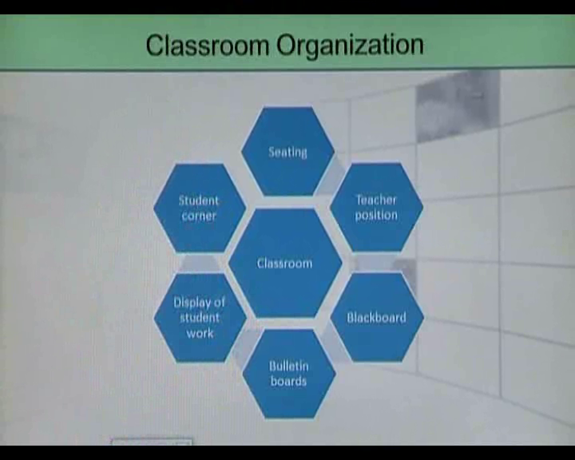

**Dimensions of classroom organization**

1. **Seating**

Are students seated in rows, pairs or groups?

1. **Teacher position**

Is the teacher standing at a position where she is visible to all?

1. **Bulletin boards**

Are there enough bulletin boards in the classroom?

1. **Display of student work**

Is student work displayed on bulletin boards?

1. **Blackboards**

Is the blackboard visible to all students?

1. **Student corner**

Is there a student corner where students can go to read, draw or do other work?

**Topic – 032: Establish Group Norms and Expectations**

**Norms**

Norms are unwritten rules stating what students should and should not do. They regulate and control behavior.

**Practicing Norms**

Norms and Expectations are established in the early years of schooling and are modeled by teachers as a means of careful reinforcement.

**Expectations**

Expectations are the norms applied to a specific situation.

**Topic – 033: Routines and Procedures**

**Topic – 034: Monitor Learning**

**Role of Teacher in Monitoring Learning**

**Teachers should:**

* be proactive in giving feedback
* continuously monitor student learning
* have a well defined mechanism to record student progress
* keep assessment portfolios to monitor student learning

**Topic – 035: Strategies to Maintain Good Behavior**

* Lay down rules at the start of the school year.
* Make classroom rules with the students.
* Issue contracts on non–compliance.
* Reinforce rules.
* Enforce rules uniformly.

**Lesson 07**

**EFFECTIVE MANAGEMENT**

**Topic – 036: Evaluation of Classroom Management & Student Achievement**

Evaluation is:

“The formal determination of the quality, effectiveness, or value of a program, product, project, process, objective or curriculum”.

**Evaluation and Classroom Management**

Classroom management approaches and styles need to be examined periodically for their effectiveness. Changes need to be incorporated if some techniques do not bring in the desired effects.

**Formative and Summative Evaluation**

Classroom management evaluation should be formative in a way that it provides continuous feedback as a way to improve learning.

Classroom management evaluation should also be summative, i.e. an end of term assessment to check the effectiveness of classroom management strategies.

**Topic – 037: Preventive Management**

Teachers who use preventive management set rules and procedures by consensus and enforce them by establishing the consequences of certain behaviors.

**Consequences of action**

Some consequences of behaviors that need to be established:

* Consequence of talking without turn.
* Consequence of breaking group rules.
* Consequence of shouting in class.
* Consequence of throwing objects.
* Consequence of littering in class.
* Consequence of bullying in class.
* Consequence of ridiculing others.

**Topic – 038: Self-Control**

A very important part of preventive management is teaching student self- control and social skill strategies.

Students need to be educated to take control of their emotions and safeguard the security of others around them.

**Ways to Teach Self-Control**

Embed self-control strategies in the school curriculum through:

* Group and pair work activities
* Task based activities
* Project work
* Sports
* Reinforcement in school assemblies

**Topic – 039: Establishing Family Connections**

**Family Connections**

Most of the disruptive behaviors in school can be prevented by establishing connections with family.

Misbehaviors can be controlled and prevented through early intervention by the school as well as the family.

Parents must agree on three issues if they are to manage their child’s behavior:

* The specific behaviors that are desired from the child.
* The mechanism by which the parents will know if their child has behaved in the desired way.
* The consequences for behavior or misbehavior.

**Topic – 040: Establishing a School Culture for Effective Management**

**School Culture**

School culture is a set of unstated expectations and assumptions that direct the activities of school personnel and students.

It becomes the guide for behavior that is shared among members of the school at large.

Culture is the stream of norms, values, beliefs, traditions and rituals built up over time.

They must be upheld and communicated to the students as a way to prevent behavioral issues in schools.

**Topic – 041: Interesting Instruction**

Teachers who provide interesting instruction promote learning by:

* Motivating student participation by means of a variety of teaching strategies and skills.
* Diagnosing learner needs.
* Planning lessons to meet those needs.
* Regularly assessing student progress.
* Assessing their own professional development.

**Lesson 08**

**MODELS OF CLASSROOM MANAGEMENT**

**Topic – 042: Preventive Management**

**Teacher’s Knowledge Domain**

* Content knowledge
* Management knowledge
* Pedagogical knowledge
* Socio-economic knowledge

**Importance of knowledge domains**

In order to have well disciplined and well controlled classroom it is important for teachers to have knowledge of all domains.

**Topic – 043: Professional Development of Teachers**

**Why is professional development needed?**

* To fine-tune and improve one’s own knowledge as a teacher.
* To improve student learning.
* To make an institution a more professional place.
* To become a ‘critical friend’ of oneself and others.

**PD and its importance**

School and Classroom management should be formidable parts of every professional development programs. Their importance needs to be highlighted so that teachers go better prepared in classrooms.

**Topic – 044: Models of Classroom Management**

**Introduction**

**Disruptive Behaviors**

Difficulty managing behavior in the classroom can be a source of frustration for teachers and can severely hamper the teaching learning process.

**A personal Philosophy of Management**

A cohesive and thoughtfully constructed personal philosophy of classroom management can provide the foundation from which teachers make classroom management decisions and respond to instances of student misbehavior.

**Models of Classroom Management**

* Assertive discipline
* Logical consequences
* Teacher effectiveness training

**Topic – 045: Assertive Discipline**

**This model was developed by Lee Canter in the 1970s.**

The premise of assertive discipline is that teachers should establish a systematic discipline plan prior to the start of the school year and then communicate expectations and consequences to the students immediately.

This approach is often characterized as focusing on rewards and punishment.

**Topic – 046: Consistent, Firm and Fair Rules**

* Rules must be set keeping in mind the age and grade level of students. Different rules should be made for different set of behaviors.
* Rules must be mutually agreed upon.

Rules can be different for:

* Classroom
* Laboratories
* Playgrounds
* Walkways
* Auditorium
* Art room
* Computer room

**Lesson 09**

**PLAN TO IMPLEMENT THE MODELS WITH STUDENTS**

**Topic – 047: Positive Consequences for Adhering to the Rules**

**Positive Reinforcement**

A teacher must praise the students when the rules are kept.

Positive reinforcements is a bid deterrent to misbehavior in school students.

When students are praised, their self-esteem increases and the instances of problem behavior decrease automatically.

**Reward Mechanism**

Verbal

* Well done!

Non-verbal

* Nods, smiles, facial and body gestures

Tokens

Stars

**Topic – 048: Negative Consequences for not Adhering to the Rules**

**Negative Consequences**

Negative consequences are the penalties that students face when they bypass or disobey rules.

It should be very clear to the students that non-compliance to rules will make them liable to negative consequences.

**Types of Negative Consequences**

* Missing recess
* Detention after school
* Relinquishing a reward won earlier
* Extra academic work
* No game period
* Assisting in cleaning the classroom
* Suspension from school

**Topic – 049: Plan to Implement the Model with Students**

**Planning for implementation**

Make the rules with the students so a mutual ownership is developed.

A constant reinforcement of rules is important

Planning of rules needs a whole school commitment

All stakeholders need to be apprised of the rules

Students need to see the rules in black and white and know both the positive and negative consequences of their behaviors.

**Topic – 050: Logical Consequences**

**The model**

This model was articulated by Rudolf Dreikurs in 1968.

This model is based on Alfred Adler’s idea that students’ misbehavior is based on their unmet needs.

All students desire and need social recognition.

When these desires are not met, students exhibit a hierarchy of behaviors based on ‘mistaken goal’.

When a student’s need for recognition is unmet, that student will first display attention-seeking behaviors.

If those behaviors do not result in the desired recognition, the student will attempt to engage teachers in power struggles, followed by extracting revenge and then a display of inadequacy.

**Topic – 051: Unmeet needs of students**

**Adler’s Theory (1870-1937)**

Alferd Adler, a philosopher and psychiatrist, stressed the need to understand individuals within their social context.

He stressed to address such crucial and contemporary issues as equality, parent education, the influence of birth order and life style of individuals. Adler believed that we all have one basic desire and goal: to belong and to feel significant.

When we feel encouraged we feel capable and appreciated and will generally act in a connected and cooperative way.

When we are discouraged, we may act in unhealthy ways by competing, withdrawing or giving up.

**Unmet needs**

Students generally misbehave when their basic needs are not looked after either by the caregivers, teachers or peers.

**Topic – 052: Attending to Misbehavior**

**Misbehavior**

Even when a teacher strives to establish a classroom where all students feel recognized and accepted, it is likely that some misbehavior will occur.

**Application of logical consequences**

It is for this misbehavior that a logical consequence is applied. These are consequences that have a clear and logical connection to the misbehavior and have been discussed and agreed upon with the student before applied.

**Example**

A student who disrupts others during class will be isolated from the group unless he/she agrees to rejoin the group without disruption.

Logical consequence requires active planning and conscious application.

**Topic – 053: Teacher’s Stance**

**Teacher’s role**

Teacher should:

Avoid power struggles with students

Try to engage disruptive students in a leadership role.

Use more productive ways to make those students feel powerful, valued and recognized who have the mistaken goal to assume power.

**Example**

Teachers can engage students with mistaken goals in:

Taking the attendance

Proof reading an answer key

Writing the day’s homework on the blackboard

**Lesson 10**

**TEACHER’S EFFECTIVENESS TRAINING**

**Topic – 054:**

**The model**

This model was advocated by **Thomas Gordon in 1977.**

Gordon conceptualizes effective management of a classroom as facilitating the shift of management responsibilities from teachers to students.

Gordon emphasizes the importance of teaching students to regulate and manage their own behavior.

He highlights the value of using intrinsic motivators and the value of I-messages when talking to students about problematic classroom behavior.

**I-messages**

I-messages focus on the speaker’s feelings and perspectives (a teacher’s) as opposed to what the student has done wrong.

**Topic – 055: Self-regulation of Behavior**

The model promotes ways that the teacher can empower the students to self-regulate their behavior through modeling and problem solving.

This approach has a higher possibility of success than simply delivering consequences because it represents an attempt to help the student change his or her behavior.

**Topic – 056: Classroom Management Strategies (An overview)**

Many discipline problems occur because of poor practices of classroom management, often during transitions between activities or changes in space.

**Classroom management**

* Classroom management is the arrangement of:
* Students (grouping)
* Materials (pencils, papers)
* Furniture and the movements of these over time

**Teacher’s role**

The teacher must act pro actively to manage problems that might erupt during transitions between activities, lesson or space.

**Topic – 057: Developing With-it-ness**

Teachers who have with-it-ness have eyes in the back of their heads.

They are aware of what goes on in the classroom. Their actions show that they are on top of what everyone is doing.

**Practice with-it-ness**

Helpful hints:

* Stand where you can see all students when you present a lesson.
* Make eye contact with as many students as possible.
* Keep your face towards the students when you move towards the chalkboard.
* Stand at an angle to write on the chalkboard so that you can see as many students as possible.
* Circulate to various parts of room.

**Topic – 058: Overlapping**

Overlapping means handling two or more situations or activities simultaneously.

A teacher who can instruct a group of students while responding to student concerns from outside of the group can keep an entire classroom working smoothly.

**Practicing overlapping**

Make eye contact with, move closer to, or stand beside a misbehaving student to deter off task behavior while continuing to direct other activities.

Direct a question to a student who has not been paying attention to regain his/her attention.

Remove an object a student is playing with without interrupting a presentation.

**Topic – 059: Managing Movement**

Skilled teachers use movement to regulate the pace and flow of classroom activities, keeping ‘dead time’ to a minimum.

**Practicing**

Helpful hints:

* Organize your materials, teaching aids so they are ready to be used.
* Train your students to take out their books/materials promptly.
* Establish efficient routine to move your students promptly from room to room or one part of the room to the other.
* Be in control, do not fumble with things. Students might consider it your lack of preparedness.

**Lesson 11**

**CLASSROOM MANAGEMENT STRATEGIES – 1**

**Topic – 060:**

1. **Fostering Group Focus**

Group focus keeps the teacher aware of all the students and keeps each student actively involved, alert and accountable for his/her performance.

**Practicing group focus:**

* Pace your lessons quickly enough to maintain your students’ interest, but not so quickly as to confuse them.
* Frame questions at a variety of levels, hem widely to keep students alert.
* Accept responses from those students whom you point out, unsolicited responses lead to classroom management problem.

**Topic – 061**

1. **Smoothness:**

Smoothness is shown by the teacher continuing with his/her lesson without digression.

**Examples:**

* Do not get distracted by an unplanned event
* Do not interrupt students from working
* Do not leave a learning activity mid-stream
* Time yourself well
* Do not show confusion
* Stay with the logical organization of the lesson

**Topic – 062**

1. **Group Alerting:**

These are behaviours used to keep students in suspense or ‘on their toes’. Teachers who keep students alerted are more successful in inducing work involvement and preventing deviations.

**Examples:**

* Call on students at random
* Induce suspense between questions, “This is a tough one coming”
* Have the entire class respond in unison
* Physically move around and see what students are doing
* While asking one student to respond, look at other students

**Topic – 063**

1. **Build self-esteem:**

Self-esteem means that we appreciate ourselves and our inherent worth. More specifically, it means we have a positive attitude, we evaluate ourselves highly, we are convinced of our own abilities and we see ourselves as competent and powerful in control of our own lives and able to do what we want.

**Teacher’s role in building self-esteem:**

* It is highly important for teachers to build the self-esteem of students. They must avoid sarcasm or actions that belittle students in front of classmates.
* Such students at times display the tendency to cause classroom management issues.

**Actions:**

* Display positive behaviour
* Do not demean students
* Help students work on their weak areas
* Help introvert students to come out of their shells and safe zones
* Display empathy and pro-social behaviour

**Topic – 064**

1. **Procedures during whole class instructional activities-1:**

**Students talk:**

Student talk can be managed through:

* Raising of hands
* Chorus responses
* For both, teachers need to signal as to when which response is required

**Use of room by students:**

Students should know:

* When it is appropriate to leave their seats and ask for help.
* How to use materials e.g. pencil, sharpener
* Obtain books from shelves
* What to do when they finish work early

A chart can be given to the students if they have finished their work earlier, such as given below:

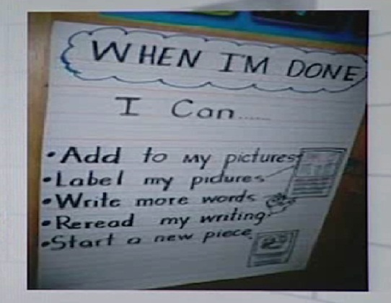

**Topic – 065**

1. **Procedures during whole class instructional activities-2:**

**Signals for attention:**

Some signals that teachers may use to gain student attention during transitions or activities are:

* Verbal cues
* Moving to a specific area of the room
* Ringing a bell
* Turn on an overhead projector

**Student behaviour during seat work:**

Expectations need to be established:

* For what type of talk is allowed
* Of how students get help
* What type of out-of-seat behaviour is permitted
* How to gain access to materials
* Of what to do when seat work is finished early

**Procedures for laboratory and Project Work:**

Routines need to be established for:

* Distributing materials
* Safety routines
* Demonstrating appropriate behaviour
* Extensive movement
* Cleaning up

**Lesson 12**

**CLASSROOM MANAGEMENT STRATEGIES - 2**

**Topic-066**

1. **Communication skills:**

Communication can be verbal and non-verbal and just as in everyday life, poor communication can cause unnecessary problems. Good communication skills and being a good listener , as well as a good speaker , can help in preventing problems in the classroom. When students feel that they are welcomed into a nonthreatening environment where learning is encouraged, they usually come ready, willing, and able to learn.

**Reprimand:**

If you must reprimand students, use a normal tone of voice, look at the student, do not use gestures such as pointing your finger, and do not insist on the last word.

Korr and Nelson (as cited in Pedota, 2007)

**Topic 067**

1. **Parental involvement:**

Keep parents informed. Parent involvement will support your role as a teacher. Parents can enforce the right behaviours at home. For example, through the use of behaviour chart. The students who are problematic or those creating continuous disturbance in classroom can be tackled by observing their behaviours on a chart. A behaviour chart is given below:

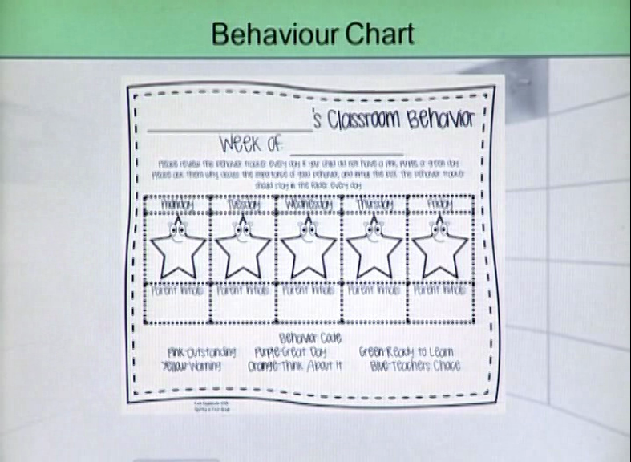

Through this chart, parents can get weekly feedback about the behaviour of their children in classroom and school.

**School’s role:**

* Hold workshop for parents about the behavioural expectation from school.
* Inform parents that appropriate behaviour is a strong expectation from school.
* Involve parents to resolve behavioural problems occurring in schools.

**Topic-068**

**Role of effective teachers in managing classrooms-1:**

Effective teachers:

* Breakdown their classroom tasks into specific rules and procedures for students to understand and follow.
* Teach the rules and procedures as an important classroom lesson consisting of presentation, examples, practice and feedback.
* Predict procedures where students will have confusions and emphasize the teaching of those procedures
* Monitor and handle problems directly and immediately

**Topic-069**

**Role of effective teachers in managing classrooms-2:**

Effective teachers:

* Instruct students in specific rules about appropriate behaviour
* Monitor student compliance by consistently enforcing acceptable behaviour
* Organize class time so that most class time is devoted to instruction

**Topic-070**

**Physical dimension of classroom and classroom management:**

**Safe environment:**

* Ensuring that all students learn in safe environment is the prime objective of a teacher.
* Classrooms should be safe zones for all students. Only then proper teaching and learning can take place.

**Develop procedures for a safe classroom:**

Before you can begin to teach, you should devote time to preparing your classroom and developing procedures that will help you maximize instruction in a positive climate.

**Topic-071**

**Classrooms: Institutional warehouses:**

**Point to ponder:**

* We seat a student for 6 hours in an overheated room, among 20-30 other eager, restless, or bored students, and insist that they all stay seated and keep quiet for long periods of time during the day.
* Are these adequate situations for learning?
* Is learning possible under such circumstances?
* Can appropriate behaviour be displayed in such situations?
* Can students and teachers cooperate in such conditions?

**Topic-072**

**Caring about physical dimension:**

A teacher, who uses his students’ works to decorate a classroom, or a teacher who makes a classroom a safe place or a teacher whose imaginative set up of classroom furniture frees students from being anchored in a seat for hours is a teacher who takes care of the physical dimension of a classroom.

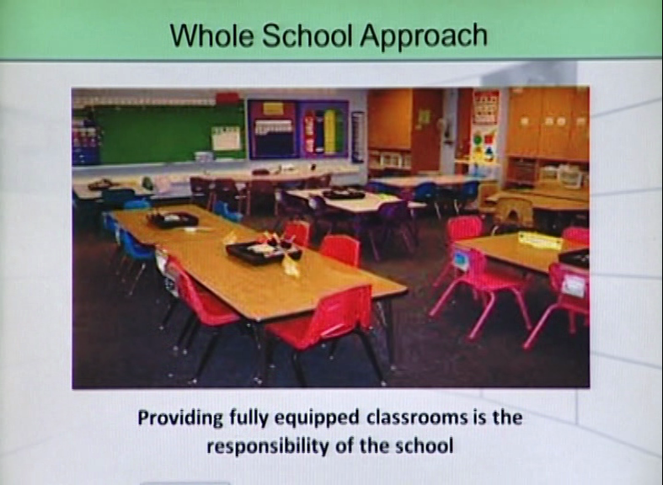

**Whole school approach:**

There should be:

* Purpose built buildings
* Big rooms with adequate facilities
* Big playgrounds
* Adequately equipped laboratories, art rooms, libraries, washrooms and infirmary
* Big staffrooms with work stations for teachers
* Adequately furnished rooms for administrative staff

**Lesson 13**

**PHYSICAL DIMENSIONS OF A CLASSROOM - 1**

**Topic-073**

**Factors that set up safe and productive classroom:**

1. **Physical space:**

The room should be arranged to ensure that:

* All students can see well
* There are no obstructions
* The lighting is adequate
* If and when students move around, they do not interfere with other students
* The room is neither too big nor too small
* No noise in the surroundings to distract students

1. **Teacher’s position:**

Your desk should be positioned so that you can monitor the activities of all students as well as not interfere with movement within the class. For example see the image given below:

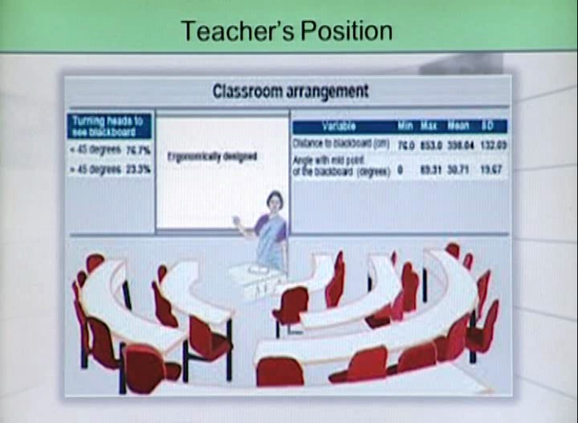

She can see all the students. She is standing at the position where all the students can see her. So, teacher’s position is extremely important as far as the physical dimension of a classroom is concerned.

**Topic-074**

1. **Noise level:**

Possible noisy surroundings outside:

* Traffic noise
* Noise from adjoining classes
* Noise from the play ground
* Music room
* Staff talking to each other in hallways

The noise level outside the classroom should be under control and monitored so that effective teaching and learning can take place.

1. **Establish listening stations:**

* It is helpful to establish listening stations with headsets if something loud needs to be listened.
* The right of others to work in quiet conditions needs to be protected.

**Topic-075**

1. **Seating Plans:**

Permanent seating arrangements will help teachers to:

* Learn students names quickly
* Take attendance
* And perform any other administrative task while students are involved in some instructional activity.

1. **Modification in seating plan:**

Seating arrangements can be modified to support different types of instruction, such as whole group instruction, small group instruction, or students working individually.

**Topic-076**

1. **Independent space:**

Each student must have a place to work and a place to store his/her things. There must be sufficient space between the rows of seats so that one student cannot disturb the other. In group work there must be separate space for materials.

For example see the image below:

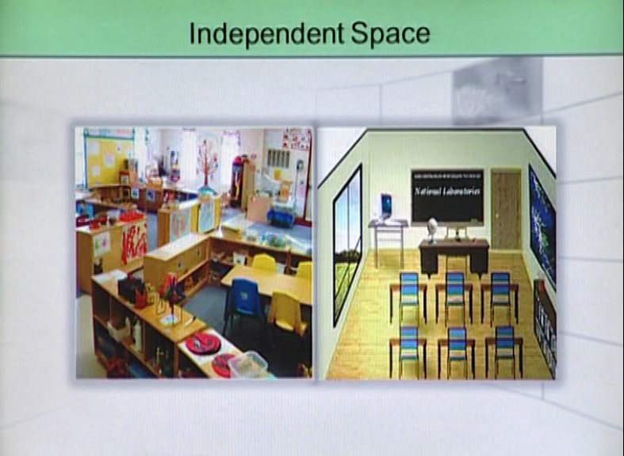

**Problems:**

Classroom management problems arise when students:

* Push each other because of lack of space
* Trample over each other’s bags
* Fight over stationary

It is important for a teacher to consider these issues otherwise she will face management problems in the classroom.

**Topic-077**

1. **Appropriate lighting in the classroom:**

Both well-lit and dimly-lit areas need to be created in the classroom by using bookcases, screens, plants, and other furniture.

1. **Placement of students:**

Allow students to sit where they feel most comfortable, or place restless children in low-light areas and listless children in brighter areas.

**Lighting and learning:**

Some children learn best in bright light while others do significantly better in low light. Bright light sometimes make some students restless and hyperactive.

**Topic-078**

1. **Appropriate room temperature:**

Students need to be made aware of their own temperature preferences and encouraged to dress accordingly.

**Temperature preferences:**

Temperature preferences can vary dramatically. Most children cant concentrate when they are either too cold or too warm.

**Temperature Conditions:**

The classrooms should be ready to handle extreme weather conditions. There should be enough fans in the rooms in summers. The rooms should be well ventilated. Similarly, in cold conditions electric or gas heaters should be provided in classrooms. The classrooms should be protected from chilly winds from outside.

1. **Student Number:**

The number of students in each classroom is also subject to the weather conditions in cities. For example, large classes should be avoided if the weather conditions are extremely hot for most parts of the year.

**Lesson 14**

**PHYSICAL DIMENSIONS OF A CLASSROOM - 2**

**Topic-079**

**Physical Dimensions of a Classroom**

1. **Furniture arrangements:**

* Establish informal furniture arrangements where students can sit on soft chairs or pillows, or on the carpet.

**Research on posture:**

* Students learn best when sitting up straight in hard chairs is a myth.
* About 75% of the total body weight is supported on only four square inches of bone when humans sit up straight in a hard chair. The results in stress on the buttock tissues, causes fatigue, discomfort, and the need for frequent changes in posture.
* Research supports the common sense notion that many students pay better attention and achieve higher grades in more comfortable settings.

**Topic-80**

1. **Arranging space:**

* The physical layout reflects your teaching style.
* Organize students around tables or clusters of desks if you want students to collaborate in small groups.
* For frequent whole group discussions, try a circle or U-shaped desk configuration.
* If you want students to work individually, arrange learning stations for them.

**Topic-081**

1. **Placement of classroom accessories:**

Classroom accessories include:

* White board/chalk board
* Bulletin boards
* Multimedia/overhead projector
* Hands-on materials
* Reading/writing corners
* Teaching platform/rostrum
* All classroom accessories should be placed at the sight level of students.
* Students should have an easy access to them
* Students works should be displayed on bulletin boards
* Students should take ownership of classroom facilities

**Topic-082**

1. **Management of facilities:**

Facilities management is a process of ensuring that buildings and other technical systems support the operations of an organization. (Fenker as cited in Okeke, 2013).

**Classroom/School facilities management:**

Classroom/school facilities management is the application of scientific methods in the planning, organizing, decision making, coordination and controlling of the physical environment of learning for the actualization of the educational goals and objectives. Human and material resources are deployed for this purpose.

**Topic-083**

1. **Maintenance of facilities-1**

There are many dimensions in the maintenance of facilities of a school:

1. **Preventive maintenance:**

Preventive maintenance is carried out to avoid breakdown and ensure optimal performance of the facility.

1. **Routine maintenance:**

Routine maintenance is carried out periodically-monthly, quarterly or even annually depending on the agreed schedule by the class/school manager.

**Topic-084**

1. **Maintenance of facilities-2**
2. **Emergency repairs:**

* Emergency repairs take place when a facility breaks down and urgent measures or steps are to be taken to remedy the situation. This normally occurs where people lack maintenance culture.
* It is expensive because the extent of damage may demand total replacement or high cost of repair.

1. **Predictive maintenance:**

* Here computer software is used to predict equipment failure
* This is based on age, user demand and performance measures

**Lesson 15**

**ACTIVITIES FOR MANAGING LEARNING & DISCIPLINE – 1**

**Topic – 085**

1. **Task Variety:**

Task variety is a very important tool for teachers and the teacher must utilize this tool to have effective management in the classroom.

**Activities in classroom:**

Activities can be regarded as ‘work’ or ‘non-work’ related. The less attractive or appealing a task, the more likely that work is delayed or students become distracted from it. Teachers need to find ways to present activities, especially those which are less appealing, which maintain or increase student motivation and interest.

**Task variety and students:**

For this, it is important for the teachers to know:

* The context
* Students’ interest areas
* Age level abilities
* The attention span of students of particular age groups
* Ways in which students get motivated

**Topic – 086:**

1. **Dimensions of Variation of Activities-1:**
2. **Time on the task:**

The length of time on a specific task should depend on the:

* Curriculum area
* Age of students
* Students’ need for frequent change in activity

1. **Complexity of task:**

* Students should be given a range of tasks which vary in their level of complexity and in the demands they make
* It is important to ensure that students are developmentally ready to undertake various tasks

**Topic – 087**

1. **Dimension of Variation of Activities-2**
2. **Presentation and Format:**

* Over-frequent use of similar format for presenting tasks may bore the students. For example, use of worksheets everyday is a tedious exercise for students.
* Variety in the way work is presented is, therefore essential when students are to take a continuous block of individual written activities.

**What are students to do!**

Boredom sets in because of:

* Doing a task for a prolonged period
* Repetition of tasks
* Continuous sitting at one place
* Continuous listening to teacher talk

Incorporating changes in the behaviour required is a powerful tool to ward off boredom.

**Topic – 088**

1. **Dimension of Variation of Activities-3:**
2. **Pupil Choice:**

* For some tasks e.g. topic choice, leave students with an element of choice.
* The extent to which a task involves choices by students provides a dimension for variation. However, where students choose tasks they still should be told what the task entails.

1. **Patterns of Interaction:**

Students should be engaged in:

* Individual
* Cooperative or competitive working patterns

**Topic – 089**

1. **Pattern of Activities:**

**Planning Activities:**

* The way in which curriculum content is planned across the year and term provides the framework from which weekly and daily patterns take shape.
* Effective planning involves both selecting those activities which enable students to achieve objectives for a session and ensuring that these activities can be completed in the time available.
* Many lesson plans fail because of problems with timings.
* “The pattern of the learning activities must fit both the educational aims and the stretch of the time available.” Marland (as cited in Bull & Solity, 1987)

**Topic – 090**

1. **Sequence of Activities-1:**
2. **Sequence Promotes Learning:**

The sequence of activities should promote the students’ achievement of a particular teaching objective. For example, preliminary activities may be an orientation exercise of what is to follow.

1. **Sequence Ensures Involvement:**

The lesson should give every student a chance to be actively involved. For example, discussion activities must be arranged so everyone can participate.

**Lesson 16**

**ACTIVITIES FOR MANAGING LEARNING & DISCIPLINE – 2**

**Topic – 091**

The most important part for managing learning and discipline is **to keep students busy.**

**Free time**

When students have noting to do, they fill in the time with their own preferred activities and not necessarily the one desired by the teacher. While making a lesson plan there must be proper utilization of the free time. When we transit from one activity to the other free time happens naturally. Teacher must be alert at that time and teacher must take care of the fact that students do not involve in any meaningless activity. Preferably the lesson duration must be of 30 to 40 minutes and there must be filler activities as well in our lesson plan. If the teacher does not plan these activities then the student off track in the longer gaps and he or she loses touch with the lesson too. Teacher makes sure that he/she has a handful of activities for the free time. In a lesson plan there must be provision for change.

**Topic – 092: Activities to keep students busy**

* **Starter activities**

These activities can be planned at the start of the lesson to motivate the students towards the lesson.

* **Filler activities**

Filler activities must be related with the content.

* **Optional activities**

For example if teacher gives the activity of paragraph writing to the students. She can give optional activity connected to paragraph writing to the students. It can be in the form of creative writing. The optional activities extend those activities which students are already doing.

* **Less exciting activities**

These can be used when a teacher feels that students have become bored doing some task. This type of activities can enhance the motivational level of students.

Through these activities students will not show any management issues or disturbance in the class.

**Topic – 093: Classroom population and management of learning**

**Teacher student ratio**

* In the classroom enough desks, chairs, lockers, instructional aids as well as ICT materials etc. must be provided to match with the population ratio of not more than 1:30 students i.e. one teacher to thirty students.
* This makes for efficiency on the part of the teacher and good performance on the part of the students.
* The quality of products (students) bears a direct relationship with the quality of facilities developed in the process of production.
* Adequate human and material faculties must be provided in the classroom to prepare the students for life in the large society.

**Topic – 094: Outdoor activities**

* Outdoor activities are part of the curriculum but their realization is possible outside the classroom.
* Outdoor activities run across the curriculum and afford students an opportunity to explore different phenomena with their own eyes.
* They are important learning experiences as they educate students in non- conventional settings. Outdoor activities make learning faster and it leaves a bigger impact on the students.
* It builds on the concept that learning needs to be connected to real life experiences and students need to learn beyond the textbook.

**Kinds of outdoor activities**

Outdoor activities are dependent on the age level of the students. These are also dependent on the subjects they are dealt with. Outdoor activities are:

* **Field trips**

These can be content related. They can deal with different subject areas. It can also be a recreation

* **Nature experiments**

These are related with the science subjects.

* **Research based studies of various phenomena**

These can be determined by the teachers.

* **Fun activities, camping**

With academics other activities are also important for the students like camping. It includes both recreation and learning.

**Topic – 095: Management of outdoor activities**

**Prerequisites of outdoor activities**

Outdoor activities should:

* be manageable
* be age appropriate
* align well with curriculum aims
* practical and interesting
* be within a particular time frame

**Management**

* Teachers must be trained to handle outdoor activities.
* Adequate support must be sought.
* Students need prior training before undertaking outdoor activities.
* Every outdoor activity should follow set rules.
* Logical consequences should follow non-compliance.
* Outdoor activities should be evenly spread throughout the curriculum and its objectives should be clearly communicated to the students.

**Topic – 096: Whole school approach**

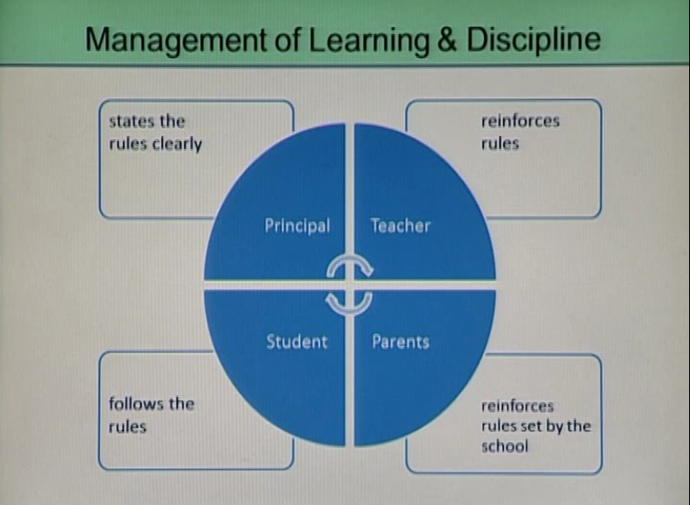

* Major stakeholders (principal, teacher, students, parent) come in the whole school approach. Management of classroom and outdoor activities and discipline need a whole school approach.
* It needs commitment from all stakeholders.

**Topic – 097: Sequence of activities-2**

**Sequence should incorporate variety**

A series of activities which provide a variety of:

* Content
* Materials
* Behavior

It will add interest and pace to the lessons.

**Example**

Children’s attention to the teacher or to a story book during story reading was consistently higher than when this activity followed a quite period rather than vigorous activities.

* Preferred or more exciting activities should follow those which are less exciting or require more effort from students.
* The satisfactory completion of the first task is rewarded by beginning the next, more desirable activity in series. This ensures active interest of the students throughout the lesson.

**Lesson 17**

**CURRICULUM INSTRUCTION & CLASSROOM MANAGEMENT - 1**

**Topic – 098:**

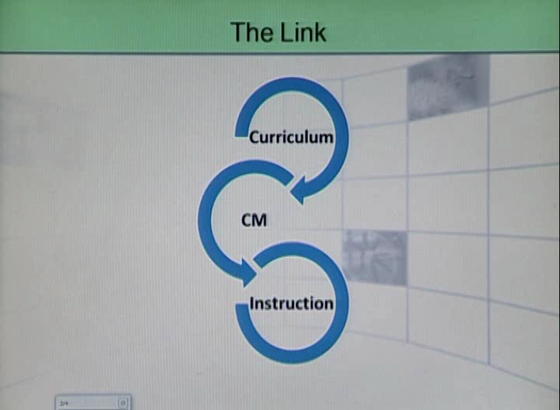

**Curriculum**

Curriculum represents all the activities a school provides to support the development of:

* Academic
* Social
* Personal abilities

It is a description of the desired outcomes for students in terms of the:

* Skills
* Knowledge
* Attitudes they need to prepare them for adult life.

**Topic – 099: Curriculum instruction and Classroom management**

**Instruction**

Instruction relates to the way teachers facilitate students to achieve curricular goals.

Learning outcomes can be increased through:

* Positive on-task behavior
* Skill achievement
* Positive attitudes to learning

There needs to be a close relationship between curriculum, classroom management and instructional activities.

**Topic – 100: Curriculum and positive behavior 1**

* The school curriculum plays a central role in developing citizens:
* Who are motivated to learn
* Who have skills to actively problem-solve
* Who are capable of making decisions individually and cooperatively

**Social skill development**

Learners, especially young ones need time to develop the required social skills of:

* Sharing
* Taking turns
* Working together

**Developing the understanding of the consequences of their actions**

**Early teaching of social skills**

Time taken to support children in learning such social skills in early years can provide a positive foundation for later social and emotional development.

**Topic – 101: Curriculum and positive behavior 2**

**Parental Support**

Social emotional training needs to be provided at home to provide a secure base as the child faces many adaptations needed at school as he/she matures socially, emotionally and intellectually.

**Increased opportunities at school**

The curriculum should provide increased opportunities to work with others to learn from appropriately modeled behavior. The skills of problem solving and cooperative decision making need to be developed through the curriculum.

The curriculum should guide social and emotional development as well as academic skills all of which are pivotal in developing a positive approach to classroom and behavior management.

**Topic – 102: Task Relevance, Achievability and Success**

**Meaningful tasks**

Students need to see a relationship between what is introduced to them in the classroom setting and their real life situations in order to view the activities as meaningful and interesting.

**Achievable tasks**

Tasks also need to be achievable so that students experience success. If tasks are too difficult students may feel frustrated. If tasks are too simple, the same frustration will set in.

**Well structured tasks**

The class curriculum needs to be structured to ensure that all students are:

* Actively engaged in worthwhile academic activities
* Challenged at their appropriate level of ability
* Able to experience success consistently

**Lesson 18**

**TECHNIQUES TO ASSIST LEARNING**

**Topic – 103: Feedback Values and Expectations**

**Feedback**

Feedback given to students in daily activities provides a key link to maintaining a positive approach to behavior and the curriculum materials being presented.

Through effective feedback the teacher also establishes a positive relationship with individual students by communicating to them that they are valued.

**Topic – 104: Techniques to Assist Learning 1**

**Content Enhancement Techniques**

Teachers can incorporate effective techniques in their lessons to enhance make learning easy, hence less chances for classroom disruption.

These techniques need to run across subject areas and be embedded in the curriculum from the start of the school year.

**Training for efficient use**

Prior to the use of these techniques it is important for teachers to be familiar to them. Adequate training sessions need to be run for them before they incorporate them in their lessons.

Most lessons get spoiled because of the inadequacy of the teachers to use them effectively.

**Topic – 105: Techniques to Assist Learning 2**

**Advance Organizers**

They include a list of steps to be taken in the lesson, background information, key vocabulary and a statement of outcomes.

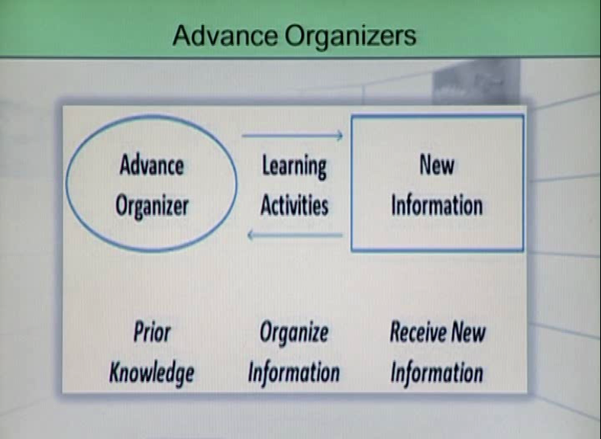

**Topic – 106: Techniques to Assist Learning 3**

**Study guides**

Study guide helps emphasize important aspects of content presented. It may include direct questions that require short answers or a set of words and definitions that need to be matched.

**Mnemonic Devices**

Mnemonic are learning techniques that aid information retention. They aim to convert information into a form that the brain can retain better than its original form.

They facilitate information acquisition.

**Examples**

**TEENS**: tongue, ears, eyes, nose, skin

**Names of planets**: My very Educated Mother Just Served Us Nachos

**Order of rainbow colors:** Richard Of York Gave Battle In Vain

**Topic – 107: Techniques to assist Learning 4**

**Visual Display**

These may include:

* Maps
* Flow charts
* Pictures
* Collages

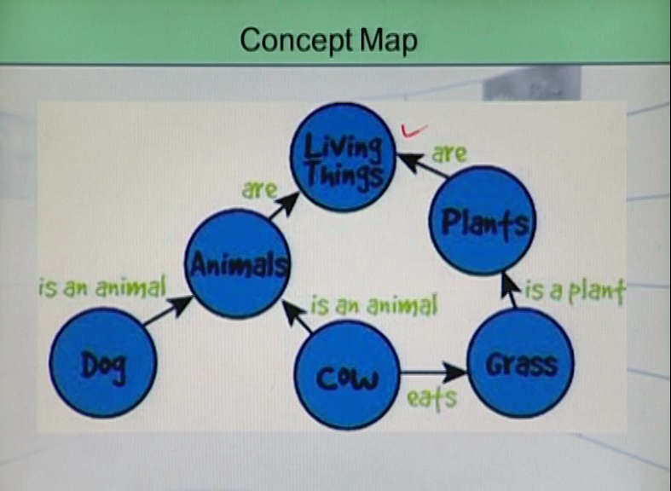

**Topic – 108: Techniques to Assist Learning 5**

**Story Maps**

A story map guides students to attend to the relevant parts of a story. It also helps in giving a direction to the way a story is developed.

**Topic – 109: Thinking the Plan Through**

**Preparation**

In planning the:

* Content
* Sequence of activities
* Material
* Room management

It is good to ask oneself this question:

**“Would this plan actually work with my students in my classroom?”**

**Lesson Preview**

It is advisable to envisage the lesson step-by-step before enacting it. Running such a preview of how the session would work in practice helps to anticipate hitches and difficulties that might arise.

It is especially suitable for novice teachers who may not be able to handle on- the-spot problems. It is better for them to preview and anticipate problems so that management issues can be avoided in the classrooms.

**Lesson 19**

**ROLE OF A TEACHER IN MANAGING A CLASSROOM - 2**

**Domains of Teacher’s Knowledge**

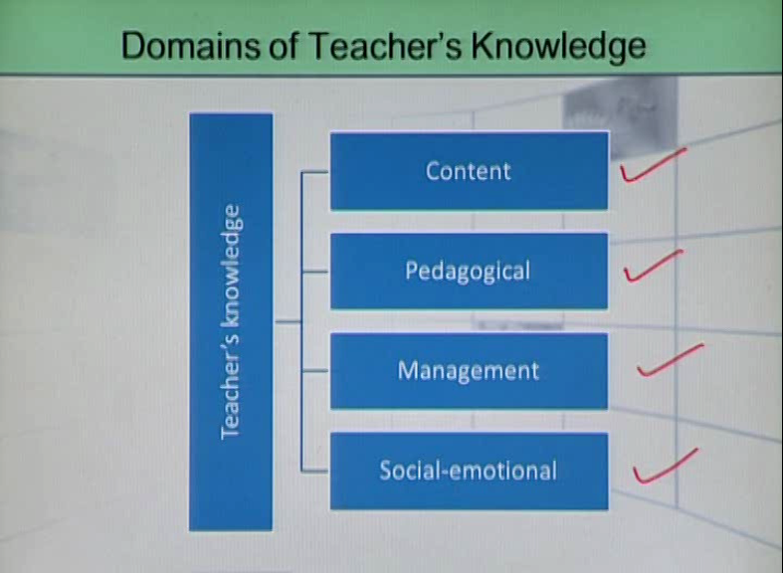

**Topic – 110: Positive Classrooms**

Specific instructional procedures that teachers use lead to increased achievement and student engagement in the classrooms.

These instructional techniques lead to successful social development and student achievement.

Student engagement is aided when the traditional one-way lecture gives way to more interactive teaching styles, leading to student success.

**Topic – 111: Effective Teaching Skills 1**

**Preparation**

Thinking about and planning for what each student in the classroom will do involves:

* Identifying content and student needs
* Lesson, unit and yearly planning
* Planning for student success

**Attention**

Guiding students to stay focused involves:

* Establishing opening focus
* Maintaining ongoing focus
* Expecting all learners to concentrate

**Clarity**

To be clear in communication with students involve:

* Giving clear instruction
* Using precise terminology
* Having students restate instructions before doing work

**Topic – 112: Effective Teaching Skills 2**

**Questioning**

* Ask open ended and probing questions
* Ask frequent question
* Questions all students over time
* Invite student questions

**Monitoring**

Oversee student work. This involves:

* Maintaining appropriate proximity to students
* Awareness of what happens in the classroom
* Not breaking the instructional flow for distractions

**Feedback**

* Give specific feedback
* Give immediate feedback as soon after the behavior as possible

**Topic – 113: Effective Teaching Skills 3**

**Summarizing**

Leave some time of the lesson for recapping and summarizing it. Make sure that deep understanding has taken place. Set the stage for the next concept but make sure that the present lesson is internalized well.

**Reflection**

Review past instruction by using evidence of learner success or failure.

Carry out long term evidence based review of prior instruction

Engage in reflective conversations with students and fellow colleagues

**Reflection types**

* Reflection in action
* Reflection on action
* Reflection for action

**Topic – 114: Instructional strategies that promote a positive classroom 1**

**Instructional strategies**

1. **Gear your instruction to the correct level of difficulty.**

Plan your lesson a step beyond the students’ current level of achievement

Lesson:

Current level+1

1. **Break instructions into smaller learnings.**

First gather what is to be taught and break the information into the small units of instruction. One unit should build on the other.

For example, teaching students to use a computer, they should first know how to use a mouse. Teaching them an adjective would first require the teaching of a noun.

**Lesson 20**

**ROLE OF A TEACHER IN MANAGING A CLASSROOM - 3**

**Topic – 115: Instructional strategies that promote a positive classroom 2**

1. **Build patterning and association into each lesson.**

At one time let the students store only about 4-5 bits of information in minds.

Help students to do chunking as they learn vocabulary. For example, vocabulary words can be grouped by initial letters (hemlock, hockey, honey, hermit)

Make students associate new concepts with what they already know.

While teaching multiplication, tell students that multiplication is similar to addition. 3x5 is same as 5+5+5.

1. **Give them adequate time to process what they have learnt.**

Give wait time (wait 3-5 seconds after asking a question)

When students process what they learned, they not only stay focused for a longer period of time, but they also retain more.

**Topic – 116: Instructional Strategies that promote a positive classroom 3**

**5. Have students work in cooperation, not competition.**

Most cooperative learning classroom are well behaved because students are motivated to learn and are actively engaged in learning activities. (Slavin, 1990: 115)

**6. Ensure success by getting to know your students’ strengths.**

Students have unique strengths as claimed by Howard Gardner (1984). Capitalize on them by getting to know their likes/dislikes.

**Topic – 117: Instructional strategies that promote a positive classroom 4**

**7. Teach students to take responsibility of their learning.**

Draw contracts with students which students and teachers follow and adhere to.

**8. Increase student interest.**

* Vary instructional methods
* Teach in multiple modalities (at times using pictures is better than using words)
* Do not vary methods too much as to confuse students

**Topic – 118: Instructional strategies that promote a positive classroom 5**

**9. Provide assessment that helps the student and informs the teacher**

* Use formative assessment (continuous assessment)
* Use informal assessment (portfolios, writing samples, journal entries)
* Use index cards for students to summarize what they have not understood
* Hand signals (thumbs up or down)
* Having a question box in class
* Web maps, concept maps
* Follow up probes – tell me more, give reasons, why?

**10. Work towards smooth flow and lively pacing**

Too fast = confusing

Confusion = boredom

Boredom = misbehavior

Too slow = dragging

Dragging = boredom

Boredom = misbehavior

**Topic – 119: Accommodate Learner Differences 1**

**Learner differences**

Students do not respond to learning uniformly. They learn at their own pace and respond in various ways while internalizing concepts.

It is very important for teachers to understand the way students learn.

**Lessons to accommodate LD**

Lessons need to be built keeping in mind the various ways in which learners comprehend concepts.

**Topic – 120: Accommodate the learner differences 2**

**Differentiated learning**

Teachers may want to prepare differentiated tasks for various types of learners to ensure that all learn.

For example, worksheets on ‘verb’ can be developed at 3 levels: basic, intermediate and above average so that all types of students can benefit.

Such lessons sometimes ensure a smooth lesson flow as there are less disruptions when all are satisfied with the learning materials. However the teachers need to be very well prepared and skillful to administer such tasks.

**Lesson 21**

**PHILOSOPHIES OF HOW TO MANAGE A LARGE CLASS**

**Topic – 121: Listen to all**

All students have the right to be heard.

Ensure that all students are heard and their needs are addressed.

**No ‘Chosen Fews’**

Most of the classroom management problems arise when students get a message from teachers that only ‘chosen fews’ are heard or given importance to. This causes frustration among students. This frustration is usually vented out in the form of disruptive behavior.

**A healthy classroom**

* Give students a patience hearing
* Have some time to listen to non academic issues as well
* No students should be allowed to dominate
* Shy students are encouraged to speak
* An atmosphere of cooperation needs to be built
* Have a good student-teacher rapport

**Topic – 122: Management Style 1:**

1. **Strong Control:**

Treat the classroom as a “sacred temple of learning.” This management style or philosophy is marked by a strong notion of control and preparation.

1. **Teacher Preparedness:**

In this philosophy of management, teachers are very well prepared and plan for as many aspects of the class as they can. Teachers fully utilize all classroom management approaches and strictly watch student behaviour. Teachers do not tolerate:

* Latecomers
* Side talking
* Mishandling materials
* Early departures

1. **Teacher’s role:**

* Teachers establish at the beginning of the term that the classroom is a place to be respected and students must behave in ways that are appropriate.
* The consequences of inappropriate behaviour are public notice of the inappropriate behaviour and embarrassment.
* In this management philosophy, the teacher is not afraid to act as the policeman.

**Topic – 123: Management Style-2**

1. **Laissez-Fair:**

According to this philosophy, teachers teach the classroom as a relaxed, “laissez-fair” place of learning. This management style or philosophy is very relaxed and “hands-off.” Teachers who use this style of management are very flexible and respond to changes easily. Teachers may not be aware of student problems and do not bother about adhering to certain rules for classroom discipline.

**Topic – 124: Laissez-Fair Teacher’s role:**

* Teachers do minimal planning, and while they can be quite prepared to deliver course content and material, they dislike rigid control and value the ability of response to changes.
* The focus in this type of classroom is a comfortable, relaxed atmosphere where the teacher tolerates reading, talking and late arrivals/early departures. Usually, the more attentive students sit in the front, and the teacher speaks to them.

**Topic – 125: Management Style-3:**

**Moderate control:**

* Teachers treat the classroom as something in between a sacred temple and a laissez-fair place of learning. This management style or philosophy is right in the middle of the two extremes.
* Teachers choose which aspects of the course they wish to control, how they decide to control those aspects, and what they are willing to let go.

**Topic – 126: Teacher’s role: Moderation:**

* With this type of classroom management, the teacher decides which behaviours are tolerated and which are not.
* There is an expectation of respectful behaviour, and the teacher will speak to students who are disruptive after class (rather than calling attention to the disruptive students during class).

**Lesson 22**

**LARGE CLASSES**

**Topic – 127**

**What is a large class?/ Class size:**

Class size is a vital component in:

* Educational planning
* Resourcing

The average perception of a large class is around 50 students. The exact number does not really matter: what matters is how you, the teacher, see the class size in your own specific situation.

**Teacher’s stance:**

The teacher usually becomes a preacher by:

* Lecturing
* Writing notes on the board for students to copy

**Topic – 128: Advantages of Large Classes:**

1. **More interaction among students:**

There are always enough students for interaction, and there is a rich variety of human resources.

1. **Heterogeneous Elements:**

* The teacher is not the only pedagogue, and since the large class is usually heterogeneous, more proficient students can be used to help lower level ones.

1. **Natural Professional Development:**

The teacher is never bored and that professional development occurs naturally as the teacher tries to find new ways of coping with the large number of students.

1. **Peer Teaching:**

Students develop strategies for helping themselves and their classmates through peer-teaching and collaboration, thus fostering an atmosphere of cooperation.

**Topic – 129: Challenges in a large class-1:**

1. **Number of pupils:**

* Numbers of pupils in a class affect pupils’ educational attainment and progress.

1. **Pupil attention in a class:**

* For some students, concentrating in a large group is very difficult-if not possible.

1. **The nature and quality of teaching:**

The quality of teaching and learning is affected in large classes. The teacher cannot give individual attention to students.

**Topic – 130: Challenges in a large class-2:**

1. **Pupil adjustment to school:**

* In large classes it is difficult to help students become independent and resourceful in the classroom.
* The students are affected in their social development by the amount of space available in class. If they fight for space in the classroom, they get emotionally upset and insecure.

1. **Teacher’s Morale, Stress and Enthusiasm:**

* Class size is associated with increased teacher stress and can lead to teacher burn.

**Topic – 131: Correcting large amounts of written work:**

1. **Group work:**

* Have students work in groups to produce one piece of writing for each group or to complete grammar exercises together.
* This encourages communication and also cuts down on the number of papers the teacher must correct.
* Tell students that students within a group will all receive the same grade so that they take an interest in producing something good.

1. **Self editing:**

For all written work, have each student go through the process of self-editing and one or two rounds of peer editing before turning in the paper.

**Challenges in large class-3**

1. **Calling the roll number:**

* **Sign in sheet:** Give the students a sign-in sheet to pass around at the beginning of the class. When it comes back to the front of the room, draw a line under the last name. Any names that are written below the line are those of late-comers.
* **Name cards:** Make students display name cards on their desks. Collect the name cards at the end of the class. At the beginning of each subsequent class, as the students enter the room; have them take their name cards. Those cards that aren’t collected belong to students who are absent.

1. **Creating a seating chart:**

* Create a seating chart
* Make students sit in their assigned seats. This can help in learning students’ names.

**Lesson 23**

**STRATEGIES TO MAINTAIN DISCIPLINE**

**Topic: 132 -**

1. **Calling the roll number:**

* **Sign in sheet:** Give the students a sign-in sheet to pass around at the beginning of the class. When it comes back to the front of the room, draw a line under the last name. Any names that are written below the line are those of late-comers.
* **Name cards:** Make students display name cards on their desks. Collect the name cards at the end of the class. At the beginning of each subsequent class, as the students enter the room; have them take their name cards. Those cards that aren’t collected belong to students who are absent.

1. **Creating a seating chart:**

* Create a seating chart
* Make students sit in their assigned seats. This can help in learning students’ names.

**Topic: 133 - Strategies to Maintain Discipline-2**

1. **Assigning roles to advanced students:**

Give the more advanced students the responsibility for helping others as:

* Group leaders
* Monitors
* Teaching assistants

1. **Showing Respect:**

Teach students to show their respect for others by listening to what they have to say in group work or when they are reporting to the whole class.

**Topic: 134 - Strategies to maintain discipline-3**

1. **Discipline problems:**

* More discipline problems are the result of boredom or alienation.
* If students are interested in the class, many discipline problems disappear.

1. **Set classroom rules:**

* Ask students to work in small groups to write down rules they think are reasonable regarding classroom behaviour and the consequences for breaking the rules.
* Ask students to vote to accept the rules and make a final copy to be hung in the classroom for the year.
* If the rules come from the students, and they consider them to be fair, they will be more willing to follow them.

**Topic: 135 - Strategies to maintain discipline-4**

1. **Variety of activities:**

* Plan a variety of activities that appeal to students with different learning styles and interests.
* This will usually keep the attention of the majority of students.

1. **Establish routines:**

* Starting the class with class agenda on the board can help students to focus and prepare for the day’s class.
* Set up signals that the students understand-for quiet, for silence, and so on—using hand signals, a bell, or some other method.

**Topic: 136 - Using pair and group work-1:**

* When you introduce pair and group work for the first time, plan simple activities for very short periods.
* Have students work with those next to them, or immediately behind them.
* Seats can be changed weekly or monthly in order to allow students to work with different classmates.

1. **Making groups:**

* Set up groups in advance and have them stay together for several class periods.
* Assign roles to group members so that everyone in the group feels involved in some way.
* For each activity, roles should rotate among group members, with different students acting as the facilitator, secretary, recorder, time keeper and so on.

**Topic: 137 - Using pair and group work-2:**

* **Using Handouts:** Make one copy of handouts per group or pair of students. This obliges students to share and to work together, and fewer copies are needed.
* **Instructions:** Give instructions clearly and carefully, and check comprehension before the pair or group work begins.

**Topic: 138 - Teaching with limited resources:**

**Encourage student responsibility:**

1. Ask students to bring an item from home to use as a talking or writing point for the class.
2. This helps to build a sense of community in the classroom.
3. It also encourages student responsibility and participation in the activity.

**Write texts on large sheets:**

1. To save time during class, write texts or questions on large sheets of newsprint or brown paper before class rather than writing on the board.
2. In a very large classroom, make two or three copies that can be posted on the side or back wall so everyone can see.

**Lesson 24**

**TEACHING WITH LIMITED RESOURCES & MOTIVATING STUDENTS**

**Topic: 139 - Teaching with Limited Resources 2**

**Bring Real Objects**

1. Bring regalia- actual objects that language learners can see, hear and touch- into the classroom.
2. A teacher can generate a great deal of interest when he or she pulls surprising thing out of the bag!

**Use Pictures**

1. Use pictures from magazines, or learn to draw simple pictures to illustrate vocabulary or to generate interest in reading, speaking or writing activities.

**Use what the students say as input**

Use what the students themselves say as input

**Example**

To practice changing direct to indirect speech, a student can be asked a question and another student asked to report what was said either orally or in writing.

**Topic: 140 - Teaching with Limited Resources 3**

* Many students in developing countries have access to limited resources.
* The teacher usually has a blackboard and chalk supplied by the school

**Using a Dictogloss**

* Dictate the information using a dictogloss, a replacement for writing notes on chalkboard.
* Students listen twice to a passage read at normal speed, taking notes during the second reading.
* They then work with a partner to try to reconstruct the text.
* When a pair thinks they have the information, they write the passage on the board and the class works together to make it as close to the original as possible.
* The teacher makes the final connections and the students correct their work.

**Topic: 141 - Motivating students 1**

**Set the tone**

1. At the beginning of the year, include some information about the importance of the subject being studied.
2. Make the students take intrinsic as well as extrinsic interest in the subject.

**Supplementary Materials**

1. To keep more advanced students challenged, prepare an activity resource book to keep in the classroom.
2. Students who finish activities quickly can work on supplementary activities while waiting for the rest of the class to finish.

**Topic: 142 - Motivating students 2**

**Ensure the students speak loud**

To ensure that students speak up loudly in class when answering questions or making comments, the teacher should move away from the student who is speaking, rather than coming closer to hear him or her better. In this way everyone should be able to hear and remain involved.

**Adaptation of the material**

1. Adapt the material according to the language level, age and needs of students.
2. In multi-age, multi-level classes, plan a variety of activities to appeal to as many students as possible.

**Topic: 143 - Motivating students 3**

Sequential activities

1. Develop sequential activities with several steps so that higher level students complete more while lower level students work at their own place.
2. When preparing worksheets, add some optional sections for more advanced students.

**Monitors**

1. Use higher level students as assistant teachers or monitors who can help and support the lower level students.
2. Encourage higher level students to teach others in classrooms.
3. It builds a collaborative atmosphere in the classroom.

**Topic: 144 - Motivating students 4**

**Teacher availability**

As much as possible be available to students before and after class to establish personal relationships, so that they feel that they are individuals in the eyes of teacher.

**Activity goals**

1. Make students aware of the goals of each learning activity.
2. If they understand why they are doing the activity, they will participate more willingly.

**Activities to be success oriented**

1. Make all activities success oriented.
2. Students will participate willingly in tasks that seem achievable.
3. When they have confidence in their success, they will be motivated to try.

**Lesson 25**

**SYSTEMATIC PROCEDURE FOR RECORD KEEPING**

**Topic: 145 -**

Develop systematic procedures for behavioral record keeping.

**Make checklists**

1. Make checklists of the desired behavior and mark students against that checklist.

**Communication with others**

Communicate with all stakeholders about the checklist and keep sending the marks obtained to parents.

**Topic: 146 - Setting benchmarks for behavioral expectations**

**Benchmarks**

1. Benchmarking is used to record performance by using a specific indicator.
2. Benchmarks are specific points of reference connected to levels of performance against which students are monitored.

**Development of Benchmarks**

Benchmarking can be done for:

1. Communication with teacher
2. Communication with peers
3. Interpersonal relationships
4. Material safety
5. Following rules

**Topic: 147 - Record of academic and behavioral progress**

1. Behavioral progression records need to be maintained like academic records.
2. Behavioral records need to be made formatively as well as summatively.

Student behavioral self-evaluation

1. Students should be encouraged to do their behavioral self-evaluation
2. The behavioral records should have a section on self evaluation and students should fill that section themselves
3. This exercise makes students more reflective and enables them to analysis their own behaviors

**Action oriented behavioral records**

1. The behavioral records should result in some actions taken as a way to address the negative behaviors.
2. Positive behaviors should be rewarded.

**Topic: 148 - Portfolio maintenance**

1. Behavioral portfolios can be maintained as a way to see a gradual and systematic development of student behaviors.

**What goes in the Portfolio?**

Portfolios can have:

* Records of behavioral progress
* Observation checklists of specific behavior
* Benchmarks that students achieve at the end of each term

**Topic: 149 - Faculty professional development**

1. Teachers get adequate training in classroom pedagogy but few training sessions are held for the behavioral development of students

**Faculty training**

Training must be imparted to teachers on:

1. Behavioral development of students at different age levels
2. Behavioral management
3. Classroom discipline
4. Positive reinforcement
5. Framing logical consequences and negative reinforcement

**Topic: 150 - Counseling services**

When the records of students behavior show deterioration, proper counseling services must be sought to address the issues.

Professional support is required to deal with:

1. Aggressive behavior
2. Bullyism
3. Criminal behavior
4. Sadistic behavior
5. Extreme shyness
6. Lack of self-efficacy

Counselors must become part of the school culture and must be available all the time on campus to handle day to day behavioral issues.

**Lesson 26**

**ESTABLISHING CARING CONNECTIONS - 1**

**Topic: 151 - Qualities that influence student success**

* **Empathy**

Empathy is extending help to students and showing concern towards them. Teachers should try their best to put themselves in their students’ shoes and solve problems.

* **Efficacy**

Self-efficacy is facilitated by a person’s beliefs and expectations about his/her ability to achieve certain tasks successfully or demonstrate certain behaviors.

**Caring and Efficacy**

* Both qualities affect students’ sense of motivation, achievement and value.
* They enhance academic performance and student behavior.

**Topic: 152 - Self- Efficacy and Learning**When individuals have low self-efficacy expectations regarding their behavior, they limit the extent to which they participate in an endeavor and are more apt to give up at the first sign of difficulty.

1. Students’ efficacy and beliefs serve as barriers to their academic and social development.
2. The kind of academic and social experiences students get in schools have a profound effect on whether some behaviors will be continued or not.

**Topic: 153 - Development of Self-Efficacy-1**

**Performance accomplishments**

* The manner in which accomplishments are received has an influence on an individual’s self-efficacy, expectations and actions.
* In the classroom, for example, poor grades and other negative assessments of ability can lower self-efficacy beliefs.

**Vicarious learning**

1. Beliefs are often acquired through observation and interpretation.
2. In observing the modeling behavior of others, the learner is able to reflect on past experiences with such behavior and make meaning of its relevance in a new situation.

**Topic: 154 - Development of self-efficacy 2**

**Verbal persuasion**

1. Beliefs about self are influenced by the message conveyed by others. Encouragement supports self-efficacy, criticism hampers it.
2. Family, teachers and friends all play a significant role in verbal persuasion about appropriate behaviors.

**Physical/Affective Status**

1. Stress and anxiety have a negative effect on self-efficacy as well as learning.
2. “The brain learns optimally when appropriately challenged but downshifts under perceived threats”.
3. It functions best in a supportive environment.

**Topic: 155 - Development of caring attitudes**

1. Show and prove that you care.
2. It is good to say “thank you” and “please” when we talk to students.
3. We should model reflective listening- never interrupt them while they are speaking.
4. Give individual attention to students.
5. Listen to their problems sincerely.
6. Avoid using red pen-use green instead.

**Topic: 156 - Communicate high expectations**

* High academic expectations from the teacher influence students’ achievement.
* Student behavior improves in response to high academic expectations.

**Lesson 27**

**ESTABLISHING CARING CONNECTIONS - 2**

**Topic: 157 - Teacher’s enthusiasm**

Teacher enthusiasm positively affects student behavior and improves student achievement as well.

1. Move around the class
2. Tone the voice
3. Share and articulate interest in the subject

**Topic: 158 - Acknowledge students**

1. Praise develops efficacy and build confidence
2. Appreciating student work is a powerful tool to make them stay focused
3. It decreases ‘learned helplessness’ where students experience failure so often that they come to expect that they will be unsuccessful no matter what effort is exerted

**Topic: 159 - Student accountability**

* Once due dates and requirements are clearly established, the teacher holds students to those dates and requirements giving reasonable reminders all the way.
* When students feel the responsibility to be accountable for their work there is more seriousness in the classroom, hence less management issues.

**Topic: 160 - Affective rules**

In order to establish caring classroom, it is important to frame rules that are socially-emotionally driven.

**Examples**

1. Be emotionally supportive
2. Be helpful to peers
3. Be respectful
4. Do not shout
5. Do not snatch or spoil the material
6. Take turns before speaking
7. Acknowledge and appreciate others

**Topic: 161 - Cognitive-affective curriculum**

1. Make the curriculum cognitive-affective
2. Embed affective objectives in the curriculum
3. Spread the affective objectives evenly throughout the curriculum
4. Assess students on affective elements of the curriculum as well

**Topic: 162 - Affective objectives in lesson plans**

1. Behavior modification happens over time
2. Drastic changes in behaviors are not long lasting
3. Integrate affective objectives in the lessons
4. Make students and other stakeholders realize that they are as important as cognitive objectives
5. Continuous integration will lead to behavior modification

**Lesson 28**

**TEACHER’S ATTRIBUTES IN TEACHING SOCIAL SKILLS**

**Topic: 163 - Social attractiveness**

A teacher should have:

* A cheerful disposition
* Friendliness
* Emotional maturity
* Sincerity

**Ego strength**

1. Self-confidence that allows teachers to be calm in a crisis.
2. Active listeners without being defensive.
3. Avoidance of win-lose conflicts.
4. Problem solving orientation.

**Topic: 164 -**

**Realistic perception of self and students**

* Teachers should have realistic perceptions of self and students without letting perceptions become clouded by the hostility or anxiety.

**Enjoyment of students’ presence**

* While maintaining identity as an adult, a teacher and an authority figure should try to be friendly but not overly familiar and being comfortable with the group without becoming a group member.

**Topic: 165 –**

**Text selection**

1. Select texts that are effective in nature.
2. Highlight effective elements and teach them through a cognitive affective approach.

**Have textual variety**

* Utilize various genres of language, i.e. narratives, poetry, information texts, historical fiction, descriptions etc.

**Topic: 166 - Pro-social activities**

* Role taking exercises
* Intergroup dialogues
* Storytelling
* Group discussion
* Self-awareness and self-regulation1
* Self-reflection and goal setting
* Jigsaw grouping

**Topic: 167 -**

**Clarity about teacher roles:**

* Teachers should have clarity about their roles and be comfortable playing them. It enables them to explain coherently to students what they expect.

**Patience and Determination**

* Teachers must exhibit patience and determination in working with students who persist in testing limits.

**Topic: 168 -**

**Acceptance of the individual**

* Teachers should accept students as individuals and accept some behaviors while taking strong notice of those which are not acceptable at all.

**Action on firm limits**

1. Teachers should have the ability to state and act on firm but flexible limits based on clear expectations.
2. Teachers should encourage students to independently uphold rules and boundaries.

**Lesson 29**

**INCENTIVES IN THE CLASSROOM**

**Topic: 169 - Rewards as a way to control problem behaviour:**

Teachers use rewards in the classroom to control problem behaviour and reinforce positive behaviours.

1. Modest rewards, use carefully and thoughtfully, can encourage intrinsic and extrinsic motivation.

**Topic: 170 - Point of views on rewards (Research Evidence):**

* McGraw (1978) identifies several studies that found that rewards enhance performance.
* Several group of researchers have found that when rewards provide evidence of competence, they can enhance motivation with individuals as young as kindergarteners and as old as college students (Boggiano et al. 1985; Pierce et al. 2003).
* Some laboratory experiments show that individuals who receive a reward for doing a task show less interest in that activity later when compared to those who are given no reward (Cameron & Pierce 2002)

**Topic: 171 - Intrinsic Motivation:**

1. Intrinsic motivation is a desire to attain targets for the sake of learning.
2. The urge for a true desire for mastery is driven by intrinsic motivation.
3. Students are rewarded for showing keen interest in the tasks assigned to them whether they are academic or behavioural in nature.
4. An intrinsic motivated reward further puts faith in students’ ability and reaffirms the displayed behaviour.

**Topic: 172 - Extrinsic Motivation:**

* Extrinsic motivation occurs when a student is driven to perform behaviour in order to win a reward or avoid a punishment. For example:

1. You want to put up a good behaviour because of fear of punishment.
2. You want to help others in a classroom to get some defined incentives.

* Students who must put forth more than the average degree of effort to accomplish a goal often become discouraged and invest less energy in challenging tasks. (Levin, 1994)
* Rewards can provide temporary incentives to encourage persistence when the natural, invisible rewards of success and mastery are infrequent.

**Topic: 173 - Problems in getting incentives:**

* Despite teachers efforts to present lessons in creative ways, for some students mastering educational tasks may require a great deal of skill and instruction. Students may have problems in areas such as:

1. Motor coordination
2. Recognition of sounds and symbols
3. Sensory processing
4. Learning rules for social interaction
5. Controlling impulsive behaviours

**Topic: 174 - Rewards for challenging students:**

1. Struggling students:

For struggling students attempts at mastery routinely meet with failure followed by:

* Teasing from peers
* Criticism from adults
* Self-criticism

(Jacobs 1983; Taylor 1990)

**Rewarding struggling students:**

* Rewards can provide temporary incentives to encourage persistence when the natural, invisible rewards of success and mastery are infrequent.
* If rewards can motivate the students to acquire basic skill that can lead to later success, then it is likely that extrinsic rewards can eventually lead to intrinsic motivation. (Lepper & Henderlong 2000).

**Lesson 30**

**PRACTICE MODELS FOR REWARDS**

**Topic: 175 -**

**Value of Reward Plans:**

* The theorists differ in their points of view regarding the nature of rewards.
* Some advocate rewards having an extrinsic purpose while others advise a more intrinsic approach. See the image below to observe the intrinsic and extrinsic rewards:

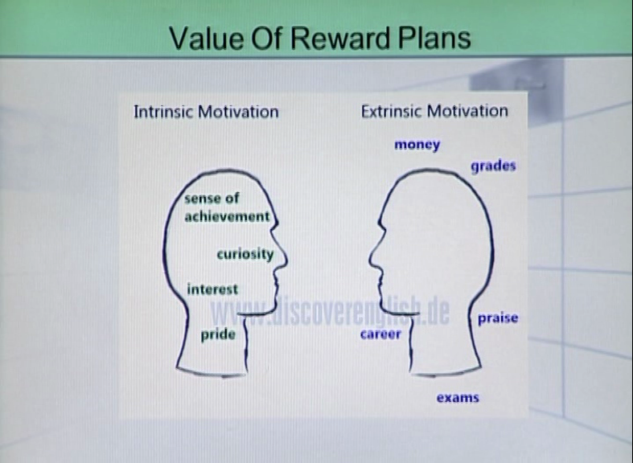

**Extrinsic reward:**

* “Reinforcement is the heart of behavioural control” (Amabile, Hennessey, & Grossman 1986).
* Behaviorists believed that teachers, parents and others in authority need only to think about external incentives when working to encourage new behaviours.

**Intrinsic reward:**

* Those behaviours need to be supported that help students enhance quality of life and enable them to become lifelong learners-humanistic approach. Kluth (2003)

**Topic: 176 - Reward plans that empower:**

A reward plan is prepared at the beginning of the school year and is clearly communicated to the students. A reward plan has three steps:

1. First, a teacher decides on one or more specific goals for a student.
2. The teacher spells out the goals concretely either on a chart or in conversation.
3. In discussing the reward plan, the teacher offers a modest reward for success in meeting goals.

**Topic: 177 - Reward Components-1:**

**Active participants:**

* Encourage children to be active participants in the process of change.
* Support their natural desires for:

1. Autonomy
2. Independence

* Teachers can invite students to help:

1. Choose goals
2. To role-play new behaviours
3. To suggest strategies they might use to meet goals

**Topic: 178 - Reward Componenets-2:**

1. **Choose incentives:**

* Choose incentives that contribute in positive ways to a student’s development or sense of self-worth such as:

1. Privileges
2. Activities
3. Small prizes, e.g. books
4. **Interpersonal rewards-** rewards that offer the opportunity to do an activity with a special person – can be powerful motivators.

**Topic: 179 - Reward Componenets-3:**

**Ownership rewards:**

Design reward charts that contribute to a student’s sense of ownership. For example:

* Teacher can personalize a chart by including a student’s photo or by inviting the student to decorate the chart.

**Topic: 180 - Reward Components-4:**

**Emphasis on positive behaviours:**

1. Emphasize positive behaviours that are simple and clearly stated.
2. While at times a teacher may deem it necessary to include penalty points for misbehavior, emphasize on negative behaviours should be kept to a minimum.

**Individualized reward charts:**

Design individualized reward charts that avoid comparing one student’s performance with those of others in any way.

**Lesson 31**

**EFFECTIVE BEHAVIORAL SUPPORT SYSTEMS**

**Topic: 181 -**

* Effective Behavioural Support(EBS) refers to a system of school-wide processes and individualized instruction designed to prevent and decrease problem behaviour and to maintain appropriate behaviour.
* It is a team-based process designed to address the unique needs of individual schools.
* Teams are provided with empirically validated practices and, through the EBS process, arrive at a school-wide plan.

**Topic: 182 - Processes of Effective Behavioural Support Systems-1:**

**Processes of EBSS:**

1. Clarify the need for effective behavioural support and establish commitment, including administrative support and participation.
2. Priority of this should be reflected in the school improvement plan.
3. Develop a team focus with shared ownership.

**Topic: 183 - Processes of Effective Behavioural Support Systems-2:**

**Processes of EBSS:**

1. Create a comprehensive system that prevents as well as responds to problem behaviour.
2. Tie effective behavioural support activities to the school mission.
3. Develop an action plan establishing staff responsibilities.

**Topic: 184 - Features of Effective Behavioural Support Systems:**

1. There is total staff commitment to managing behaviour, whatever approach is taken.
2. There should be clearly defined and communicated expectations and rules.
3. Have an instructional component for teaching students, self-control and/or social skill strategies.
4. Prepare a support plan to address the needs of students with chronic, challenging behaviours.

**Topic: 185 - School Wide Code of Conduct:**

1. **Safety:** Are my actions safe for myself and for others?
2. **Respect:** Do my actions show respect for myself and for others?
3. **Honesty:** Do my words and actions represent truth?
4. **Responsibility:** Do my actions meet the expectations to take care of myself and be a dependable member of the community?
5. **Courtesy:** Do my actions help make this a nice place, where people feel welcome and accepted, and where they can do their work without disruptions?

**Topic: 186 - Unified Discipline:**

Teachers and school personnel believe that:

1. Instruction can improve behaviour
2. Behavioural instruction is part of teaching
3. Personalizing misbehavior makes matters worse
4. Emotional poise underlies discipline methods that work.

**Unified expectations:**

Consistent and fair expectations for behavioural instruction are a key to successful discipline plans.

**Unified Consequences:**

Using a warm yet firm voice, teachers state the behaviour, the violated rule, and the unified consequence and offer encouragement.

**Unified team roles:**

Clear responsibilities are described for all school personnel.

**Lesson 32**

**SCHOOL DISCIPLINE**

**Topic: 187**

School discipline has two main goals:

1. To ensure the safety of staff and students
2. To create an environment conducive to learning.

**Topic: 188 – Discipline problems in schools - 1**

Discipline problems arise because rules are:

* Unclear
* Perceived as unfairly or inconsistently enforced
* Students do not believe in rules

**Topic: 189 - Discipline problems in schools – 2**

Discipline problems arise because:

* Teachers and administrators disagree on the proper responses to student misconduct
* Teacher-administration cooperation is poor or the administration is inactive
* Teachers tend to have punitive attitudes
* Misconduct is ignored
* Schools are large or lack adequate resources for teaching

**Topic: 190 – Countering discipline problems in schools**

Rules and the consequences of breaking them should be clearly specified and communicated to staff, students and parents by such means as:

* Newsletters
* Student assemblies
* Handbooks

**Enforcement of rules**

Once rules have been communicated, fair and consistent enforcement helps maintain students’ respect for the school’s discipline system.

**Establishment of Approval Process**

Providing a hearing process for students to present their side of the story and establishing an appeal process will also increase students’ and parents’ perceptions of fairness.

**Topic: 191 – Administrative Leadership & Discipline**

The principal plays a very important leadership role in establishing school discipline, both by effective administration and by personal example.

**Administrative Models:**

Principals of well-disciplined students are usually highly visible models.

**Principal-Teacher Rapport**

* Teachers’ satisfaction with school discipline policy is related to their relationship with the principal.
* A principal should be able to create consensus among staff on rules and their enforcement.

**Topic: 192 – School-wide Discipline Plan**

* A school discipline plan should be designed around the individual school’s learning goals and philosophy of education.
* A uniform reporting system is an important element of a school discipline plan.
* Written policies should be developed with input from everyone who will be affected by them.
* Teacher input is especially important because their support is crucial to plan’s success.
* Once developed, discipline policies must be communicated to staff, students, parents and community.

**Lesson 33**

**SCHOOL-WIDE PREVENTIVE DISCIPLINE PRACTICES**

**Topic: 193 – School-wide commitment to Discipline**

Commitment, on the part of all staff, to establish and maintain appropriate student behaviour should be an essential precondition of learning. Well-disciplined schools tend to be those in which there is:

* A school-wide emphasis on the importance of learning
* Intolerance of conditions which inhabit learning

**Topic: 194 – High Behavioural Expectations**

In contrast to poorly disciplined schools, staff in well-disciplined schools share and communicate high expectations for appropriate student behaviour.

These expectations are strictly adhered to:

* Failure to meet with the desired behavioural expectations lead to pre-established and communicated negative consequences.

**Topic: 195 – Clear & Broad Based Rules**

* Rules, sanctions and procedures are developed with input from students, are clearly specified, and are made known to everyone in the school.
* Students’ participation in developing and reviewing school discipline programmes creates a sense of ownership and belongingness.
* Widespread dissemination of clearly stated rules and procedures assures that all students and staff understand what is and is not acceptable.

**Topic: 196 – Warm School Climate**

A warm social climate, categorized by a concern for students as individuals, is typical of well-disciplined schools. Teachers and administrators should take interest in the:

* Personal goals
* Achievements
* Problems of students and support them in their academic and extracurricular activities

**Topic: 197 – Delegation of Authority to teachers**

* Principals in well-disciplined schools should delegate authority to teachers to handle routine classroom discipline problems.
* Principals should assist teachers to improve their classroom management and discipline skills by arranging for staff development activities as needed.

**Topic: 198 – Close Ties with Communities**

* Disciplined schools are those which have a high level of communication and partnership with the communities they serve.
* These schools have a higher-than-average incidence of parent involvement in school functions, and communities are kept informed of school goals and activities.

**Lesson 34**

**CLASSROOM DISCIPLINE - 1**

**Topic: 199**

The primary aim of discipline in a well-managed classroom is to train students to take responsibility for positive self-discipline.

Teacher’s stance in the classroom:

* I care about you
* I know that you can behave and learn well
* I want to help you develop into a *more I mature* You

**Topic: 200 – Using Rewards in the Classroom**

* A reward is s desirable consequence of suitable behaviour, effort or achievement.
* Rewards should be attainable by reasonable effort, for if they are too easy, or too hard to earn, they lose their motivational value.

**Topic: 201 – Using penalties in the Classroom**

Penalty is an undesirable consequence of inappropriate behaviour. Penalties should ‘fit-the-crime’ and be neither too harsh nor trivial. Penalties might include:

* Reduction of grades
* Loss of privileges
* Referral to an administrator

**Topic: 202 – Avoid Nice Teacher Syndrome**

* Do not fall into the trap that imprisons many beginning teachers. Avoid the nice teacher syndrome.
* These teachers want their students to like them and thus give them unnecessary allowance.
* Thus disruptive behaviour is encouraged and sometimes becomes difficult to handle.

**Topic: 203 – Exercise Preventive Discipline**

* Tell your students that you cannot tolerate disruptive behaviour because it interferes with the rights of other students to learn and grow, and with your right to teach.
* Well-planned classroom activities reduce disruption.

**Topic: 204 – Teach Self – Discipline**

* Self-discipline is to train one’s behaviour and actions responsibly without being told.
* Teach students to self-respect themselves and this will lead to self-discipline.

**Lesson 35**

**CLASSROOM DISCIPLINE - 2**

**Topic: 205 – Dealing With Disruptions – 1**

* The teacher is the authority in the classroom
* Deter unacceptable behaviour
* Enforce your classroom: a) rules b) expectations c) consequences

**Topic: 206 – Dealing With Disruptions – 2**

Issue a direct desist:

* Confront the student
* Reprimand
* Be firm
* Objective

Gain credibility as a teacher with the principal/ administrative head.

**Topic: 207 – Caution with Disciplining Students 1**

* Personal responses are critical
* Teaching calls for personal self-control
* Follow a professional pattern of management
* Stay calm and in control of your emotions

**Topic: 208 – Caution with Disciplining Students 2**

1. Stay in control
2. Never over react
3. Never attack the personal worth of the individual
4. Keep your ego out when dealing with students disruptions

**Topic: 209 – Caution with Disciplining Students 3**

* Monitoring and checking task performance deters repetition of minor errors
* Use with-it-ness and overlapping to avoid minor disruptions

**Topic: 210 – Remediating Classroom Discipline Problems**

**Group Contingencies**

* The use of structures in which rewards and punishments are meted out to groups based on the behaviour of individuals within those groups have been found effective in remediating misbehaviour.
* Training in self-awareness, values clarification, cooperation and the development of helping skills has been successfully used to improve the behaviour of misbehaving students.
* Peer tutoring structures lower the incidence of misbehaviour in classrooms. Depending on the situation, students with behaviour problems may serve as either tutors or tutees.

**Lesson 36**

**SPECIFIC DISCIPLINE PROGRAMMES**

**Topic: 211 – Reality Therapy**

Reality Therapy involves teachers, helping students make positive choices by making clear the connection between student behaviour and consequences.

Chief Features:

* Class meetings
* Clearly communicated rules
* The use of plans and contracts

**Topic: 212 – A Positive Approach to Discipline**

This programme is grounded in teachers’ respect for students and instilling in them a sense of responsibility.

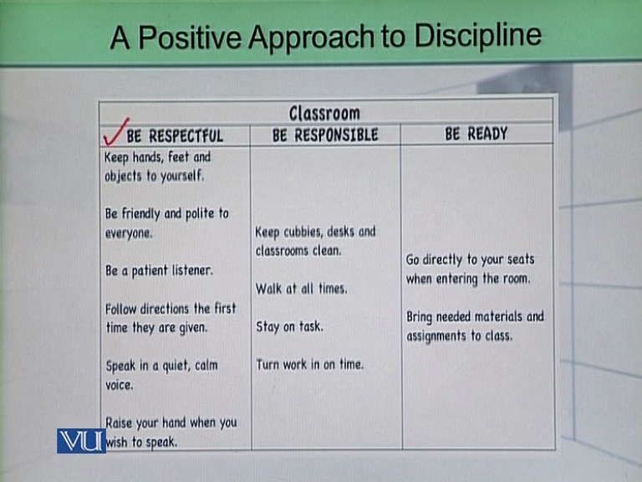

Programme components include:

* Developing and sharing clear rules
* Providing daily opportunities for success
* In-school suspension for noncompliant students

**Topic: 213 – Transactional Analysis**

* Students with behaviour problems need to be analyzed within their particular contexts for the identification of issues.
* Counselling programmes should seek guidance from contexts for resolution.
* The notion that each person’s psyche includes child, adult and parent components is basic to the TA philosophy.

**Topic: 214 – Adlerian Approaches**

* ‘Adlerian Approaches’ is an umbrella term for a variety of methods which emphasize understanding the individual’s reason for maladaptive behaviour and helping misbehaving students to alter their behaviour.
* It seeks to find ways to get students’ needs met.
* These approaches have shown some positive effects on self-concept and attitudes of students.

**Topic: 215 – Student Team Learning**

* Student Team Learning is a cooperative learning structure and is an instructional rather than a disciplinary strategy.
* Its use, however, appears to have a positive effect upon the incidence of classroom misbehaviour as it enables students to interact with each other learn interpersonal skills.

**Topic: 216 – Teacher training in Class Discipline**

Training Programmes should include learning activities and practice in the areas of:

* Organizing the room and materials
* Developing a workable set of rules and procedures
* Assuring student accountability
* Formulating and explaining consequences
* Planning activities for the first week
* Maintaining the management system

**Lesson 37**

**BULLYING**

**Topic: 217**

Bullying occurs when a person wilfully and repeatedly exercises power over another with hostile or malicious intent. See below the cycle of bullying:

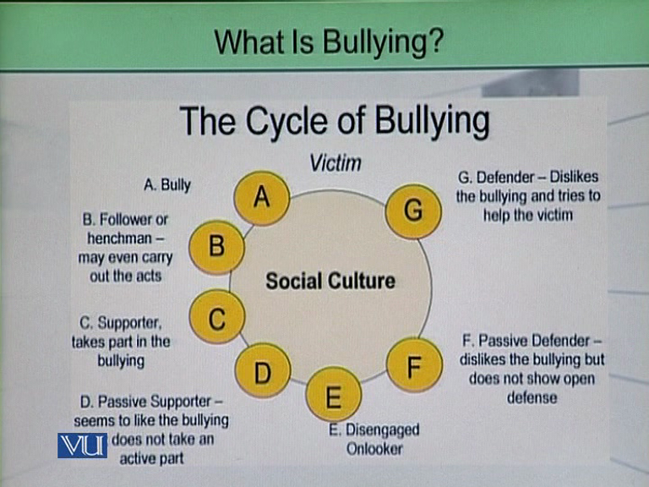

**Bullying includes:**

* Insulting
* Teasing
* Abusing verbally & physically
* Threatening
* Humiliating
* Harassing
* Mobbing

**Topic: 218 – Types of Bullying**

1. Direct Bullying: is used when verbal and physical aggression is used to harm a student.
2. Indirect bullying includes:

* Threats
* Insults
* Name calling
* Spreading rumors
* Writing hurtful graffiti
* Encouraging others not to play with a particular student

Indirect bullying involves purposeful actions that lead to social exclusion or damage to a student’s status or reputation in an attempt to get others to not socialize with the victim.

**Topic: 219 – Consequences of Bullying – 1**

Bullying can have serious and long-term consequences for the:

* Bully
* Victim
* School community

Victims of bullying can have:

* Long-term
* Emotional
* Academic
* Behavioural problems

**Topic: 220 – Consequences of Bullying – 2**

* Students who are targeted by bullies have difficulty concentrating on their school work, and their academic performance tends to be “marginal to poor”.
* Bullied students feel anxious, and this anxiety may in turn produce a variety of physical or emotional ailments.
* Rate of absenteeism are higher among victimized students.

**Topic: 221 – Teachers as Bullies**

A bullying teacher is one who uses his/her power to:

* Punish
* Manipulate
* Ridicule a student beyond what would be a reasonable disciplinary procedure
* Teacher bullyism is professional malpractice
* It is teaching through coercion and creates a disconnect between teacher and students
* Sarcasm and humiliation of students lead to lower self- esteem in students

**Topic: 222 – Teacher’s Knowledge of Bullyism**

Many teachers do not possess the knowledge or skills to recognize bullying behaviours among their students.

Teachers need to know explicitly:

* How to talk to bullies and targets
* How to develop a whole school policy on bullying

**Lesson 38**

**BULLYING PREVENTIVE PROGRAMMES**

**Topic: 223 – Ineffective Bullying Prevention programmes**

1. Conflict resolution
2. Peer mediation strategies
3. Group therapy that focuses on increasing self-esteem have been shown to be relatively ineffective with bullies

* Bullying behaviour results from a power imbalance rather than deficits in social skills.
* Bullies tend to manipulate situations according to the reaction of their victims, thus have good command on social skills.

**Topic: 224 – Effective Bullying Prevention programmes – 1**

Effective Bullying Prevention programmes should aim at:

* Changing the culture and climate of the school
* Developing a comprehensive strategy that targets bullies, victims, bystanders, families and communities.

**Topic: 225 – Effective Bullying Prevention programmes – 2**

Effective Bullying Prevention programmes should develop:

* Classroom level interventions, targeting teachers and other adults in the school
* Student-level interventions that target individual or small groups of victims and bullies

**Topic: 226 – Effective Bullying Prevention programmes – 3**

**Full execution of Prevention Programmes**

Effective Bullying Prevention Programmes should be executed to the full. “watered-down” interventions usually result in incomplete, inadequate, or sporadic implementation

**Avoid Modifications**

Modifications usually dilute the effectiveness of the intervention, or in some cases the intervention results in no improvement at all.

**Intervention of prevention must be:**

* Well-tested
* Standardized
* Reflected in lesson plans and student materials

**Topic: 227 – Whole School Approach in Bullying Prevention**

Bullying prevention programmes are more likely to be successful if the entire school community is engaged, committed and involved. Whenever we talk about whole school approach, the following strategies must be kept in mind.

* Progressive discipline
* Restorative practice
* Character education
* Bully and cyberbullying prevention and intervention
* Healthy choices
* Safety and security

Moreover,

* Administrators must express their support for the programme
* Financial resources must be available
* The Programme should be integrated into school curriculum

**Topic: 228 – Parenting and Bullyism**

* Parenting styles have a strong impact on children’s development.
* Bullies and victims tend to come from families where parenting is either passive or authoritarian.
* Children who come from homes where they have experienced authoritative parenting are less likely to be involved in either bullying or victimization.
* With authoritative parenting, children learn self-determination and independence within reasonable boundaries.

**Lesson 39**

**SOCIAL INTERVENTION STRATEGIES TO CONTROL BULLYING**

**Topic: 229 – School Level Intervention**

School-level interventions should aim at:

* Clarifying and communicating behavioural norms- that is, developing classroom and school-wide rules that prohibit bullying.
* Promoting adult modeling of respectful and nonviolent behaviour.
* A written bullying prevention policy can send a clear message that bullying incidents will be taken seriously.
* The policy could include a clear definition of bullying and a reporting procedure.
* A confidential reporting system may encourage students to report if they are victimized or have witnessed bullying.

**Topic: 230 – Classroom-level Interventions to Control Bullying**

* Teachers can be encouraged to integrate bullying prevention material into their curriculum.
* This can be accomplished by holding regular classroom meetings to discuss bullying.
* Classroom meetings with students help increase students’ knowledge of how to intervene, build empathy, and encourage pro-social norms and behaviours.

Teachers should involve the class in:

* Establishing and enforcing class rules against bullying.
* Discussing the importance of bystanders in stopping bullying.

**Topic: 231 – Student Level Interventions to Control Bullying**

Student-level interventions are designed to develop social competence by changing students’:

* Knowledge
* Skills
* Attitudes
* Beliefs
* Behaviours by using interactive teaching techniques

Victims of bullying can be helped to:

* Recognize attributes that place them at risk of becoming targets.
* Understand the consequences of their choices
* Modify their behaviours to minimize their chances of becoming victims

It is important that students understand that by staying calm in bullying situations, the bullying may subside, whereas responding aggressively or acting helpless may worsen the situations.

**Bullying & Classroom Management**

**Topic: 232 – Social Structure & Classroom Management**

* Social structure of a classroom determines the kind of social or anti-social incidents that may take place in a classroom.
* Social structure includes the informal relationships among the students and associated friendship, support, attraction, isolation, power relations between subgroups.

**Topic: 233 – Teachers & Social Structure of a Classroom**

In order to prevent bullying, teachers need to:

* Care about students
* Organize classrooms such that positive student relationships develop
* Manage learning and behavioural issues in positive, educative ways

**Relational Matrix example**

Bullying is thus a complicated problem which must be solved by means of the development of:

* The social environment of the class
* The school
* Home
* Society

**Topic: 234 – Peers as Preventive Tools**

Bullying is increasingly viewed as a “group phenomenon,” and intervention approaches should be directed towards witnesses as well as direct participants.

Anti-bullying attitudes among peers should be developed through:

* Awareness-raising
* Opportunity for self-reflection
* Awakening feelings of responsibility
* Role playing or rehearsing new behaviours
* In order to control bullying teaching respect and nonviolence should start in elementary school.
* Non-violence training conducted by older peers can be particularly powerful.

**Lesson 40**

**PARENT-TEACHER PARTNERSHIPS & CLASSROOM MANAGEMENT**

**Topic: 235 – Parents’ Attributes**

Following are the parents’ attributes that support meaningful partnerships:

* Warmth and sensitivity
* Nurturance
* The ability to listen
* Consistency and a positive self-image
* A sense of efficacy and personal competence
* Effective interpersonal skills
* Parents who are high in self-esteem are more assertive in their family and school involvement.

**Topic: 236 – Teachers’ Attributes**

Teachers should:

* Model respect
* Have good communication skills
* Show a genuine interest in the children
* Respond constructively to parents’ concerns
* Promote a teamwork philosophy
* Be sensitive to parent & family needs

Teachers encourage parents to be positive through the example they set in by being:

* Supportive
* Responsive
* Dependable

**Topic: 237 – Parent-teacher partnership Roles**

Parents and teachers can engage in:

* Joint learning activities
* Supporting each other in their respective roles
* Carrying out classroom and school improvement activities
* Conducting collaborative curriculum projects in the classroom
* Participating together in various decision-making activities

When parents sense an inviting school climate, they emphasize nurturing and supporting behaviours in their interactions with teachers, their participation in the school environment also increases.

**Topic: 238 – Strategies for Parent-Teacher Partnerships – 1**

* Relating classroom activities to the varying needs and interests of children and families is a reflection of a firm teacher-parent relationship

Parent-teacher partnership strategies are unique and should have the following elements:

* Needs assessment
* Goal statements
* Prioritization of activities
* Strategy development
* implementation plans
* evaluation tools

**Topic: 239 – Strategies for Parent-Teacher Partnerships – 2**

Strategies for effective parent-teacher collaborative roles:

* Home visits
* Conferences
* Parent centers
* Telecommunication involvement in the classroom
* participatory decision-making
* Parent and adult education programmes
* Home learning activities
* Family- school networking

**Topic: 240 – A Caring Curriculum**

* For effective parent-teacher partnerships, a caring curriculum should be developed.
* A caring curriculum should promote a shared learning process among children, parents and teachers.

This school-family curriculum should focus on:

* The caring elements of self-image
* Pro-social relationships with others
* Development of multicultural understandings
* Sensitive and empathetic relationships
* Nurturing and positive discipline
* Creative problem-solving strategies

**Lesson 41**

**VIOLENCE AND CLASSROOM MANAGEMENT**

**Topic: 241 - Dealing with Violence – 1**

* Troubled students need habilitative services instead of haphazard punishment.
* A full range of educational, mental health, and other services should be available to them.
* Aggressive and violent behaviours do not develop overnight and cannot therefore be eliminated in short periods of time.

**Topic: 242 - Dealing with Violence – 2**

* The entire community is better off when troubled students are served more appropriately.
* It is important to identify them and apply behavior modification strategies.
* School-wide discipline policies need to be formulated and taught to all students.

**Topic: 243 – Aggressive Students**

Aggressive students often:

* Exhibit deficits in social information processing
* Are likely to misinterpret social clues
* Mis-assign hostile intent to others, especially during stress

They are more likely than others to have some social skills deficits such as:

* Poor impulse control
* Low tolerance
* Limited ability to generate alternative responses to stress
* Limited insights into the feelings of self and others

**Topic: 244 – Sources of Frustration Among Aggressive Students**

Sources of frustration can be:

* Failure
* Lack of maintenance of social relationships
* Boredom
* Lack of positive reinforcement
* Irrelevant curriculum
* Overexposure to punishment
* Feelings of powerlessness

**Topic: 245 – Stages of Frustration & Responses – 1**

1. **Stage: Anxiety**

Student sighs or uses other nonverbal cues.

**Teacher response:**

Teacher can respond by active listening and nonjudgmental talk.

1. **Stage: Stress**

Student exhibit minor behaviour problems

**Teacher response:**

Teacher can use proximity control, boost student interest, or provide assistance with assignments.

**Topic: 246 – Stages of Frustration & Responses – 2**

1. **Stage: Defensiveness**

Student argues and complaints

**Teacher Response**

Teacher can remind student of rules, use conflict resolution, and encourage student to ask for help.

1. **Stage: Physical Aggression**

Student has lost control and may hit, bite, kick, or throw objects.

**Teacher Response**

Teacher can escort the student from class, get help, restrain student if necessary, and protect the safety of the other children.

1. **Stage: Tension Reduction**

Student releases tension through crying or verbal venting, or student may become sullen and withdrawn.

**Teacher response**

Teacher can decide whether to use supportive or punishment techniques

**Lesson 42**

**PLANNING TO CONTROL VIOLENCE**

**Topic: 247 – How To Respond To Violence**

* A nurturing, caring environment is one antidote to frustration and aggression.

Teachers who are therapeutic demonstrate:

* A high level of self-awareness and self-confidence.
* Realistic expectations of self
* The ability to exhibit and model self-control in managing stress and frustration.

**Early Intervention:**

Early intervention to control violence is the most important predictor for success. If comprehensive intervention is not provided by Grade 3 or 4, success in controlling aggression is unlikely.

**Topic: 248 – Intervention to Control Violence**

**Primary Prevention**

It aims at keeping problems from emerging. The curriculum can be designed in a manner as to divert antisocial young children from a path leading to adjustment problems.

**Secondary Prevention**

It requires individually tailored interventions applied to students who show at risk status. Individual counseling and one-on-one behaviour management plans are hallmark of this stage of intervention.

**Tertiary Prevention**

It involves intensive “wraparound” services that extend beyond the school building to encompass family and social support services. It is applied to the most severely at-risk students.

**Topic: 249 – Planning to Control Violence – 1**

1. **Practice for a Crisis**

Prepare students and teachers just as they are trained for the eventuality of a fire.

1. **Train all staff to respond to student aggression:**

Precise methods to be used, procedures to be followed, and role-playing should be a part of this training.

**Topic: 250 – Planning to Control Violence – 2**

1. **Dress Appropriately**

Low-heel shoes, proper clothing, and the omission of sharp jewelry and dangling earrings are recommended.

1. **Move items of value out of reach**

**Topic: 251 – Planning to Control Violence – 3**

1. **Establish trust and rapport with students**

Although rapport alone will probably not eliminate violent or aggressive acts, it will enhance prevention and intervention procedures.

1. **Remain calm and in control**

Act authoritatively as a teacher and remain calm in the wake of an aggressive act by a student.

**Topic: 252 – Planning to Control Violence – 4**

1. **Define behavioral expectations and apply consequences for rule compliance and noncompliance**

Clear identification of rules and other boundaries and consistent application of consequences can help minimize aggressive acts.

1. **Maintain a therapeutic attitude**

Therapeutic adults are able to maintain a willingness to understand students and to consider their emotional fragility.

**Lesson 43**

**TEACHING POSITIVE BEHAVIOURS**

**Topic: 253**

* Teachers should avoid focusing on students’ inappropriate behaviour and, instead, focus on desirable replacement behaviours.
* Focusing behaviour management systems on positive, prosocial replacement responses will provide students with the responsibility to practice and be reinforced for appropriate behaviours.

**Topic: 254 – Opportunities to Practice New behaviours**

* Increased opportunities for students to interact within the school environment need to be provided so that prosocial skills can be learned.
* If a student performs as a passive participant in the classroom, then little growth in a social skill acquisition can be expected.

**Topic: 255 – Developing pro-Social Behaviour To Counter Violence**

Developing pro-social behaviour:

* Taking turns
* Working with partner
* Following directions
* Working in a group or with others
* Displaying appropriate behaviour towards peers and adults
* Increasing positive relationships
* Demonstrating positive verbal and nonverbal relationships
* Showing interest and caring
* Settling conflicts without fighting

**Topic: 256 – Treat Social Skills Deficits as Errors In Learning**

During assessment of a students’ present level of functioning, the teacher must determine whether the social skill problem is due to a:

* Skill deficit
* Performance deficit

The teacher can test the student by directly asking what he or she would do or can have the student role play responses in several social situations.

**Topic: 257 – Identification of Social Skill Deficit**

**Example:**

A peer on the bus calls you a bad name. What should you do?

**Performance deficit**

If the student can give the correct response but does not display the behaviour outside the testing situation, the social skill problem is probably due to a performance deficit.

**Skill deficit**

If the student cannot produce the socially correct response, the social skill problem may be due to a skill deficit.

**Topic: 258 – Arranging For Social Skills’ Lessons**

* Social skill lessons are best implemented in groups of 3 to 5 students and optimally should include socially competent peers to serve as models.

A social skill group lesson should focus on three things:

1. An explanation of why the group is meeting
2. A definition of what social skills are
3. An explanation of what is expected of each student during the group.

It may also be helpful to implement behaviour management procedures for the group (i.e. contingencies for compliance and non-compliance).

**Lesson 44**

**DEVELOPING SOCIAL COMPETENCE AMONG STUDENTS**

**Topic: 259 – Social Competence**

It is a skill that helps to:

* Generate good social interactions among peers.
* Establish caring connections
* Develop warm attitudes
* Downplay violence and aggression among students

Social competence is the ability to act in a caring and helpful manner towards others.

**Topic 260 – Social competence and Classroom Management**

* Social competence has strong implications for classroom management.
* A classroom is a social phenomenon.
* Effective classroom management depends a lot on the kind of social skills students have.

**Topic: 261 – Development of Social Competence**

* Social competence develops very early in childhood and should be nurtured to the maximum.
* Children who lack human interaction may fail to thrive

Such children may:

* Fail to gain sufficient weight
* Become indifferent
* Listless
* Withdrawn
* Depressed

**Topic: 262 – Family Role In The Development of Social Competence**

Family role is critical to the child’s welfare and social-emotional development.

**Methods Used In Controlling Children**

* Authoritarian (high control)
* Authoritative (authority through having knowledge and providing direction)
* Permissive (low control or direction)
* Combinations of the above

**Topic: 263 – Peer Relations And The development Of Social Competence**

* Piaget (1932) pointed to peer interaction as one major source of cognitive as well as social development, particularly for the development of role-taking and empathy.

From 6 to 14 years of age, children shift their views of friendship from:

* Sharing of physical activities to sharing of materials
* Being kind or helpful
* Perceiving friendships that allow individuality to be expressed or supported (Berndt, 1981)

The role of the school is critical in encouraging healthy social interactions among peers.

**Topic: 264 – Limiting Factors in Social Development**

A child’s connection with a:

* Given family
* Neighborhood
* School may limit opportunities for social development

Lack of diversity in social interactions, at home and in school, may also limit a child’s ability to be socially competent in various circumstances.

**Lesson 45**

**SOCIAL COMPETENCE**

**Topic: 265 – Social Competence For All Students**

Schools are under pressure to create:

* safe
* orderly
* effective learning environments
* Efforts should be made by schools to create environments where all students acquire social as well as academic skills that will allow them to succeed in school and beyond.
* Social skill instruction in schools benefit students not only socially, but also academically, as appropriate behaviours increase their access to instructional time.

**Topic: 266 – Social Competence vs Punishment**

* Traditional punishment and exclusion may provide a short-lived relief from disciplinary problems.
* In the long term, punishment and exclusion are ineffective and can lead to renewed incidents of disruptive behaviours.
* It is, therefore, important to teach social competence so that instances of problem behaviours can be reduced.

**Topic: 267 – Helping Students To Become Socially Competent**

The success of teachers and administrators in helping students develop social competence depends on their ability to:

* Develop a school-wide culture of social competence
* Infuse the curriculum with situation-specific social skills lessons that target key behaviours
* Match the level and intensity of instruction to students’ social skills deficits

**Topic: 268 – Developing a School-wide Culture of Social Competence**

To establish a school climate acceptable to all, a team representing all members of the school community should be formed and asked to define school-wide behavioural expectations.

Some school-wide behavioural expectations:

* Be respectful
* Be responsible
* Follow directions
* Hands and feet to self

**Topic: 269 - School-Wide Behavioural Expectations**

School-Wide Behavioural expectations typically:

* Address the most frequently observed problem behaviours across all school settings
* Are condensed into three to five short and easy to remember statements
* Are age appropriate
* Are positively stated (e.g. “be respectful” instead of “don’t tease”)

**Topic: 270 – Integration of Social Skills in the Curriculum**

* To support the development of a school-wide culture of competence, social skills instruction must be an integral part of the school’s curriculum and daily operations.
* To create a classroom environment where all students can learn, teachers must teach appropriate social skills giving students access to the academic curriculum.