**Lesson No. 1**

Purpose and Main Components of a Thesis

**Topic 1: Purpose of the Thesis**

To enable students to develop:

* deeper knowledge
* understanding
* capabilities

Overall goal is for student to display knowledge and capacity to:

* contribute to research and development work
* deal with complex theoretical issues
* to plan and use adequate methods and evaluate

Thesis at the end of the programme offers the opportunity to:

* delve deeply into
* and synthesize acquired knowledge

**Topic 2: Writing Style and Audience**

* Audience and Purpose
* Context of writing
* Range of audience
* Authority readers or ‘critics’
* Primary Audience
* Scholarly community
* Real and imagined
* Internalize audience
* Supportive
* Hostile
* Adversarial
* Secondary Audience
* External examiners
* Representative of scholarly community
* Immediate Audience
* Supervisor
* Highly influential
* ‘Ideal Reader’

**Topic 3: Order and Component of Thesis**

1. Title page
2. Statement of originality/ copyright page
3. a) Dedication

b) Acknowledgements

1. Abstract
2. Table of Contents
3. List of :

- Tables

- Figures/ illustrations

1. List of Abbreviations
2. Chapters

* Introduction
* Literature Review
* Methodology
* Results
* Discussion
* Conclusion

1. References
2. Appendices

**Topic 4: Title**

Title should SUMMARIZE the main idea:

* be concise
* highlight key variables
* full explanatory

Title should not have abbreviations.

**Function*:***

* inform
* statement of content (data based)

**Topic 5: Statement of Originality; Dedication and Acknowledgement**

* Statement of Originality:
* appears after the title page
* may differ in form
* declares that the work is your own
* Dedications, Acknowledgements
* dedication optional
* acknowledgements on a separate page
* no heading required
* Dedications: a short statement of tribute
* Acknowledgements: statement of gratitude and recognition

**Topic 6: Table of Contents and Appendices**

Provide:

* Any outline of you thesis
* Titles of all chapters – Subtitles: sections
* Hierarchy
* Page numbers

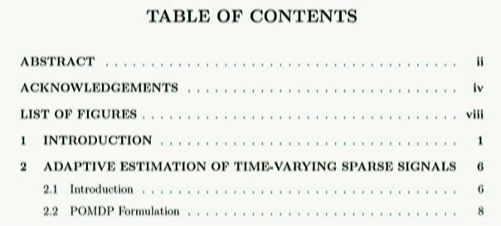

What to include:

* Important supplemental material
* Some interview transcripts
* Pictures
* Consent forms
* Ethical clearances

Purpose:

* Validate the research process
* Provide important information that cannot be included
* Overcome the limitations of word restriction

**Lesson No. 2**

Appendices and Footnotes

**Topic 7: Footnotes and Endnotes**

* Footnotes
* Appear at the bottom of the page
* Separated from the text
* Single-spaced
* Double-spaced line between each note

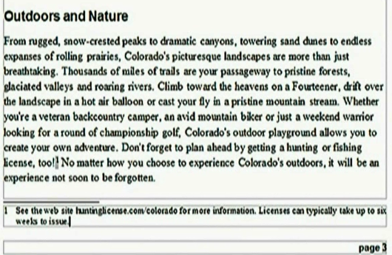

* Purpose of the Footnotes
* Additional information
* Comment
* Source
* Adapted of ideas
* A Footnote should:
* Convey one idea at a time
* Be concise
* Be inserted with the use of computer software-numbering options
* Difference between Endnote and Footnote:
* Endnotes appear at the end of each chapter or at the end of a thesis
* Choice depends on the discipline
* Footnotes should be used sparingly *(economically, carefully, in moderation)*

**Topic 8: Abstract**

It is the gist of your study and functions to provide an overview of your work.

* Correctly reflect the purpose and content

It should be accurate:

* Not include any information that is not in the text
* Not leave out important details – comparison with headings
* Replication of theory or methods to be mentioned

It should be non-evaluative:

* Avoid comments – reports

It should be coherent and readable:

* Clear statements
* Verbs instead of noun equivalents
* Example: investigation of – investigate

It should be concise:

* Brief – word limit
* Each sentence important
* Specific words
* Avoid lengthy explanations

**Topic 9: Abstract: Functions**

Aims to provide:

* A snapshot of thesis
* Key considerations of the thesis regarding:
* Focus
* Methodology
* Findings
* Contribution

Functions of Thesis Abstract are to give an overview of:

* Aim of the study
* Background and context of the study
* Research design and Methodology
* Methods
* Sampling
* Site
* Key findings
* The contribution of the study to the field of knowledge

**Topic 10: Abstract: Content and Structure**

Structure of an Abstract:

* Introduction
* Purpose
* Method
* Product/ Results
* Conclusion

***Introduction****:*

* Significance of the issue
* Background
* Identify research gap

***Purpose***:

* Identify aims/ intentions
* Questions/ hypotheses

***Research******Methods/ Design***:

* Overall approach
* Key aspects – sampling – instruments
* Data sources
* Data analysis

***Product/ Results***

* Key findings

***Conclusion***

* Significance of research
* Implications/ arguments for application

**Topic 11: Analysis of a Sample Abstract: Pattern**

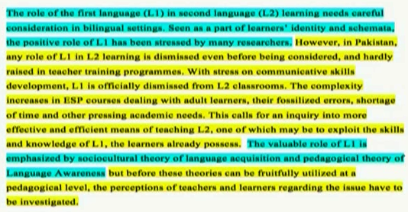

**Abstract**

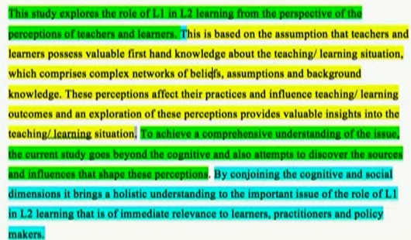



Missing aspects:

* Sample
* Methodology
* Key findings

**Topic 12: Key Linguistic Feature of an Abstract: Tense**

Different Tenses convey different meaning:

* Highly important feature

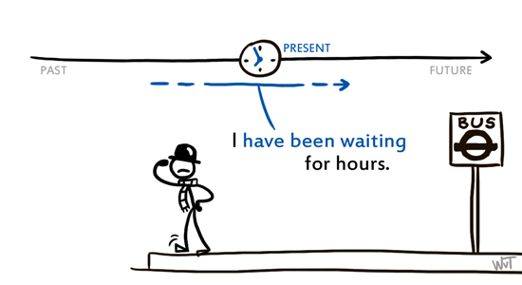

**Present Perfect tense**: continuity up to present

Example: This “has been” explored.

Appropriate for introduction – previous work in the field

Simple Present: reference to the **immediate** present

* The aspect that “remains” unexplored is:
* Identifying a gap
* Purpose
* Findings generalizability

Simple Past to report a completed action:

Example: The study used a multiple case=study design. The sample included….

For: reporting methodology.

**Lesson No. 3**

Abstract Writing

**Topic 13: Questions Related to Abstract Writing**

How long should it be?

* Varies: Most abstracts are confined to 350-500 words

Best time to write an Abstract:

* At the end
* A draft in the beginning

Required detail:

* Varies – but the main structural parts should be there

Should all results be presented?

* Key results must be presented – others are optional but this should not be longends

How specific should one be while referring to implications?

* Depends on individual preference but must not be:
* Too stretched
* An over-statement or tall claims

**Topic 14: Introduction Chapter in a Thesis**

Introduction:

* The opening chapter of the thesis
* Extremely important
* Shorter and at the forefront

Should:

* Give an overview of the work
* Simple and clear without too much complex arguments

It involves consideration of several steps.

**Topic 15: Functions of the Introduction Chapter**

The Introduction of the thesis functions to present:

1. The problem and its significance
2. Brief overview of what is known from literature
3. Gap in the body of knowledge
4. Explanation of how you want to address this gap – aims
5. Outline of your plan of investigation
6. Contribution of your work
7. An outline of the content and structure of your thesis
8. Key constructs

**Topic 16: Introduction: Content and Structure**

* Establish a Research Territory
* Establish a Niche
* Occupy the Niche

**Topic 17: Introduction: Establishing a Research Territory**

Explain the extent to which it is:

* significant
* central
* interesting
* problematic
* or relevant
* Provide background research about the relevant questions that have been raised
* Introduce and briefly review aspects of previous relevant research to answer

**Topic 18: Indicating a Gap/ Niche**

Establish a Niche:

* Indicate gaps in previous research
* Raise a question about previous research
* Identify problem or need
* Extend previous knowledge

**Lesson No. 4**

Occupy the Niche/ Gap

**Topic 19: Occupy the Niche/ Gap**

Establish a Niche:

* Indicate gaps in previous research
* Raise a question about previous research
* Identify problem or need
* Extend previous knowledge

**Topic 20: Statement of the Problem and the Context**

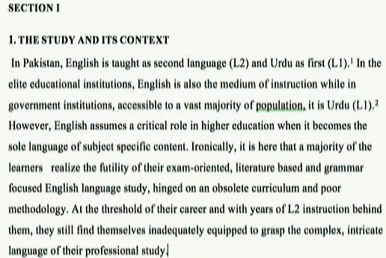

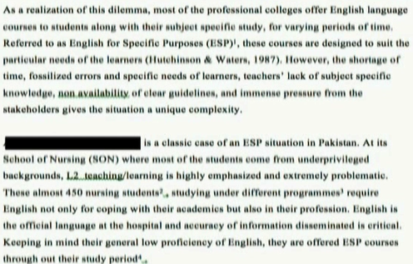

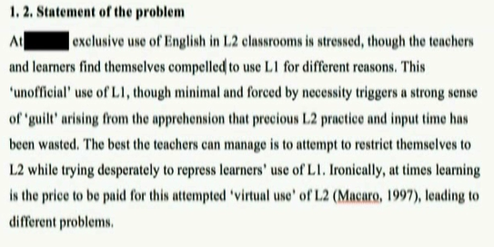



A research problem is a statement about an area of concern, a condition to be improved upon, a difficulty to be eliminated, or a troubling question that exists in scholarly literature, in theory, or in practice that points to the need for meaningful understanding and deliberate investigation. A research problem does not state how to do something, offer a vague or broad proposition, or present a value question.

The purpose of a problem statement is to:

* Introduce the reader to the importance of the topic being studied. The reader is oriented to the significance of the study and the research questions or hypotheses to follow.
* Place the problem into a particular context that defines the parameters of what is to be investigated.
* Provide the framework for reporting the results and indicates what is probably necessary to conduct the study and explain how the findings will present this information.

**Topic 21: Aims of the Study**

* The primary focus of the research project
* Delimitation
* Clear and concise statements
* It determines methods and scope of the study
* Can be in a separate section after the indication or gap or appear in a separate paragraph
* The aim of the study was to…
* Explore...
* Gain insight into the processes…

**Topic 22: Clarification of Key Constructs**

What are Key Constructs?

* Key words appearing in your research question
* Key variables

Constructs because they are socially constructed:

* Different meanings assigned to the same term or construct

Example: Does education lead to women empowerment?

Education

Empowerment

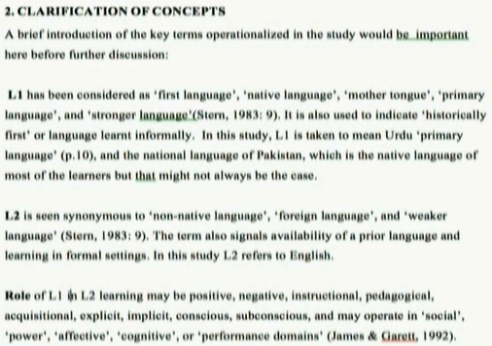

**Topic 23: Organization of the Thesis**

Introduction to the organization of your thesis:

* Appears towards the end of the chapter
* Signposting *(marking, labeling, pointing out)*

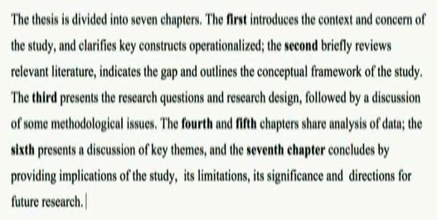

Can choose to add details:

* **Example**: “Chapter 3 depicts the methodological approach of the study. In order to enrich the study multi-method design was adopted. It is contended that such a design is advantageous”

**Topic 24: Key Linguistic Features in Establishing Significance of the Study**

**Linguistic Features:**

* When describing the importance of the problem, use ***present tense*** and the ***present perfect tense***.

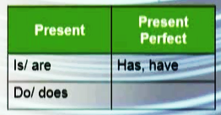

Examples:

* The study addresses the current gap in literature….
* The significance of the current study lies in….

Theoretical perspectives and existing research use:

* *Present perfect* (some researchers *have advocated*….)
* The research in this area has mainly focused on….
* Can also use present tense – when presenting theoretical framework….
* The simple *past tense* (MacIntyre et al. *examined*….)
* When referring to a completed study

**Lesson No. 5**

Key Linguistic Features in Indicating the Gap

**Topic 25: Key Linguistic Features in Indicating the Gap**

**Establishing a niche**: When identifying a gap in available research, use:

* Present perfect tense
* And/ or the present simple tense

It describes what has not been investigated up to the present point in time.

* Example: “While a number of studies related to leadership in public sector education have been undertaken, the aspect of gender remains ignored”.

**Topic 26: Key Linguistic Features in Occupying the Gap in the Introduction**

**Aims**: use simple present

Example:

* The primary purpose of the study is to explore….
* The current study contributes….

**Occupying the niche**:

* Explaining your aims as goals that have been achieved, as methodology use past simple tense
* Example: The study involved eight international students….

**Topic 27: Active vs. Passive Voice Use**

Which one to choose?

* No hard and fast rule
* Matter of choice
* Whether one wants to give prominence to the object of the sentence or the subject

Use of Passive Voice:

* To maintain anonymity of the subject
* To suggest something as an established fact

Examples: - Gaps in previous research *are* subsequently *identified….*

- Key findings from an analysis of the research data *are presented* in chapter 4

**Topic 28: Key Linguistic Features: Adjectives and Pronouns**

Use of Adjectives:

* To emphasize the importance or centrality of research territory

Example: A *dominant* feature of leadership has been…

* Also when identifying the gap

Example: Research is unclear, ambiguous…

First Person Pronoun:

* Opinions vary about using ‘I’ and ‘we’ in academic texts
* Some believe it as being too personal

Use of I/ We:

* Active voice encouraged – less wordy
* We – where reader and writer are implied
* Vary the style
* Another option – “This chapter discusses that….”

**Topic 29: Language Use in Making Comparisons**

* A large range of way of expressing comparisons are available
* Needed when identifying a gap – vary

**Verbs**:

* disregard
* fail to consider
* ignore
* is limited to
* misinterpret
* neglects to consider
* overestimates
* underestimates, etc.

**Adjectives**:

* Controversial
* Incomplete
* Inconclusive
* Misguided
* Questionable
* Unconvincing
* Unsatisfactory, etc.

**Noun Phrases**:

* Little information
* None of these studies

**Passive Forms**:

* It remains unclear that
* It would be of interest to

**Topic 30: Introduction: Questions Answered**

***How long should the introduction be?***

* If written as a separate chapter, it may take 5-10 pages
* Must not be too long

***Should introduction include references?***

* Extensive referencing is not a norm

***Should it be written before other chapters?***

* A draft may be written at the beginning
* Will be drafted many times and finalized in the end.

***To what extent should terms and constructs be defined in Introduction?***

* Helpful to present key constructs to allow the examiner to understand the frame of reference

***Would the research question come in the Introduction?***

* Background/ Context
* Statement of the problem
* Aims and objectives
* Research questions
* Key constructs
* Thesis structure

**Lesson No. 6**

Literature Review

**Topic 31: Literature Review**

* First draft is usually written during the preparation of thesis proposal
* Then expand before deciding methodology
* Sections of literature review will be revised with new material being added and some existing possibly being removed
* This revision process may continue up to the point one finishes the discussion of findings

**Topic 32: Literature Review: Functions**

* To provide in-depth account of background literature
* To provide an ‘argument’ or justification for the study
* review of non-research literature that summarizes and synthesizes background and contextual information
* Review of theoretical perspectives
* Review of relevant research literature
* A critique
* Gap identification in this knowledge and research
* A rationale justifying why the gap was important

It explains how literature provided:

* a focus for research question
* guidelines for an appropriate methodology and design

**Topic 33: Content and Structure: Organization Options**

**Content of Review**:

* comprises series of themes/ topic units
* more than a summary of material
* includes critique
* identifies arguments and controversies
* It weighs up the value of theories, ideas, claims, research designs, methods and conclusions
* It identifies gaps or shortcomings
* It provides rationale for research focus

**Organization Options**:

1. The themes and topics of the review
2. The research questions being addressed
3. The variables
4. Chronological presentation of literature
5. A combination of these options

**Topic 34: Body of the Literature Review**

Determining themes/ topics that will be included in review:

1. Keep a record/ summary of relevant literature

* Categorize whether or not it is:
* directly relevant
* possibly relevant
* not relevant
* Year-recent

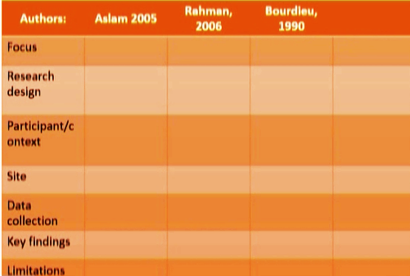

1. Develop mind-map of key themes/ topics

* Identify relationships
* Mark the hierarchy
* Arguments and counter-arguments

**Topic 35: Body of the Literature Review: Structure**

Constructing a Thematic Unit:

1. Establish background of relevant knowledge
2. Create research gap
3. Announce how will you occupy the gap in research

**1. Establishing relevant background**

* Present knowledge – statement – theories
* Significance of the topic/ theme
* Presentation of research evidence

**2. Indicating a research gap**

* Critique
* Provide research evidence to support critique
* Indicate relevance
* Rationalize the new perspective or research

**3. Announce how your research will fill the gap**

* Provide aim of the study
* Research design or conceptual map
* Key constructs
* Research questions

**Topic 36: Organizing a Literature Review**

* Discuss from ***General to Specific***
* Discuss key themes
* Then synthesize *(blend, combine, join)*
* Research-gap
* Conceptual map of your study
* Develop and outline
* Different sections
* Decide the best way to persuade the reader to agree

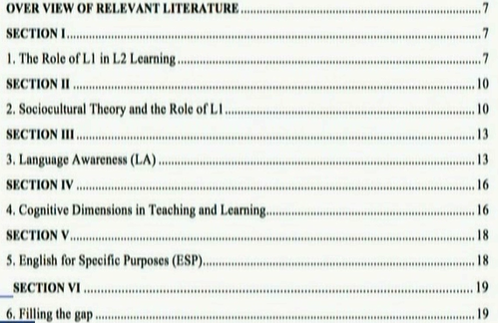

**Lesson No. 7**

Reporting Research

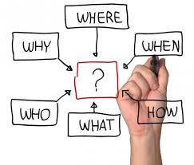

**Topic 37: Reporting Research**

Frequently Presented Details:

1. Author(s) and date
2. Focus of study – aim or purpose
3. Sample size and setting/ location

Example: Evans (1988) explored the perceptions of a hundred students in Australia regarding most important leadership qualities in an attempt to identify…..

1. Key findings
2. Discussion

Example: The results indicated that the qualities of a leader perceived by the students were culturally specific…

1. Comparison with other studies

Example: This finding also corresponded with that of another comparative study….

**Topic 38: Summarizing Key Elements of Literature Review**

***The body of the review:***

* Provides understanding of relevant literature
* Informs about the known and unknown areas of knowledge
* Identifies gaps/ shortcomings in theoretical arguments, revels further thinking
* Tells how the project aims to investigate those gaps and why
* Identifies and justifies the research niche, and methodology

**Topic 39: Conclusion of the Literature Review**

* Conclusion starts with **Summary** of the key claims - involving an evaluation
* Identifies gaps – incorporates different moves mentioned earlier
* Announces key elements of the project

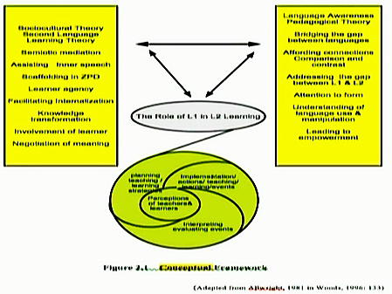

**Topic 40: Introduction to the Literature Review Chapter**

* Placed before the body of review
* Written in the last

**Primary Function of Introduction**:

* To give an overview of themes and topics
* Often referred to as “advance organizer”
* An effective Introduction makes explicit connections between various units/ sections

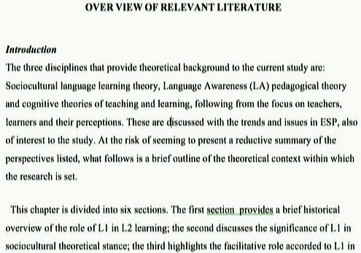

**Topic 41: Paraphrasing and Coherence**

Argument is to explain:

* The context of the study
* why is it worth doing

Large number of studies mentioned but the most relevant discussed in detail

Summarizing requires paraphrasing

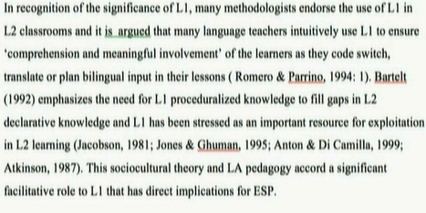

**Topic 42: Synthesizing: Cohesion in Literature Review**

To show similarities and differences in the issues being discussed

(Synthesizing: putting the pieces together)

**Tips for synthesizing**:

Cohesive links between ideas need to be clear.

**Cohesive Techniques**

* Repetition of key words
* Add connector (furthermore)
* Pronoun reference ( This means…)
* Firstly, secondly
* Contrast connections (however, nevertheless, besides)
* Result connectors (therefore, consequently, thus)

**Lesson No. 8**

Language Focus: Tense and Citation

**Topic 43: Language Focus: Tense and Citation**

**Tense**

* Subtle and flexible choice
* Mostly citation statements fall into one of the following three major patterns:

1. Past – Researcher Activity as Agent:

* Jones (1987) investigated the causes of illiteracy
* The causes of illiteracy were investigated by Jones (1987)

2. Present Perfect – Researcher Activity not as Agent:

* The causes of illiteracy have been widely investigated (Jones 1987….)
* Several researchers have studied the cause of illiteracy.

3. Present –No Reference to Researcher Activity:

* The causes of illiteracy are complex (Jones 1987, Ferrars 1990, Hyon 1994)
* Illiteracys appears to have a complex set of causes.

**Topic 44: Plagiarism**

**Claim over ideas and words:**

* Unethical
* Quotes should be used in direct borrowing of words
* “prioritized”

**Paraphrasing**

* In every re-wording, summarizing, paraphrasing – acknowledge the source

**Extends to Ideas**

* Credit where the ideas originated
* Plagiarism has very strong repercussions

**Self Plagiarism**

* Reproducing your own published work
* Self reference
* The point is to make sure that the work is original

**Topic 45: Reporting Literature: Approaches**

**Reasons for Reporting**

1. To explain what has been reported in the literature and what has not been reported
2. To evaluate or critique other’s work to negotiate own stance
3. To find support for the stance taken or findings

**Approaches to Reporting**

a. Central reporting

* Michael (1992) concluded that the perceptions of the teachers were rooted in their learning experiences

b. Non-central reporting

* The results appear to offer the best instrument for measuring motivation (McCroskey & Riichmond 1987)

c. Non-reporting

* Educational leadership has its specific challenges that need to be explained with reference to context (Usman, 1993)

**Topic 46: Choice of Verb and Tense**

**Choice of Reporting Verb**

* Reveals your stance towards the published literature
* One needs to be careful in selecting verb
* Similar verbs can mislead the interpretation

**Difference in Meanings**

* State and claim
* Noted
* Argued
* Contended
* Claimed
* Established
* Proposed
* Admit
* Acknowledge

**Tense of Reporting Verb**

* Varies even within a single paragraph

**Choice Reasons**

a) Past Simple

* To refer to a claim or finding
* e.g. Smith (2008) revealed that…

b) Present Simple

* to convey current state of knowledge
* make generalization
* to present earlier findings as accepted facts
* e.g. Smith (2008) revealed that…

**Topic 47: Evaluating and Critiquing Published Research**

**Evaluation Questions**

1. research issue clearly stated?
2. Content sufficiently explained?
3. Justification for research?
4. Research question/ hypothesis clear?
5. Methodical approach relevant/
6. Data collection methods sufficient
7. Are the instruments appropriate?
8. Variables and constructs defined?
9. Procedures sufficiently complete?
10. Analysis and its process?
11. Findings related to research question?
12. Findings relevant?
13. Findings sufficient?
14. Claims/ conclusions based on findings?
15. Implications drawn from the findings?

**Topic 48: Stance towards Published Research**

Linguistic Strategies:

a) Hedges

* To withhold your full commitment to a statement: i.e. may; might; possibly; likely; seemed to; appeared to…

b) Boosters

* To reveal certainty: i.e. clearly; definitely; without doubt….

c) Attitude markers

* Like: interestingly; surprisingly; unfortunately….

d) Engagement markers

* Like: as you can see; you will have noted that; consider whether….

e) Self mentions

* To make reference to the research: I; we; my; our…

**Lesson No. 9**

Reviewing the Literature: Organizing

**Topic 49: Reviewing the Literature: Organizing**

**Role and Purpose of Citations**

* To acknowledge intellectual property rights of authors
* To show respect to previous scholars
* To give a statement greater authority
* To “pay” respect
* To demonstrate familiarity
* A defense against plagiarism
* To create a research space for the citing author

**Organizing**

* Start with major traditional views
* For the remaining views, either chronological order can be followed
* Or can be presented in categories – research in the end

**Topic 50: Important Questions Answered**

How long should the literature review be?

* Master’s thesis may have only on chapter around 5000 words
* Shorter than your findings chapter

How to decide what to include and what not to include?

Ask yourself:

* Which aspects of literature are related to this thesis?
* Does it add anything new to what has been included already?

Should I refer to methodology literature in literature review?

* That is usually presented in methodology chapter
* However it may be referred to in order to explain a claim-special circumstances

If many writers have made the same claim, how many should I refer to?

* Best to refer to three or four
* Include the most recent and the most significant

**Topic 51: Methodology**

Overview:

* Functions of methodology chapter
* The content
* Organization

Methodology:

* Relatively straightforward chapter to write
* Issues and processes were discussed before data collection

All it requires is:

* Attention
* Careful consideration
* Clear understanding of the aims and functions of chapter

Extremely important:

* Entry into dangerous waters
* Coherence
* Essentially a defense

**Topic 52: Methodology of a Thesis: Functions**

Description and justification:

* Suitability of methodical approach to the research
* Choice of research design
* Specific methods of data collection
* Ways in which issues of validity and reliability were dealt
* Data collection procedures
* Data analysis procedures
* Ethical concerns
* Delimitation

**Topic 53: Methodology: Content and Structure**

Three parts:

* Introduction
* Main body
* Conclusion

1) Present the paradigm

2) Methodology

3) Describe the data collection process

4) Data analysis process

5) Conclude

6) Summarize and evaluate

**Topic 54: Introduction in a Methodology Chapter**

The Introductory part needs to provide an:

* Overview of methodological chapter and key arguments
* Justification with brief reference to the literature review
* Theoretical framework as applied
* Key constructs if not defined earlier
* Signposting
* Research question if not given earlier
* Maybe divided into sections

**Lesson No. 10**

Methodology: Main Body

**Topic 55: Methodology: Main Body**

Methodological framework:

* Paradigms and approaches
* Theoretical issues

Data collection:

* Describing sample : Location, Size, Characteristics, Criteria

Data

* Steps and justification in data collection and analysis

Other issues

* Piloting
* Ethical concerns
* Validity and reliability

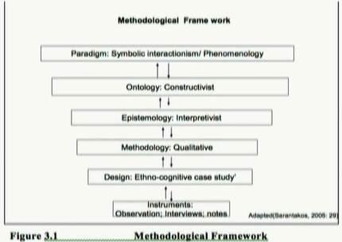

**Topic 56: Conclusion of a Methodology Chapter**

* Summarize
* Justify the data analysis procedure
* Evaluate
* Relate to research question
* No new information

**Topic 57: Triangulation**

Triangulation can be

1. Methodological
2. Research triangulation
3. Theoretical triangulation

Methodological

* Data sources
* Methods
* Participants

Researcher

* Investigation
* Analysis

Theoretical

* Theories
* Paradigms

Triangulation must be

* Discussed in detail and justified
* Reflected in findings

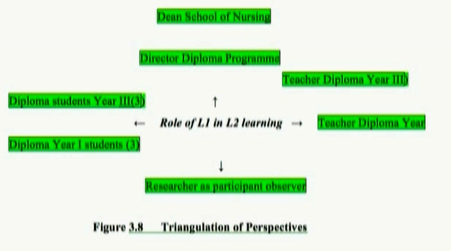

**Topic 58: Key Structural Points in Methodology Chapter**

Key points

* Approach
* Basis of determining methodological approach
* Justification and procedure
* Qualitative and quantitative – methods
* Triangulation
* Integrated approach
* Procedures
* Sampling
* Piloting
* Validity and reliability
* Ethical concerns
* Detailed characteristics and data collection analysis
* Make connections
* Evaluate
* Discuss issues

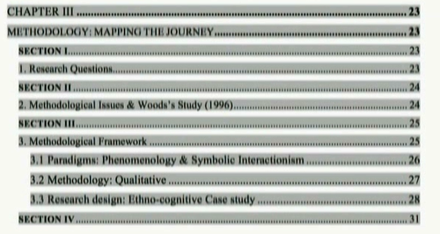

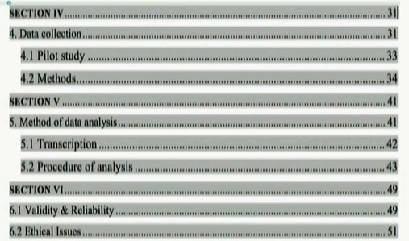

**Topic 59: Data Collection Procedures**

Explain and justify choices regarding:

* Sampling
* Sites
* Processes and issues
* Pilot study
* Instrument development

Sampling criteria

* Background of participants: gender, age, ethnic group

Explain and justify

* Size
* Location
* Context
* Characteristics

Pilot study

* Processes and issues
* Positioning of self (optional)

**Topic 60: Instruments**

Data collection instruments / methods

* Justify the choice of instrument

Data collection instruments include:

* Observations
* Questionnaires
* Interviews
* Documentary/ video analysis

**Lesson No. 11**

**Topic 61: Data Collection**

* Identify and outline stages
* Justification of steps
* Representations of procedures

Interview Example:

Multistage sampling was used in the process

Firstly class observation were carried to identify participants’ attitudes

Secondly these students were chosen for interview

**Topic 62: Data Analysis**

* Steps in analytical process
* Levels of details and illustration
* Basis on which data analysis methods were chosen
* Decision taken when deciding to represent analytical data

**Topic 63: Data Reliability**

Importance for

* Study deign
* Data collection
* Analysis procedures

Data reliability measure

--Data collection procedures is

* Consistent
* Accuracy

--To achieve data reliability

* Triangulation approach

For example

* Methods of interviews to ensure the reliability
* Structured interview and same interviewer
* Audio-tapes
* Pilot study to ensure the reliability of instrument

**Topic 64: Issues of Data validity**

Are the instruments measuring what they claim to measure?

Is the data collection process is valid?

* Content validity of questionnaires
* Item analysis
* Construct validity
* Use of triangulation
* Language

**Topic 65: Ethical Concerns**

* Privacy and confidentiality must be respected through research process specially like name
* Aims of research and nature of study should be explained clearly to the participants
* Participants’ right to withdraw form study anytime should be respected
* Written consent (Appendix)
* Details of ethical issues and how they were dealt with

**Lesson No.12**

**Topic 66 Summarizing**

Chapter should have

* Justified research approaches and paradigms

Described

* Outlines Research design
* Research process
* Collection and analysis of data

Discussed

* Ethics
* Validity
* Reliability

Explained

* Researcher positioning (qualitative research methodology)
* Limitations

**Topic 67: Methodology: Language Use**

**Tense:**

Writing methodology Chapter involves various tense

* Simple past tense for saying what you did for example “Verbal report allowed to access….."
* Present tense for defense for example “interviews provide an in-depth……”
* Present perfect tense to what others have said “Patton (1990) has suggested that………”
* Past perfect/past for reflecting on choices commanding on why example “Data from classroom observation was….”

**Topic 68: Important Questions Answer**

What is the difference between methods and methodology?

* Methodology- theoretical approach or frame work
* Methods- the specific method used for data collection

When should methodology chapter be written?

* First draft is often put together when writing research proposal
* Detail are added after literature search and after the research process is completed
* Then while doing and reviewing pilot study
* It is likely to be work for many months

**Topic 69: Result Chapter Functions**

Introduction

Focus:

* Presentation of results/ findings of study and analysis
* Some thesis combines results finding and the discussion of the result in one chapter
* But mostly they are presented in separate chapters
* Difference between findings and analysis to be kept in mind
* Accuracy in recording and analysis
* Contradictory evidence?

**Topic 70: Result Chapter Functions**

Key purpose to:

* presenting findings
* enable the reader to link between findings with research question

It requires:

* Referring back to the material presented in methodology chapter
* And point forward to what will be considered in chapter discussion

Presenting Results:

* Carefully consider how much explanation is needed
* Evidence from data and analysis is feature frequently as you support your findings
* Evidence from data and analysis will be link between findings with research question

**Topic 71: Result, Content and Structure**

The macro-structure is mostly organize around research question

* Some authors present result thematically
* In case of triangulation- all data sources need to be covered

**1. Present meta-textual information**

1. Provide back ground information
2. Reference to methodology
3. Point forward to discuss
4. Provide links to sections

**2. Present Results**

Restate research question/hypothesis

Present procedures of result for generating results

Present result

Provide evidence

Explain what each results means

**3. Integrate, summarize and conclude**

**Topic 72 Quantitative Results**

Clarification of how the results are presented:

* According to research questions
* According to methods
* Both
* Highlight sections

Example

The researcher presents quantitative results from:

1. Classroom observation
2. Questionnaire Survey

Followed by qualitative results

Re-state the result question and methodology

Present the results in tables. Graph or pie charts as appropriate

**Refer to the tables/ graph to explain**

* Self-report strongly predict the studied behavior of the worker
* Self-report negative predict
* Indicate immediate numbers

**Lesson 13**

**Topic 73: Qualitative Research**

Indicate how they are organized and presented:

* Highlight sections
* Refer to the methodology briefly and research questions

Example:

1. Response to general questions
2. Response to stimulated- recorded questions
3. Individual questions
4. Factors affecting WTC behavior in class

Response to general questions:

* Using table information in which author provided textual report on each questions
* Then he presents a serious of separate findings in response to a questions
* Instead of specific frequency, authors use words such as “predominantly”, “generally” etc

Critique:

* Should ideally be presented in themes
* Emerging vertical and horizontal themes
* Thematic headings
* Numbers/ percentages important

**Topic 74: Qualitative Responses**

Thematic findings

* Findings to be presented thematically as related to each questions
* Heading as themes

Quotes/ verbatim

* Use of verbatim to validate
* Longer quotes to be presented- formatting important
* Interpretation

Participant profile

* Participant profile to be presented in the findings to be relate

Consolidated summary at the end of each section

Percentages/numbers

**Topic 75: Key Linguist Features: Tenses**

The tense and voice selections depends on functions of statement being made

Reporting of questions and methodology: past and passive past

Examples

* “This question considers whether learners WTC behavior differed ….”
* “The question was analyzed using ANOVA……” ( passive voice)

Indications

* “The means and standard deviation of WTC across three class context are present in table 6.3” (passive present)

Interpretation or explanation: Simple present

* The results reveal patterns of deviation

**Topic 76: Caution in Presenting Results**

There are sometime options in using tense and voice but there must be functional reason for choice

Simple Past/Present Tenses

Examples of its consist use:

* Data from interviews revealed/ reveal
* Comments from individual participants… suggested/ suggests that…
* All participants appeared/appear to be….

**Topic 77: Key Linguist Features in Qualitative Research**

Qualitative research involve subjective interpretation

Hedging

* Definitive Language is avoided
* Buffering of statements

Example:

* The results seems to indicate an emergence of pattern
* A theme of conflict is discernible here with the use of words

Example

* Relatively larger number of….( percentage can come)
* It can be argued

**Topic 78: Presenting Results visually**

Guidelines for visual Representation:

1. Consistency in approach

* Weather compares values down a column or across a row

1. Be selective

* Avoid unnecessary detail
* Visual appeal and clearly are key considerations

1. A clear connections between tables, figures and text
2. Appropriate labeling

Consult most recent style manual for guidelines

**Lesson No. 14**

**Topic 79: Presenting Qualitative Results**

Qualitative Results

* More likely to present words and ideas
* More flexible with the idea

Data need to be

* Summarized
* Categorized
* Coded

Thematic categorizes to be developed

Illustrate it in with textual presentations

* Example with table or figures
* Direct quotations from transcribed records

**Topic 80: Data Display**

* Tables and figures provides information more efficiently
* Make data more understandable
* Figures include chart, graphs, photograph, drawing, illustration or any textual depiction

Guidelines on Tables and Figure:

Data display purpose

* Exploration
* Communication
* Calculation
* Storage

Design and preparation

* Decide hierarchy of purpose
* Chose best template for its primary purpose
* Graphical material require careful attention to organization content
* Label
* Use fonts large enough to read
* Use all information needed to understand with graphical image
* Keep it freeform extraneous material

**Topic 81. Data Display: Formatting and Numbering**

Formatting:

* All elements of manuscript must be in electronic form
* eg, doc, pdf, jpg,
* preparing tables with word-processing programs lowers the probability of typesetting error

Table and Figure Number:

* Use Arabic numerical
* Their order must match with those mentioned in text
* Do not use suffix letters (Table 5, Table 6 instead of 5, 5a, 5b)

Appendix

* If it includes tables and figures, identify elements with capital letters and Arabic numerals
* i.e Table A1, Figure C2

Tables:

* Limit the content to essential material
* Should be integral to the text but can be understood in isolation
* Their layout should be logical and easily grasped by the reader
* Compares entries should be next to one another
* Different indicates (e.g mean, standard deviation, sample size) should be segregated
* Tables are meant to show something specific

**Topic 82: Discussion of Tables**

Discussing Tables in Text:

* An informative tables supplements the text
* Refer to the text and tell the reader what to look for
* Discuss only table highlights
* Citing example; “as shown in table 8...”

Relation between tables

* Combine table that repeats data
* Be consistent in the presentation to facilitate comparisons

Table Title

* Brief but clear and explanatory
* Neither to general nor too detail
* Abbreviations used in title may be explained with an asterisk

**Topic 83: Principles of Figures Use**

Consider:

* Informative value
* A figure should not be included
  + It does not add to the understanding of the paper
  + It duplicates other elements
* Weather a figure is the best way to communicate the information
* These must be able to understood on their own
* Label clearly
* Can be used effectively to show relationship or hierarchy

**Topic 84: Types of Figures**

Graphs:

* Typically indicates comparison between two quantitative indices

Charts:

* Display non-quantitative information
* Such as flow of subjects through a process

Maps:

* Generally display spatial information

Drawings:

* Shoe information pictorially

Photograph:

* Direct visual presentation of information

**Topic 85: Standard for figures**

Basic standard:

* Simplicity
* Clarity
* Continuity
* Information value

A good figure:

* Augments rather than duplication the text
* Convey only essential facts
* Omits visually distracting detail
* Easily readable
* Easily to understand
* Is efficient in showing the relationship and comparisons
* Is carefully panned and prepared

Be sure that:

* Axis and elements within figures are clearly labeled
* Sufficient information is given
* Symbols are easy to differentiate
* Graphs are large enough to be discernible

**Topic 86: Important Questions Answered**

Do all results from analyzed need to be presented?

* Only those contributing to research questions/ hypothesis

Which of the results should be visually represented?

* Depends on:
* The numbers of statistics
* Intention
* Complexity of information

How much explanation should accompany tables and figures?

* Text should focus on key observation and patterns
* Explanation should be as concise as possible

**Lesson No. 15**

**Topic 87: Discussion of Results**

* A separate chapter from the presentation of results and conclusion
* Some say combine it with results or conclusion-later not advised
* Discussion needs to be divided into meaningful sections and themes
* Consider it as single chapter we need to look at its
* purpose
* and functions

**Topic 88: Discussion of Results: Functions**

**Functions:**

1. An overview aims of the research
2. Summary of theoretical and research context
3. A summary of methodological approach for investigated the research questions
4. A discussion of perceived contributions of our results
5. Interpretation your results
6. Key themes with relevance to your research questions
7. Previous relevance researches

**Topic 89: Discussion Chapter**

* Discussion depends vary on:
  + Research question(s)
  + Positions of discussion section in the thesis
* Discussion should be more than the summaries
* They should go beyond the results

**Discussion can be more:**

* Theoretical and abstract
* General
* Integrated with the field
* Connected to real world
* Connected with the implications
* And combinations of these

**Discussion Moves:**

* Consolidate your research space (obligatory)
* Indicates the implications (optional but common)
* Identifies the area for future research (optional)
* Evaluates

**Topic 90: Discussion: Content and Structure**

Moves and Sub-Moves

1. Provide back ground information
2. Restatement of :
   1. Aims
   2. Published research
   3. Approach
3. Present statement of results
   1. Restatement of key results
4. Evaluate/ comment on results or findings
   1. Explanation of results
   2. (Un) expected results- comment on whether it was expected or not
   3. Reference to previous research
   4. Exemplification- provide example of the results
   5. Deduction- make a more general claim
   6. Support from previous research- to support the claim
   7. Recommendation – for the future research
   8. Justification of future research- why future research is recommended?
   9. Limitation of the research

**Topic 91: Sample Analysis of Discussion Chapter**

Introduction to the discussion:

* Provide an advance organizer what is to be presented in this chapter

Few Moves Samples:

* The first research question investigate relationship between …( move 1a background)
* Correlation analysis indicate that self-reported strongly predict ……(move 2a)
* The strong positive relationship between self-report … and… showed….. However the participants’ behavior in whole class and pair work contradicted what was reported in the questionnaire (move 2b expansion)
* Here self-report… seemed to contradict the claim of participant being generally an extroverted and talkative person (move 2d illustration)

**Topic 92: Conclusion of Discussion**

Conclusion of Discussion

* This sections begins with restatement of what has been discussed
* Significance
* Study’s contribution to existing body of knowledge is highlighted

Examples

1. This chapter has summarized and consolidated findings of the current study….
2. Results from this study pointed to a number of factors that participants perceived as being most important….
3. The findings conform the results or contradict … why
4. Limitations of the study
5. Future research here or in the conclusion chapter?

**Topic 93: Discussion Key Linguistic Feature**

**Discussion Key Linguistic Feature**

* While discussing the significance of findings or comparison, one can be very assertive.
  + “The results of current study do not support this conclusion”
* But at times one needs to be more tentative in claims
* If you are presenting possibilities rather than absolutes certainties, you need to hedge in your presentations
  + “The findings above seemed to be reveal…”

**Lesson No. 16**

**Topic 94: Limitation in Discussion**

**Reporting the Limitations:**

* Discussions are not about the weakness in research but emphasizing its on strength , implications and interpretations

**Reporting Limitations Research Report Scope:**

1. It should be noted that this study has examined only…..
2. The results of the study have limited generalizability because ….
3. The limitations of the study are
4. It would be pertinent to remember that these finding to not imply…
5. The lack of…. means we cannot be certain
6. However the findings do not imply

**Topic 95: Important Questions Answered**

**Can I introduce new literature in discussion of the results?**

* Not advised. If necessary then add in literature review too

**How much literature do I need to refer when comparing my results with that refers it in review?**

* Only the relevant results and aspect needed to explain differences

**To what extant do the ideas needs to be based on literature presented in literature review?**

* Your reasoning must be informed by the literature

**Topic 96: Conclusion**

**Conclusion**

* The conclusion often presented in the separated chapter
* But sometimes may be combined with discussion of results
* Advice- present as separate chapter

**Commonalities with introduction but is more in-depth**

* Aims or purpose
* Significance of the study
* Methodology

**Common Elements**

* Results
* Interpretations-comparison with discussion
* Implications
* Limitation
* Future research
* Contribution of the study

**Topic 97: Conclusion of a Thesis Functions**

Functions:

1. A reminder of the aims and key methodological features of your research
2. Summary of the findings
3. Evaluation of the study’s significance with commentary on
   1. Its contribution to development of theory and development
   2. Limitations
   3. and methods
4. Practical implications
5. Recommendations for future research

**Topic 98: Conclusion: Content and Structure**

**Moves and Sub-moves:**

1. Restatements of aims and methodological approach
   * Stating aims
   * Stating key features of methodology and method
2. Summary of findings
   * Summary of key findings
3. Evaluation of the study’s significance contributions
   * Significance to findings for theory and research development
   * Significance for practical applications
   * Justification
   * Identification on any limitations
4. Recommendations
5. Recommendations for future research

**Topic 99: Introduction in the conclusion chapter**

Introduction

* An advance organizer

Sample

This chapter presents, firstly, a summary of the key findings of the research, followed by the consideration a consideration of the pedagogical implications for teacher and institutions as well as recommendation for future research.

* Gives a very clear listing of the area that will be included

**Topic 100: Summarizing key Findings**

**Sample text**

* “The primary objective of this study was to investigate…” (Move 1a aims)
* The study was carried out at a university language center in Auckland… a triangulation approach was adopted (move 1b method)
* “… this study investigated factors that influences willingness…” (Move 3a significance)
* “Although data analysis indicated some relationship but could not be generalized beyond….” (Move 3b limitations)

**Sample Analysis**

* Very clear and logical summarization
* Offer more than a list of summarized items

**Lesson No 17**

**Topic 101: Implications**

**Sample Text**

* “The results of the present study have confirmed that WTC is a factor that must be recognized as important in second language instructions.” (Move 3a, significance)
* “The teacher could help ensure that L2 communication needs of the students are accommodated.”
* “It is believed that group activities have the potential to increase the learning since students help one another……, thus leading to language development.”

**Topic 102: Implications for Future Research**

**Sample Text**

* “The results have provided evidence that WTC is useful construct in accounting for L2 communications” (Move 2, finding)
* “This study has identified a number of factors that…... future research could examine in further detail.” (Move 4a, further research)
* Another has introduce at least one new recommendation in each paragraph
* Recommendation are accompanied by findings, a limitations, a justifications or significance

**Topic 103: Limitations**

Limitations can be:

* Methodological
* Contextual
* Pragmatic

Sample Text:

* “The most obvious limitation in study was that of a small sample size…” (Move 3d, limitations)
* “Still the small population did not negate recognition of the importance of WTC in learning” (move 3a Significance)
* Limitation can be presented before the recommendations

**Topic 104: Concluded Paragraph**

Final selection of conclusion:

* Read very much like abstract
* Has Lenoir and logical presentation

Text of Conclusion (examples)

* “The primary purpose of the study was” (Move 1a, aims)
* “Eight students enrolled……. Participated in this study … multiple instruments…. were used” (Move 1b, method)
* The most useful finding……. (Move 2, finding)
* Results from this investigation….pointed to pedagogical implications….. (Move 3, significance)
* Increased awareness may be expected to leads practical steps….. (Move 3b, justification)
* “Further research was suggested to look at the... Proficiency level…” (Move 4a, further research)

**Topic 105: Conclusion: Key Linguistic Features**

**Modal verb**

* Recommendation for applications and further research tends to be use:
* Frequent use of modal ‘should’ rather than weaker modal choice ‘could’ or ‘May’

**Examples**

* “The findings should be seen……”
* “The teacher should be informed that……”
* “The teacher should create suitable interaction opportunities …”
* “The techniques should engage students in class discussion….”

**Subordination**

* Subordinates clause are often used while presenting limitations
* Such as
  + Clouse of concession
* Example

“Although WTC was found to change over the one-month period in this study, time span was not long enough to document a systematic change in WTC classroom behavior.”

**Topic 106: Important Questions Answered**

**Q: 1 What is the difference between summary and conclusion?**

Conclusion is the statement about:

* The importance
* Significance
* contribution of your findings

Summary is:

* mere summing up

**Q.2 Does the conclusion present any new information?**

No- but expands certain points

**Lesson No 18**

**Topic 107: Confidentiality**

**Researcher should never disclose:**

* Personally identifiable information of the participants

**Protecting confidentiality:**

* Obtaining written consent
* Disguising some aspect

**Disguising strategies:**

1. Altering specific characteristics e.g. names
2. Limiting description of specific characteristics
3. Using composites

**Topic 108: Writing Clearly and Concisely**

**Organizing:**

* Consider the best length and structure of your findings
* Logical ordering strengthens the impact of writing

**Length:**

* Rule: “less is more”
* Discursive writing often obscures author’s main point
* State points clearly and directly
* Eliminate repetitions

**Organizing Manuscript with Headings:**

* Organizational structure is key to clear, precise and logical communication
* This includes the use of headings to effectively organize the ideas

**Topic 109: Headings**

**Concise headings**

* Inform key point
* Track the development of arguments
* Level of headings establish the hierarchy of sections
* Use at least two subsections headings within any sections

**Levels of Headings**

APA suggest formatting arrangement for different headings levels:

1. Centered, Boldface, Uppercase and Lowercase Headings
2. Flush Left, Boldface, Uppercase and Lowercase Headings
3. Indented, boldface, lowercase paragraph headings endings with a period
4. Indented, boldface, italicized lowercase paragraph headings endings with a period
5. Indented, italicized lowercase paragraph headings endings with a period

**Topic 110: Numbering**

Seriation helps the reader understand the organization of key points

Separation points are identifies with Arabic numerals, followed by period, written in sentence format

Example

1. Individuals who ….

(Paragraph continues)

1. Non depressed persons exposed to …..

(Paragraph continuous)

1. Depress person exposed to…..

(Paragraph continues)

The use of bullets instead of “numbered lists” helps eliminate risk of unwanted original position, e.g.

* Individuals who ….

Paragraph continues)

* Non depressed persons exposed to …..

(Paragraph continuous)

* Depress person exposed to…..

(Paragraph continues)

**Topic 111: Writing Style**

**Prime objective of writing of reporting:**

* Clear communication

Clarity can be achieved through:

* Presenting ideas orderly
* And expressly oneself smoothly and concisely

Establishing an effective tone also:

* Engages readers
* Communicate ideas clearly

**Topic 112: Writing Style: Continuity**

**Continuity in Presenting Ideas Includes:**

* Continuity in words
* Continuity in concepts
* Thematic development from opening statement to the conclusion

**Achieving Continuity:**

Punctuation marks

* Contributes through showing relationship between ideas
* Neither overuse nor underuse
* Use it to support meaning

**Transitional words**

* Help maintain flow of thoughts
* Especially when material is complex and abstract
  + Use f pronoun
  + Times links: then , next, after, while, since, after
  + Cause effect links: therefore, consequently, as a result
  + Additional links: moreover, furthermore, similarly, in addition
  + Contrast links: but, conversely, never the less, however, although

**Lesson No. 19**

**Topic 113: Smoothness of Expression**

* Try to be clear and logical
* Ambiguity sudden shift to topic, tense or person, inserting the unexpected; omitting the expected can confuse or disturb the readers
* Peer review can help indicates the contradictions
* Reading the paper aloud also help

**Noun Strings:**

* Several noun used one after another also create abruptness
* Skill full hyphenation can address it
* Best approach is to untangle the string

**Untangling Example:**

* “Commonly used investigative explanation issue control question technique”

A control question-technique that is commonly used to expand issues in investigation

* An expanded-issues control- question that is commonly used in investigations

A common technique to using control questions to investigate expanded questions

**Topic 114: Tone**

* Writings tone does not need to be dull
* Present ideas and finding directly

But

* Aims for interesting and compelling style
* Tone must reflect your involvement
* Difference should be presented in a professional, non-combative manner

Example

“Fong and Nissber did not address....” is acceptable,

Whereas “Fong and Nissber completely overlooked…” is not.

**An effective technique:**

* Imagine a specific reader
* Indent to educate and persuade that individual
* Envisioning a familiar person will make it effective

**Topic 115: Economy of Expression**

* Say only what is need to be said
* Eliminate:
* Redundancy
* Wordiness
* Jargon
* Evasiveness
* Overuse of passive
* Circumlocution
* Clumsy pose

**Wordiness**

* Can be impede the ready grasp the ideas
* Short words and short sentences are easier to comprehend

**Redundancy**

Use no more words tan necessary to convey the meaning

* The total of 68 participants
* Absolutely essential
* Small in size

**Unit length**

* Varied sentence length maintained interest
* Similar caution applies to paragraph length, neither too lengthy nor too short

**Topic 116: Precision and Clarity**

**Word Choice**

* Make sure to use the word that convey exact meanings
* Informal words are not accepted

**Colloquial Expressions**

* Avoid them
* The diffuse meanings
* Approximation weakness statement and is interpreted differently
* Avoid jargon
* Pronoun confuse readers unless referent for each pronoun is obvious
* Refrain from ambiguity or illogical comparisons

**Topic 117: Linguistic Devices**

* Devices that attract attention to words or sound
* Instead of ideas
* These are in appropriate
* Avoid heavy illation, rhyming, poetic expressions and clichés
* Avoid:

Mix metaphor

Words with surplus

* Don’t use figurative expression

**Topic 118: Strategies to Improve Writing Style**

The fit between the author and strategy is more important than a particular strategy used

Approaches to Effective Communication:

1. Writing from outline
2. Putting aside the first draft, re-read later
3. Asking a colleague to review and critique the draft
4. Thinking of audience and purpose

**Lesson No. 20**

**Topic 119: Appropriate level of specificity**

**Precision:**

* Essential in scientific writing
* Choose accurate words
* Clear and free from bias

The appropriate degree of specificity depends on:

* The research question
* Present state of knowledge in the field of study
* To describe age group:
  + Give specific age range
  + Instead of broad category (over 65 year)

Be careful in describing racial or ethnic groups

**Topic 120: Reducing Bias in Language**

**When describing racial and ethnic groups appropriately**

* Be specific
* Sensitive to issue of labeling
* Describe people by their nation or region of origin
* Chinese Americans, Africans Americans

**Be Sensitive to Labels**

* Avoid labeling
* Respect peoples preferences
* Call them what they prefer to be called
* Accept the prefer change with the time and individual within the group

**Topic 121: Acknowledge Participation**

* Write about the people in that way acknowledge participate
* Use descriptive terms such as respondents, participate, college students etc..

**Passive Voice**

* It is suggested that people are acted upon instead of beings actors
* Thus “the students completed the survey” is preferable or “the student were given the survey”
* Avoid term failed “the participants failed to complete…”
* It can imply the personal shortcoming instead of results research
* Did not is more neutral choice

**Topic 122: Reducing Bias: Gender**

**Gender**

* Refer to role not biological sex
* It is cultural
* Avoid ambiguity in sex identity or gender role
* Sexist bias Can occur when pronoun are used carelessly
  + As he is used to refer to both sexes
  + Or pronoun is used to exclusively to define roles by sex
  + The use of man as a generic noun
  + Or as ending for an occupational tile
  + Police man instead of police officers
  + Use alternatives to generic he
  + Combining forms such as he/ she or (s) he are awkward and distracting
  + Avoid referring as opposite sex
  + Appropriate wording: the other sex

**Topic 123: Reducing Bias: Ethnicity**

* Preferences for term referring to racial or ethnicity change group often
* Use commonly accepted designations
* Blacks and African are currently acceptable but Negro American is not acceptable
* Use more specific terms
* Language that essentializes or reifies race is strongly discourage
* Word should minority should also be used with modifier ( such as ethnic or racial)

**Indigenous Group:**

* You use broader terms
* Like native American, first nations
* Term Asian or Asian American is preferred to oriental
* Better to specify names of subgroups: Pakistani, Chinese etc

**Topic 124: Reducing Bias: Disabilities and Age**

**Disabilities**

* Maintain the integrity of all individual as human beings
* Avoid language that objectifies a person by condition ( autistic ,neurotic)
* Or that use pictorial metaphor (wheelchair bound)

**Avoid language that:**

* Use excessive and negative labels (AID, victim, damaged)
* Can be regarded as slur (cripple, invalid)
* Use people first language (people with intellectual disabilities)

**Age:**

* Should be reported as a part of participants’ description
* Be specific in age ranges
* Avoid open ended definitions such as under 18 years
* Terms young and adolescent- individual age 13-17 years
* Terms as elderly or senior are not acceptable as noun

Age groups may be describe as adjectives

**Lesson No. 21**

**Topic 125: Grammar and Usage**

* Incorrect grammar and careless sentences construction distract the reader
* Incorrect grammar introduce ambiguity
* And generally obstruct communication
* Let us review some frequently grammatical and usage problems in manuscript

**Topic 126: Subject Verb Agreement**

Verb must agree in number with it subject

* **Correct:**

The percentage of correct responses as well as the speed of responses **increases** with practice

* **Incorrect:**

The percentage of correct responses as well as the speed of responses **increase** with practice

The plural of noun that may be singular need attention

* **Correct:**

The data **were** collected

* **Incorrect:**

The data **was** collected

* **Correct:**

These phenomena **occur** every 100 years

* **Incorrect:**

The phenomena **occur** every 100 years

**Topic 127: Crediting Sources: Direct Quotations**

**Quoting**

* Reproducing word by word material directly in quoted form:
  + Another authors work
  + Your own previously published work
* Always provide the author, year, specific page citation
* Incorporate a quotation into text if it has fewer than 40 words
* Use quotation marks within the text
* Must fit in coherently in the text
* Must be accurate
* Longer quotation separate from the main text
* Smaller font
* Indented followed by citation

**Topic 128: Paraphrasing and Quoting**

**Direct quoting and online material without pagination**

* Quoting and paraphrasing require or paragraph number
* If sources do not provide page number, use given paragraph number

**Accuracy**

* Follow wording, spelling, interior, punctuation, even source is incorrect
* If any incorrect spelling or grammar might confuse the reader, insert [sic] immediately after error
* Use […] to indicate omitted material
* To emphasized a word, italicize and immediately after it [emphasize added]
* Quoting more than 800 words require written permission from the owner of copyrighted work
* Paraphrasing require staying close to meaning
* If the meanings is being adapted then a footnote must follow

**Topic 129: Citations in the Text**

**Requires References:**

* With author date citation system
* Listed alphabetically references list
* To be identical in spellings at both places
* Exception: classical works [ Bible, Qur’an] will be cited only in the text

**One Work by one Another**

* Surname (suffixes not required)
* Year of publication

Examples:

Kessler (2003) found that….

Early onset result in a more persistent and severe course (klesser, 2003)

**One Work by Multiple Authors**

* Kisangau, Lyaruu, Hossh and Josph (2007) found….
* Kisangau et al. (2007)
* Ibid. use

**Topic 130: References**

**References Why?**

* Acknowledge the work of previous scholars
* Provide a reliable way to locate it
* Validate arguments

**References List**

* Start on a new page
* The word references should appear in uppercase and lower case letters, centered.
* Double space all entries
* Use hanging indent format

**Footnotes**

* Supplement or amplify
* Should not include irrelevant information
* Include copyright permission for lengthy quotes

**Lesson No. 22**

**Topic 131: Mechanics of Style: Punctuation-Period**

**Punctuation:**

* Establishes the cadences of a sentence
* Telling where to pause, stop or take detour
* Denotes a pause in thoughts

**Period:**

* Use to end a complete sentence
* With a abbreviations, as in U.S. Navy
* In initials of names (J. M. Smith)
* Reference abbreviations (Vol. 1. 2nd

Do not use period with:

* Abbreviations of state names (NY, OH)
* Capital letter abbreviation (APA, IQ)
* Web addresses (<http://www.apa.org>)
* Metric and non-metric measurement abbreviations 9 (cm ft, hr, kg, min, ml)
* Exceptions:
* Abbreviations for inch (in.) takes period

**Topic 132: Capitalization**

Uppercase letter for the first letter of the word

* The first word in complete sentence
* The first word after the colon that begins a complete sentence
* Major words in the title and heading (Example: In her book, History of Pathology )
* Major words in article headings and subheadings
* Exception: level 3,4,5 headings
* Proper nouns and trade names
* Nouns followed by numerals and or letter
* Titles of test
* Names of factors, variables and effect

**Topic 133: Numbers**

* Use words to express numbers below 10
* Use numerals for number above 10 in the abstract or graphical display that precede a unit of measurement
* Statistical or mathematical function
* Times, date, age
* Scores and points on scale
* Exact sum of money
* Numbers that denotes a specific place in numbered series

**Numbers express in words**

* Any numbers that begins a sentences title or text headings
* Common Fraction
* Use combinations to express back to back modification i.e. 2 two way interaction ten 7 point scale
* If readability suffers, spell out both

**Topic 134: Punctuation: Quotation Marks**

Use double Quotation Marks

* To introduce a word or phrase as an ironic comments e.g. Considered “normal” behavior
* To set off the article or chapter title when mentioned in text
* To reproduce material from a test or verbatim instruction to participants

Don’t use double quotations marks, italicize instead

* To identify the anchors of a scale
* To cite letter, word, phrase or sentences as a linguistic example

**Topic 135: Latin Abbreviations**

**Latin Terms:**

* Add technical precision
* Latin phrases have strong influence on academic English

**Latin Abbreviations**

e.g. (*exempli gratia*)

i.e. (*id est: that is*)

N.B. (*note bene: take note)*

**Few Abbreviation Derive From Latin**

* A.M. / P.M.
* Ibid. (*ibidem*)
* etc. (*et cetera*)
* et al. ( *et alii: and others*)

**Topic 136: Academic Writing: Some Other Considerations**

**Considerations**

Audience

Purpose

Organization

Style

Flow

Presentation

**Purpose & Strategy**

* Audience, purpose and strategy are interconnected
* Instructional for audiences who knows less
* Displaying familiarity, expertise and intelligence

**Organization**

* Use a structure format
* Take advantage of regular, predictable patterns of organization
* It helps reader follow even if you make error

**Style flow and Presentation**

* Will be guided by purpose and audience
* Use signposting
* Reminders
* Ensure clarity in presentation

**Lesson No.23**

**Topic 137: Academic Style: Formal Language**

**Nouns & Other Parts of Speech**

* There may be more than one way to express an idea
* Strive to choose the most precise and formal words

**Formal Grammar & Style**

**Formal Grammar & Style**

1. Avoid Contractions
   * *i.e. will not* instead of *won’t*
2. Use more appropriate formal negative forms
   * not …any no
   * not …much little
   * not …many few
3. Limit the use of “run on” expressions
   * i.e. “and so forth”
   * and “etc."
4. Avoid addressing the reader as “you”
5. Limit use of direct questions
6. Place adverb with the verb where clarity is required

**Topic 138: Writing Process**

**Writing Process**

* Set a realistic pace
* Recognize your progress by setting goals and acknowledge the effort

**Arithmetic of Writing**

* How will you measure your written output?
* How will you identify the pace of writing that suits you?
* How will you establish momentum in your writing?
* Consider range of strategies
* Thesis requires the writer to experiment with new techniques
* Keep a focus on what you are thinking

**Three Principles:**

* Learning comes through writing
* Quality comes through revising
* Regular writing leads to fluency

**Topic 139: Principles of Academic Writing**

**Helpful Questions**

* What are the conventions of writing in this discipline?
* What language – noun, verbs, links, etc. – do writers use?
* How are debates presented?
* How is the researcher represented, if at all?
* How is structure revealed?
* What are the options in style and structure?

**Topic 140: Analyzing a Thesis**

* Scan the table of contents:
  + What type of structure is used?
  + Experimental/narrative/other form of logical progression?
  + What are the approximate relative lengths of chapters?
  + Is this structure reflected in the abstract?
* Read the introductory paragraphs of each chapter.
  + How is progression made from chapter to chapter?
* What are the main differences between chapters?
  + Look at structure and style: long/short sentences and paragraphs.
  + Look at language used: what are the key words?
  + Types of verbs used

**Topic 141: Goal Setting**

Be SMART Effective goals are:

* Specific
* Measurable
* Achievable
* Realistic
* Timed

**SMART Version 2**

* **S**imple: understandable
* **M**eaningful: to you, aligned with your core values
* **A**s if now: real to you
* **R**esponsible: for everyone involved
* **T**owards what you want: not someone else’s goal

**Writing Goals**

* Define the purpose of writing task
* Choose a writing verb
* Define your audience
* Define the scale and scope of your writing
* Decide how long you will take to write it
* Declare when

**Topic 142: Defining the Writing Task**

**Making Checklist**

* Provides a route map on a long complex journey
* makes it all manageable
* clarifies what needs to be done
* Start writing now
* Discuss writing explicitly with your supervisor.
* Read one book on writing in your discipline.
* Make up a rough timetable for writing
* Set long- and short-term writing goals.
* Find about punctuation rules and grammar.
* Define audience and purpose for your writing.
* Discuss all these points with your supervisor.
* Consider taking a workshop

**Lesson No. 24**

**Topic 143: Writing Purpose**

What purpose will writing serve for you?

* You are writing to learn.
* You are writing to explore your research topic.
* You are writing to report.
* You are writing to persuade.

**Topic 144:How will my thesis be assessed?**

The external examiner will scrutinize:

* Review of the literature
* Design of the study
* Presentation of results
* Discussion and conclusion

**Review of Literature**

* Relevance to the research study?
* Has the candidate slipped into ‘here is all I know about x’?
* Evidence of critical appraisal?
* Explicit links between the review and design of study?
* Gap?
* Rationale for research focus, design and method?
* Research questions answered?
* Coherence

**Topic 145: Assessment of Thesis Design**

**Design of Study**

* Were the research questions answered?

**Assessment of Thesis Design**

* What precautions were taken against likely sources of bias?
* What are the limitations of the design?
* Is the candidate aware of them?
* Has candidate given an adequate justification for the design used?

**Topic 146: Tackling Issues**

**What can I write about the design of the study?**

* Precautions against bias?
  + I am most likely to be biased in . . .
  + I am least likely to be biased in . . .
  + Bias would reveal itself as . . .
  + Would be reflected in …
* I will limit the design in order to make it feasible by . . .
  + This is a positive choice – rather than weakness – because . . .
* I can justify the design I am using/going to use by . . .

**Topic 147: Defining Originality**

**Checklist:**

* Saying something never said before
* You do the empirical work no one has done so far
* You synthesize things that were not put together before
* New interpretation of material/ideas.
* New to context
* You take an existing technique and apply it to a new area
* Working across disciplines, using different methodologies
* Focusing on topics that people in your discipline has not looked at
* You test an existing knowledge in an original way
* You add to the knowledge in a way that has not been done before
* You write down a new piece of information for the first time

**Topic 148:Keeping Back-ups**

**Data safety**

* Make a second set of back-up disk/ memory stick
* Put each chapter on a separate disk/ memory stick
* Put your bibliography on a separate disk/ memory stick
* Keep them in a different building from your other set or on a server
* When going on holidays/ to a conference, take a set of back-ups with you and leave a set with a friend
* Update your backups EVERY DAY
* Printout hard copy after all major revisions

**Lesson No. 25**

**Topic 149: Reasons for Not Writing: Peer Support**

Reasons for Not Writing

* Numerous reasons stated by people
* Displacement activity
* One Good Reason: Taking a Break.
* People may prefer to do field work first,
* Putting off writing till later
* Don’t know what to write or how?

**Peer Support**

Discussion with peers:

* helps develop understanding of what you are getting into,
* and how to get through it.
* Supports when the task seems impossible

**Topic 150: Discussing Feedback**

Discussing Feedback

* A way of enhancing communication
* It has to be a genuine dialogue

Points to Consider:

* What feedback has been provided on your writing?
* When was this discussed/agreed?
* Was it explicit?
* Do different comments require different types of revisions?
* Have the links been discussed clearly?
* Does your supervisor have a method of signaling them?
* When will this subject be reviewed (in future discussions)?

**Topic 151: Free Writing**

What is Free Writing?

* Writing for five minutes without stopping
* In sentences
* Private writing: no external reader
* Topic: what is worrying you
* No structure needed

**Topic 152: Benefits of Free Writing**

Benefits of Free Writing

1. An experience of ‘personal success’ associated with writing
2. Stepping back to see the project as a whole
3. Frees up the thinking process
4. Surfacing of deep thoughts
5. It gives value to emotions and feelings
6. Increases confidence
7. Increases optimism about the study

**Topic 153: Generative Writing**

Key Points:

1. Write for five minutes
2. Without stopping
3. In sentences
4. Stick to one topic, possibly something from your free writing
5. Let someone read it

Difference from Free writing

* More closed
* Awareness of the audience
* Responsibility to make sense

**Topic 154: Writing to Prompts**

Writing to prompts

* What have I written and what would I like to do?
* Where do my ideas come from?
* How does what I read compare with my own views?
* What I want to write about next is . . .

**Lesson No. 25**

**Topic 155: Other Problems in Writing**

**Other Problems in Writing**

* Fear of supervisor
* Fear of feedback,
* Fatigue
* Boredom, often a sign of stress
* Lack of momentum
* Not writing often enough
* Fear of the big picture: failure
* Lack of rewards
* Difficulty in signaling problems
* Not achieving high standard in writing

**Topic 156: Writers Block**

**What is it?**

* Block moments: when we cannot produce writing
* It may occur at particular points

**Most Often:**

* used term
* feared
* difficult to resolve

**Why ?**

* They think they must work out what they think – and what they want to say before they can write . . . and get stuck at that point
* They want to be sure before they write . . . instead of when they are not sure
* There is no end to the project in sight

**Topic 157: Resolving Issues**

**Strategies for Unblocking**

* Free writing
* Generative writing
* Discussing writing with supervisor
* Mind-mapping
* Verbal rehearsal
* ‘Write down all you know about ..
* ‘Write down all your ideas on …
* Construct a sense of an ending
* visualize the completed thesis

**Preventive Strategies**

* Become addicted to writing
* Finish today’s writing session by defining tomorrow’s
* Write before everything else
* Don’t worry writing.
* Gather together all the writing you’ve done and notice how much there is.

**Topic 158: Scaffolding an Argument**

**Steps for Scaffolding**

* Decide on the main point
* Define terms
* Elaborate your point
* Discuss examples or evidence

**Paragraph Structure**

1. Topic sentence
2. Elaborate
3. Say how your example makes the point in your topic
4. Conclude or signpost the next paragraph

**Topic 159: Positioning of Self**

**Important in qualitative research**

* Objectivity not possible

**Purpose:**

To disclose:

* Possible influence on data collection-responses
* Possible researcher bias in interpretation
* Gender
* Age
* Ethnicity
* Religion
* Discuss strategies to minimize the effect of self
* Awareness of the issue

**Topic 160: Writing a Case Study**

1. Examine the case thoroughly
   * Take notes
   * Highlight relevant facts
   * Underline key problems
2. Focus your analysis
   * Identify the key problems
   * Why do they exist?
   * How do they impact the organization?
   * Who is responsible for them?
3. Uncover possible solutions
   * Review readings, discussions
4. 5. Read case studies for samples before writing your own
5. 6. Thick descriptions