Lesson No. 1

Teaching of Literacy Skills

Topic 1: Concept of Literacy
What is literacy?
The term literacy refers:
- often mainly to reading,
- sometimes to reading and writing,
- and rarely, to reading, writing, speaking and listening
The activities of reading, writing, speaking and listening in a learning environment are included in literacy.
The National Literacy Trust defines: “We believe literacy is the ability to read, write, speak and listen well. A literate person is able to communicate effectively with others and to understand written information.”
As such, these skills are essential components of literacy, and the active ability to combine these skills is known as developing or engaging in literacy skills.
These skills are critical in communication. In today’s world, media and technology are essential components of communication. For example, when you use your laptop to obtain information from some website; you are using the literacy skills.

Topic 2: What is Meant by Literacy Skills?
We use the term of Literacy Skills in many contexts: for instance, while reading, while writing, while speaking, etc. We also talk about literacy rate of a country, and compare it with that of the other. So what do we mean by this term? What are the skills related to “Literacy”? Let us try to define it in more detail.
Literacy skills are those which help in:
- developing literacy, and
- improving literacy
Each skill contains several sub-skills. For instance: reading.
When you are reading a text on the page of a book in front of you
- you pass though unfamiliar words, and search for their meanings to understand the individual words contained in the text
- you connect the words to understand the meaning of the text as a complete set
- these activities help you read and understand the text of the book
- these sub-skills are involved in the “reading” skill
As such the “Reading” skill includes a number of sub-skills, which collectively help in developing “Literacy,” Same is the case with the other skills.
Using literacy skills students gain knowledge though reading as well as using media and technology. These skills also help students create knowledge through writing as well as developing media and technology.
All skills that are needed for reading or writing are included in literacy skills. They include even such things as awareness of the sound of language, awareness of print, and relationship between letters and sounds.

Topic 3: Different Types of Literacy Skills
There are different types of literacy skills:, e.g.:
- Reading: even if you read a sentence, it is literacy skill because you had that level of literacy which enabled you to read the sentence. Reading a book, newspaper or thesis etc. is all included in literacy skills.
- Many sub-skills are involved in the reading skill, like reading the words, understanding the words, connecting the words, connecting the meaning of those words, and then collectively understand the message.
- However, there could be different levels as reading a children story book would require different level of literacy than reading a book of philosophy. There could also be different versions of the same text available for adult reading and for children reading requiring different levels of reading skills.
- Different levels of skills are also involved in writing a sentence and writing a book.
- Listening requires familiarity with the sounds; because while listening you pick up different sounds, understand them, and connect these sounds with the message for overall understanding. These are all included in literacy skills.
- Words are also essential part of literacy skills.

Extra Reading
- Literacy is the ability to read and write, but also includes skills like critical thinking, listening, speaking, viewing and presenting.
- Numeracy is being at home with numbers, and knowing the smartest way to solve mathematical problems.
(Literacy and numeracy are globally ranked in the top three skills that employers look for in an employee).

Topic 4: Learning Literacy Skills
Literacy skills help students gain knowledge through reading as well as using media and technology. These skills also help students create knowledge through writing as well as developing media and technology.
There are two ends to the concept of learning literacy skills.
- Students’ concern is to learn these skills
- Teachers must ensure that their students learn all the main and the allied sub-skills included in literacy skills.
Literacy is the ability to read, view, write, design, speak and listen in a way that allows you to communicate effectively. The power of literacy lies not just in the ability to read and write, but rather in a person’s capacity to apply these skills to effectively connect, interpret and determine the workings of the world in which they live.

Topic 5: Significance of Literacy Skills
Figure 1
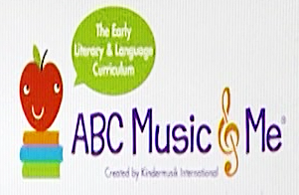
Figure 1 presents a very basic level of literacy – some alphabets, a musical note, some pictures – it is, most likely, connected with very young children who are starting to learn. For them, nevertheless, these are the literacy skills that they have to learn, and proceed to improve forward.
Figure 2
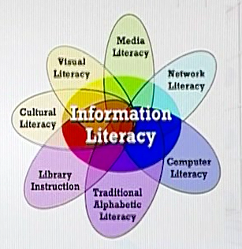
A much more complicated situation is presented by Figure 2. It is a highly developed and advanced model of literacy. For instance, computer literacy will require knowledge of technology, writing, typing, reading, how to download information from web, how to search, save, how to put/ retrieve information in/ from mail, etc.

Literacy skills provide the basics to proceed for learning and gaining, and creating knowledge in any discipline. The level of these skills may be different according to the level of learners.

Extra Reading
If it were up to us, the benefits of reading and writing would be mentioned and celebrated on every broadcast of morning and evening news: "It's 11 o'clock, have you read to your children today?" Here are 5 powerful facts about literacy.
1. Reading aloud is vital.
Research proves that reading aloud to children every day puts them almost a year ahead of children who do not receive daily read-alouds and that is regardless of parents' income, academic or cultural background. On top of that, pediatricians are now prescribing read-alouds alongside their nutrition and health advice in recognition of the proven benefits on brain development and vocabulary acquisition.
2. Literacy saves lives.
According to UNESCO, improvements in women’s education explained half of the reduction in child deaths in the past twenty years. Mothers who are educated are more likely to have their children vaccinated, and more likely to send them to school. Imagine what will happen when every child and adult can read, write and learn all they want and need to know.
3. Literacy teaches you to own and value your own story.
The Education for All Global Monitoring report states that there is a clear link between literacy and a positive self-image. Building confidence as a reader, writer, listener and speaker is transformational in a person's life. These core abilities are used every minute of every day to read the world. More than that, reading stories gives a greater understanding of self. Suddenly there are characters who feel the same feelings as you, who share your struggles, your hopes and your dreams. Literacy brings us out of isolation and into a community of readers and writers.
4. Literacy gets you to the goal.
Studies have shown that people who write down their goals are 80% more likely to achieve them. Having documentation of our goals and reading them back to ourselves on a regular basis keeps our motivation at the forefront of our minds and allows us to start to create action plans. This is productive literacy in action. Simply having the ability to write down what you want to do and where you want to go leads to an impressive head-start.
5. Literacy empowers.
The ability to seek out and understand information gives us all independence to make choices, to advocate for ourselves and to learn about our community and world. People who can read and write are powerful in society and studies show that literacy leads to greater self-reliance and civic engagement.

http://www.litworld.org/blog/2014/8/29/5-things-you-need-to-know-about-the-power-of-literacy

Topic 6: Literacy Skills in Classrooms
Development of literacy skills is strongly connected to the development of a country. Supporting young children’s language and literacy development has long been considered a practice that produces strong readers and writers later in life, who then contribute positively in the country’s development and growth. Literacy skills are also strongly connected to classroom learning, which again ultimately contributes to the country’s development and growth.
Figure 3 presents a picture of a classroom that is not using any technology, which is a very important helping factor of the modern classroom. While Figure 4 shows a modern classroom, where each student is using technology and is learning in an interactive manner. Notice that there are no heavy bags in Figure 4.
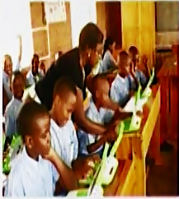
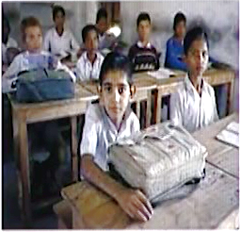

Figure 4
Figure 3

Classrooms help to a great extent in improving literacy skills that provide the base for the development of a country. For instance:
- Literacy rate in Pakistan – 58%
- Literacy rate in USA – 90-95%
As such, the literacy skills being used or developed in the classroom connect with the development of the country at the macro level.

Lesson No. 2

Levels of Language

Topic 7: What is Language?
The connection between language and literacy is powerful. Some language and literacy learning happens naturally during play and everyday experiences, and some depends on clear instructions from observant and sensitive adults. Language and literacy are connected from infancy onward. Speaking, listening, reading, and writing develop concurrently (together) rather than sequentially (one after the other).

- Language is a system of communication using sounds or symbols that enables us to express our feelings, thoughts, ideas and experiences.

- Language is the key to communication.

- The basic purpose of the system of language is communication. It means whenever we have to communicate with others, we have to use language in one or other way.

- Purposes, modes or styles of communication can be different, e.g. chit-chat with a friend, talking with teacher, reading a philosophy book, writing a story, etc. Nevertheless, in each case, a system of language is used.

Topic 8: Different Levels of Language
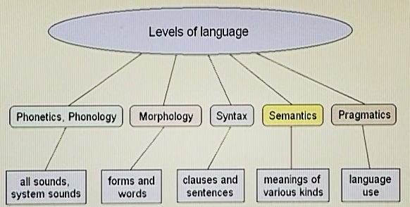

- The first level of language is Phonology which is related with sound
- Next, Morphology, is the level of words and forms in language. It is what one normally understands by grammar (along with syntax).
- Syntax comes next and is related with clauses, phrases, and sentences. It involves differences in meaning that occur by changes in word order
- Semantics is the area of meaning.
- Pragmatics is the last and is related with use of language

- All languages are known as systems of communication.
- The systems of languages may be different from each other but they follow the same levels that start from the basic one (phonology) and go up to use of language (pragmatics).
- When we study language scientifically in stages like above, it is known as “linguistics”
Extra Reading – Short Note
Linguistics is the scientific study of language. There are three aspects to this study: language form, language meaning, and language in context

Topic 9: Phonology
Phonology is the study of how sounds are organized and used in natural languages. It is a branch of linguistics concerned with the systematic organization of sounds in languages. The phonological system of a language includes a list of sounds and their features, and rules which specify how sounds interact with each other.
Sounds are represented by signs or symbols in a language, as in this chart which represents sounds in English language. It is called the “International Phonemic Chart of English”. There are 26 alphabets in English and 44 sounds related with those alphabets. These sounds help us to know the exact pronunciation of particular alphabets.
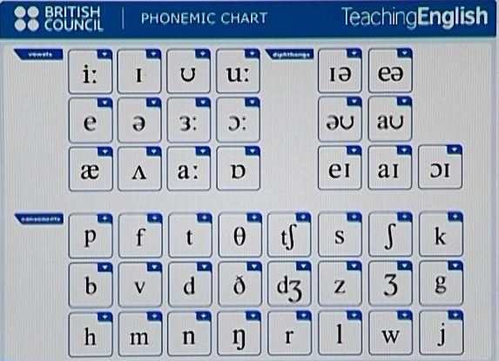

Phonology, therefore, is the study of sounds, and the combination of sounds, that is, how are these sounds organized.
- Sounds are known as “phonemes”

Topic 10: Morphology
Morphology is a sub-discipline of linguistics in which forms and structure of words in a language are studied. In easier words, one can say that sounds combine to form words, and that is Morphology.
Morphology is the study of how things are put together, like the make-up of animals and plants, or the branch of linguistics that studies the structure of words.
In morphology, the word part morph- means "form" and -ology means "the study of." So, those who study how something is made or formed are engaged in morphology. In biology, the morphology of fish might investigate how the gills work as part of the respiratory system. In language morphology, you might study how prefixes and suffixes added to a word change its meaning.
- Words in a language consist of one element, or elements, of meaning which are known as “morphemes”
- Number of “phonemes” (sounds) combines to give a “morpheme” (word).

Topic 11: Syntax
Syntax is the sequence in which words are put together to form sentences. In English, the usual sequence is subject, verb, and object. (Note: Syntactic languages, such as English, use word order to indicate word relationships).
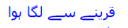
- “Syntax” is a Greek word, which means “order”
- If words are not put together in certain order in sentence, they will just be morphemes and will not form a proper sentence to convey any meaningful message
- To understand a sentence, a proper order, or sequence of words is necessary. This order or sequence is called Syntax.
- Word arrangement is essential to communicate properly
SVO
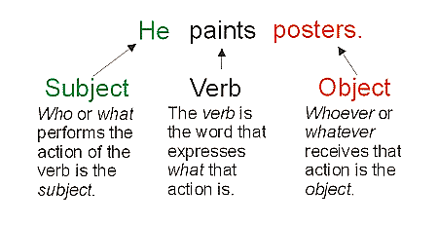
Object
Subject
Verb
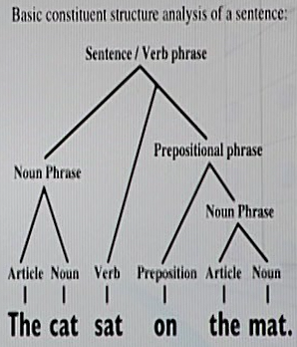

Topic 12: Semantics and Pragmatics
- Whenever we enter the sphere of “meaning”, we are talking about “semantics” and “pragmatics”.
- “Meaning” is what we use the language for—to communicate with each other, to convey 'what we mean' effectively.
- Both semantics and pragmatics have to do with the meaning of language, and link language to the world.

The branch of linguistics and logic concerned with meaning. It is concerned with the meaning of a word, phrase or text. Similarly, analysis of word meanings and relations between them is also studied here.

Extra Reading
SEMANTICS
The most general definition of semantics is that it is "the study of linguistic meaning", or "the study of the meaning of words and sentences"

PRAGMATICS
Pragmatics is the study of "how to do things with words", or "the study of the contribution of context to meaning".

Lesson No. 3

Certain Terms
(related to language and language learning, and literacy)

Topic 13: Acquisition and Learning
Language acquisition is the process by which children acquire the capacity to perceive and comprehend language, as well as to produce and use words and sentences to communicate in a natural way and not consciously.
GLOSSARY
- Acquisition: Gaining, Attainment, Acquirement
- Perceive: Notice, Identify, Make out, Sense, Become aware of
- Comprehend: Understand, Know, Grasp
Children acquire language through a subconscious process during which they are unaware of grammatical rules. They get a feel for what is and what is not correct. In order to acquire language, the learner needs a source of natural communication. The emphasis is on the text of the communication and not on the form. Young students who are in the process of acquiring English get plenty of “on the job” practice. They eagerly acquire the language to communicate with classmates.
Language learning, on the other hand, is the result of direct instructions in the rules of language. It certainly is not an age-appropriate activity for your young learners. In language learning, students have conscious knowledge of the new language and can talk about that knowledge. They can fill in the blanks on a grammar page. Research has shown, however, that knowing grammar rules does not necessarily result in good speaking or writing. A student who has memorized the rules of the language may be able to succeed on a standardized test of English language but may not be able to speak or write correctly.

Topic 14: Difference between Acquisition and Learning

- Acquisition is implicit, but learning is explicit.
- Acquisition is age-related, but learning is not.
- Acquisition is not effort related, but learning is.
Therefore, teaching literacy comes under the heading of learning.
GLOSSARY
- Explicit: Clear, Obvious, Precise, Unequivocal
- Implicit: Hidden, Implied, Understood, Tacit

Acquiring language is said to be a subconscious process. It’s the act of internalizing language to which you have been exposed without the deliberate memorization of a word and its definition. With acquisition, you don’t need to be aware of the learning process. Acquisition of language occurs from your environment where your surroundings provide the input and language acquisition just happens magically with repeated exposure to the target language.
Learning is a conscious activity. It’s what we do when we look a word up in the dictionary. It’s also what happens when we learn rules about how language works or purposefully study lists of vocabulary and grammar forms. Enrolling in a language class involves deliberate learning. Here, the language will be learned through memorization and direct study.

Topic 15: Native Language
- It is the language that a person acquires in early childhood because it is spoken in the family and/or it is the language of the region where the child lives.
- Also known as mother tongue, first language, arterial language, or L1.
- Native language is the one that the child learns from their parents in home environment.
- Children growing in bilingual homes can have more than one mother tongue or native language
- Child acquires the words, sentences, rules of the language, etc, of L1 automatically from immediate family and the surrounding environment.

Topic 16: Second Language
- It is the language other than the mother tongue that a person or community uses for public communication, especially in trade, higher education, and administration.
- It is a language learned by a person after his or her native language, esp. as a resident of an area where it is in general use.
- A person's second language (or L2) is a language that is not the native language of the speaker, but that is used in the locale (setting, area, locality) of that person.
- It is next to native language
- The user of the second language (L2) often has the same or almost the same competency in this language as in their native language (L1).

Topic 17: Foreign Language
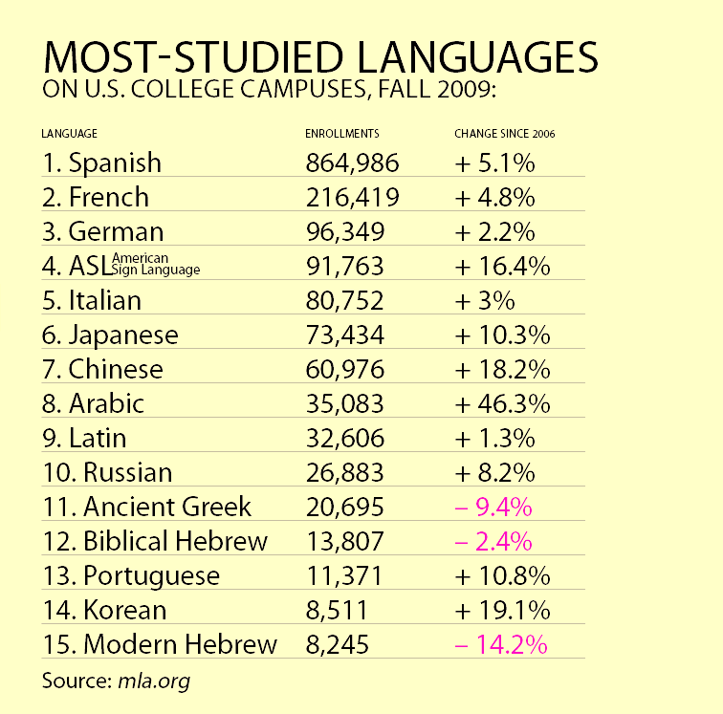
- A foreign language is a language originating from another country.
- It is also a language not spoken very commonly in the native country of the person.
- For instance, Italian or French language in Pakistan.
- Teaching foreign language should start from the very basics

Topic 18: Regional Language
- A regional language is a language spoken in an area of a sovereign (independent, self-governing) state, whether it is a small area, a federal state or province, or some wider area.
- A regional language is a language spoken in an area that is part of a larger nation state.
- For instance, Punjabi, Sindhi, Hindko, and Sareiki are regional languages of Pakistan among many others.
- Regional language becomes the native language (L1) of the people in that particular region. For instance, Punjabi, Sindhi, Pashto or Balochi are the native languages of the people of their respective areas because these languages are spoken and understood in those particular areas only.
- A dialect is a variety of a language which has different pronunciation, grammar or vocabulary than the standard language of the region. For example, Shahpuri dialect (also known as Sargodha dialect), or Utradi, a form of Sindhi language regarded as a dialect of Sindh; spoken mainly in Upper Sindh.
Lesson No. 4

Stages of Language Development

Topic 19: First Stage
Introduction
Language development is the process by which children come to understand and communicate language during early childhood.
- From birth up to the age of five, children develop language at a very rapid pace. The stages of language development are universal (common) among humans.
- However, the age and the speed at which a child reaches each highpoint of language development differ greatly among children.
- Thus, language development in an individual child must be compared with norms (standards) rather than with other individual children. In general girls develop language at a faster rate than boys.
- Language development reflects the growth and maturation of the brain. After the age of five it becomes much more difficult for most children to learn language.
- There are six stages of language development.
First Stage
Sounds: Infants, from birth, make and respond to many sounds. Crying, gurgling, and cooing are important first steps in the language-development process.
- This period is also known as Pre-Linguistic Language Development stage
- The child is learning to control the sounds they can produce and to string these sounds together in vocal play. In this stage, the child is not yet able to manipulate these sounds into proper words.
- The foundation of L1 is created during this stage.
Topic 20: Second Stage
Babbling: All of the sounds found in all languages are encompassed in children’s first babbling. Gradually, babbling becomes more specific with native language syllables being consistently practiced.

- This period is also included in the Pre-Linguistic Language Development stage
- At this time, the child starts ‘babbling’.
- Sounds are given intonations (pitches, tones) learned from the family.
- The child begins to produce a series of consonant-vowel syllables and may develop utterances, but has yet to produce proper words.
- Babbling continues during the first year of the birth and then normally finishes.
Topic 21: Third Stage
Holophrases: The first word evolves to many single words or syllables that stand for a variety of meaningful sentences or phrases in different situations. “Car” said while looking out the window may mean, “Look at the car outside”.
- Holophrases are related with nouns
- They are context related, because child has a specific meaning in their mind
- They may be having only one word, but for the child they express a complete sense.
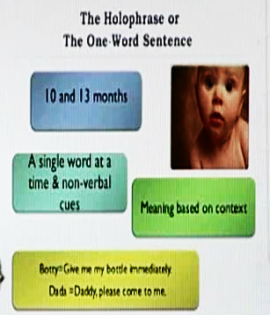
- This stage starts from 10 – 13 months.

Topic 22: Fourth Stage
Two-Word Sentences: Two-word sentences appear between eighteen and twenty months of age and express ideas concerning relationships: e.g.

- “Mommy-sock” (possessor-possession) – my mother owns these socks
- “Cat-sleeping” (actor-action)
- “Drink-milk” (action-object)
- A vocabulary of about 300 words is typical.
At this stage, the child has not attained competency in rules of grammar. The child has simply attained capability in putting two words together in some logical relationship.

Topic 23: Fifth Stage
Telegraphic Sentences: Simple three or more word sentences usually comprising at least one noun and verb that stick to the grammatical standards of the culture's language.
- At least 50 different words
- No function words (is, are, am) and grammatical morphemes – e.g. “Mommy juice”, “baby fall down”
- Reflecting the order of the language (maintaining sequence of the language) – e.g. “kiss baby”, “baby kiss” (SVO^{ENG} – SOV^{URDU})
- Creatively combining words – e.g. “more outside”, “all gone cookie”.
Telegraphic sentences are short and simple. Similar to telegram, they omit function words and endings that contribute little to meaning. For example: “Where Daddy go?”, “Me push truck”.

Topic 24: Sixth Stage
Joined Sentences: As language development proceeds, children learn to join related sentences logically and express ideas concerning time and spatial relationships. They come to understand social expectations for language use.
- At this stage, child learns to complete the sentences with the so far missing elements (functions, endings)
- Child learns to use language as is done by their adults
- Child acquires all these skills unconsciously and naturally
- The vocabulary extends to about 1,000 words
- Child also learns the rules, forms and norms for using these words as is required by the language

GLOSSARY
A spatial relation specifies how some object is located in space in relation to some reference object. In the beginning of language development, early spatial concepts include: in front of, behind, top, etc.

Lesson No. 5

Some Guidelines

Topic 25: Need for Guidelines
- Guideline is a general rule, principle, previous example, or piece of advice; a line by which one is guided.
- Guidelines always help us to determine a course of action especially when we are planning or designing something.
- By discussing different examples, we will try to focus on certain guidelines for teaching literacy skills.

Topic 26: Language Development
- There are different stages starting from sounds, and going to babbling, holophrases, two word sentences, telegraphic sentences, and finally joint sentences.
- It can be observed that language starts with simple sounds which develop into understandable conversations.
- During the language development process, the child moves from the simple to complex, and broken sentences or incomplete sentences to complete sentences (this is the guideline).
- The acquisition of language is one of the more remarkable achievements of early childhood. By age 5, children essentially master the sound system and grammar of their language and acquire a vocabulary of thousands of words.
- Literacy skills are related to language development – so the same guidelines apply.

Topic 27: Language Model
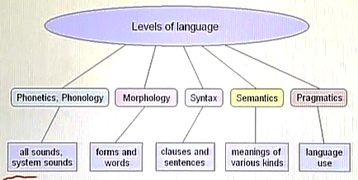

- Sounds develop into forms and words, which mature into clauses and sentences, followed by meanings and proper use of language.
Full conversation
Holophrases, Telegraphics
One-word stage
Baby makes sounds

- Both models follow the same pattern of "from simple to complex”, “from incomplete to complete”.
- Guideline: start with the basics and move on to the complex.

Topic 28: Literacy Models
Basic Model Complex Model

Literacy is fundamental for learning in school. It has an impact on an individual's ability to participate in society and to understand important public issues. And it provides the foundation upon which skills needed in the labour market are built.

- It is possible that an individual fails to reach the level of the complex model; but anyone who has reached the level of the complex model must have passed though the level of the basic model.
- Guideline: we should start from the basics when teaching literacy skills

Topic 29: Literacy Classroom
- In literacy classroom, we teach all of the skills needed for reading and writing.
- They include such things as awareness of the sounds of language, awareness of print and the relationship between letters and sound.
- When we say somebody is literate, we mean that s/he is able to read, write, speak and understand the subject matter – all these skills contain within themselves several other skills.
- Literacy classroom is a combination of several skills and corresponding sub-skills

Topic 30: Starting from Basics
- The models discussed previously guide us that we should start from the basics when teaching literacy skills – start with the simple and move to the difficult from there onwards – step-by-step

- Alphabets
- Sounds
Sequence to follow for attaining any of the major literacy skills like reading, writing, speaking, listening.
- Words
- Pronunciation
- Order of words
- Sentences
- Reading
- Writing, etc.
Above is based on the guideline for a literacy classroom: from easy to difficult.

Lesson No. 6

What Should Literacy Do?

Topic 31: What is a Code?
Code is the message conveyed through communication (read, view, listen) and encode (write, speak, present) – uses alphabet, sounds, spelling conventions, sentence structure, etc.
- In communications and information processing, code is a system of rules to convert information—such as a letter, word, sound, image, or gesture—into another form or representation, sometimes shortened or secret, for communication through a channel or storage in a medium.
- Literacy is connected to certain codes – in the effort to attain literacy, you are trying to achieve a competency to deliver your code effectively.
- The basic purpose of language is communication – the more refined the literacy skills, the more effective the communication is.

Topic 32: Code Breaker
Code breaking ability is the ability to decode (read, view, listen) and encode (write, speak, present) – uses alphabet, sounds, spelling conventions, sentence structure, etc.
- When you are making or delivering a message, you are encoding; when you are trying to understand a message, you are decoding
- The encoding of a message is the production of the message. It is a system of coded meanings, and in order to create that, the sender needs to understand how the world is comprehensible to the members of the audience.
- The decoding of a message is how an audience member is able to understand, and interpret the message.
- Literacy skills refine a person’s ability to encode and decode
Sender
Receiver
Channel
Decode
Encode
Communication Model

Topic 33: Meaning Making
(One of the most important objectives to be achieved by literacy)
The ability to draw on prior knowledge, interpret and make meaning of texts and inferred meaning
- Meaning making is a lengthy process, involving different stages
- Depends upon individual’s level of knowledge, and how refined it is
- Because of difference in the levels of knowledge in various people, the same message may be understood differently by different people.
- Making meaning out of a message is a very important target of literacy
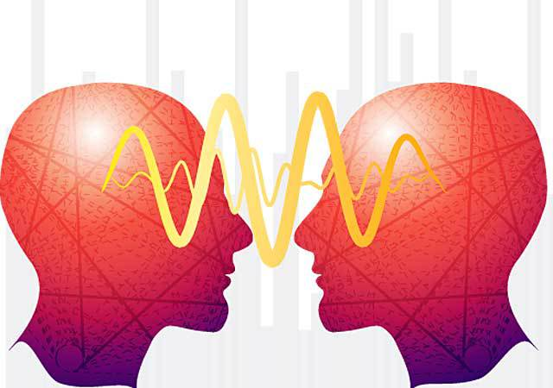

Topic 34: Using Text
Ability to draw on prior knowledge (mental storage, back-up, schemata), interpret and make meaning of texts and use them for different purposes. This is another important target of literacy skills.
- If a student is given an assignment and has to add information from a particular reference, but is unable to do so, it means that s/he is not literate enough to use that text.
- Texts have different purposes, for instance, letter to a friend, application to a higher authority, trying to answer a question in a question sheet, etc. have different objectives and different audiences.
- Literacy skills teach you to make proper codes for using text efficiently

Topic 35: Analyzing Text
Analyzing involves digging deeper into the meaning of the text. It goes beyond memorizing facts, dates, and names. It requires more than main ideas and details. Analyzing means forming an educated opinion about what you have read.
- Understand and act upon the knowledge that texts are not neutral but position and influence the audience through various means.
- For instance, a joke may be funny and may make the audience laugh, but if it humiliates a certain part of the community it is not in good taste. We reach to this conclusion after analyzing the text of the joke. We are using our background knowledge for this purpose.
- Texts are not neutral – they have different purposes, and influence different persons differently.
- For example: text in a philosophy book or in a story book – both have different purposes and different effects on the readers. Similarly, a news in a Newspaper will have different effect on different people.
- You cannot understand a text properly without analyzing it.
- Literacy skills help you learn to analyze text competently

Topic 36: Examples
- Following processes are involved when you read:
- Coding
- Decoding
- Using text
- Interpreting meaning
- Analyzing text
- The same processes are used when you write, except for “decoding” where you “encode” the text instead.
- Eliminating one process (or literacy skill) will have drastic effects on coding and communication.
- Literacy skills target all these areas.

Lesson No. 7

Literacy Classroom

Topic 37: Student-centered
Student-centered learning is focused on each student’s interests, abilities, and learning styles, placing the teacher as a facilitator of learning.
- While teachers are an authority figure in this model, teachers and students play an equally active role in the learning process. The teacher’s primary role is to coach and facilitate student learning and overall comprehension of material. Student learning is measured through both formal and informal forms of assessment, including group projects, student portfolios, and class participation. Teaching and assessment are connected; student learning is continuously measured during teacher instruction.
- In student-centered classrooms, students are directly involved and encouraged in the discovery of their own knowledge. Through collaboration and cooperation with others, students engage in experiential learning that is authentic, holistic, and challenging. Students are empowered to use prior knowledge to construct new learning
- This classroom teaching method acknowledges student voice as central to the learning experience for every learner, and differs from many other learning methodologies (e.g. teacher-centered)
- Target of teaching: every student must advance towards achieving learning goals – facilitate every student to learn.
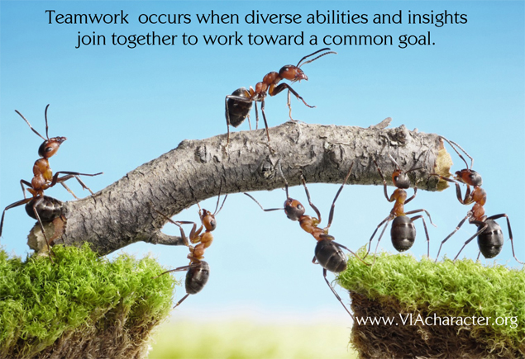

Topic 38: Teacher-centered
Teacher-centered learning is focused on teacher’s interests, abilities, and learning styles, placing the teacher as the center of classroom.
- Teachers are the main authority figure in this model. Students are viewed as “empty vessels” whose primary role is to passively receive information (via lectures and direct instruction) with an end goal of testing and assessment. It is the primary role of teachers to pass knowledge and information onto their students. In this model, teaching and assessment are viewed as two separate entities. Student learning is measured through objectively scored tests and assessments.

- Teacher’s interest and learning style are important here; i.e. the teacher makes students learn in the same style as she used to learn, for instance, if the teacher was an audio-learner the students will be required to learn through lectures. Visual-learners may not be able to follow the teacher properly.
- This classroom teaching method acknowledges teacher voice as central to the learning experience for every learner.
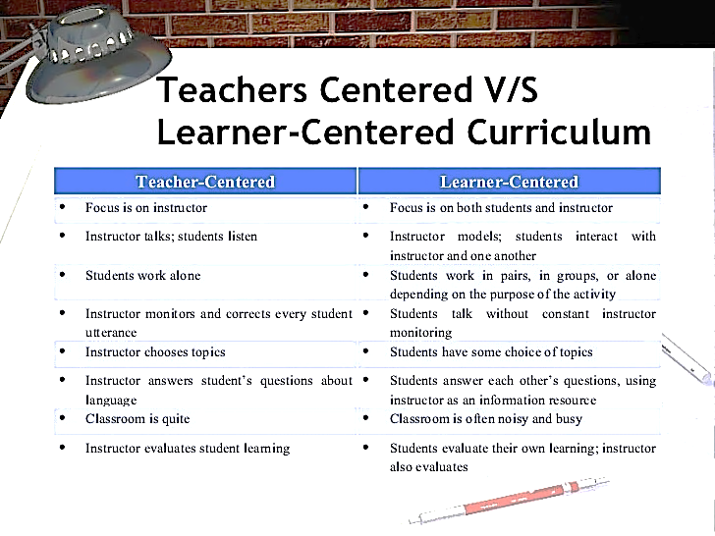

Topic 39: Roles of Teacher
A teacher can adapt different roles in a classroom. These roles decide not only the dimensions a classroom can take, but also the quality of teaching and learning.
- The role of a teacher is not eliminated even from the modern classrooms which use a significant amount of technology.
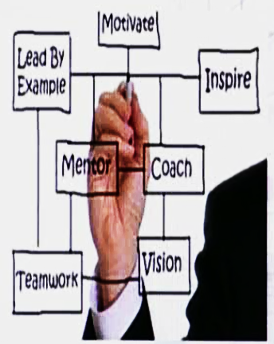
- A teacher decides through different roles in a classroom that class is teacher-centered or student-centered. For instance, if the teacher keeps controlling the class, it becomes teacher centered.

Topic 40: Details of Teacher’s Roles
Teachers assume a wide range of roles to support school and student success. Whether these roles are assigned formally or shared informally, they build the entire school's capacity to improve. Because teachers can lead in a variety of ways, many teachers can also serve as leaders among their peers.
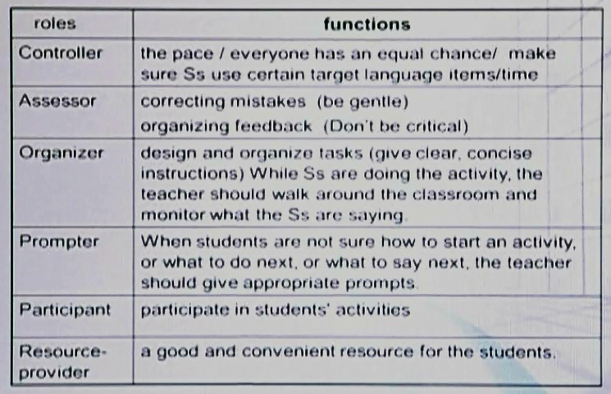

Among the most important roles a teacher may assume is that of learner. Learners exemplify continual improvement, demonstrate lifelong learning, and use what they learn to help all students achieve.
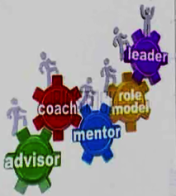
- Jeremy Harmer https://www.google.com.pk/#q =jeremy+harmer+practice+of+ english+language+teaching+pdf
(this is a continuous string – no breaks)

Topic 41: Activity Based
Where teaching and learning are based on different activities related to the topic; for instance, sequencing, sorting, measuring, predicting, testing, acting out, role playing, observing/ comparing, memorizing, dancing/ singing/ chanting/ making music, mixing, joining, tracing/ painting, etc. – all these activities can be conducted in a literacy classroom.
- Activity Based Learning (ABL) is a methodology where children of different ages are grouped together in one class and learn at their own pace through teacher-facilitated exercises.
- It is a student-centered classroom.
- Activities are related to the topic, learning target and objectives.
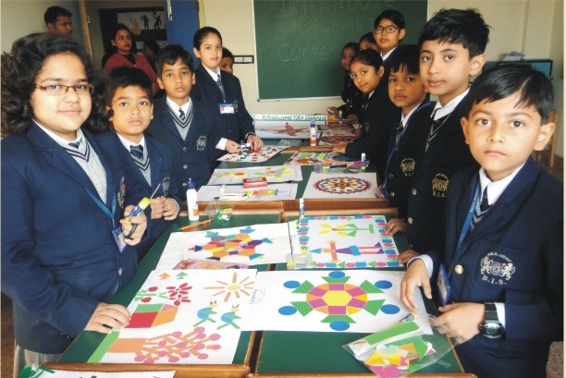

Topic 42: Conclusion
The principle behind the activity based approach is that children are “doers” and learn the language because they have encountered and used it in a realistic situation.
- Children learn best from experience.
- Children learn by doing, using their senses, exploring their environment of people, things, places and events.
- They learn from first-hand and concrete experiences as well as “vicarious” (second-hand) forms of experiences, (e.g., storytelling, listening to another person, reading a book and looking at pictures, watching television or listening to the radio).
- Children do not learn as effectively when they are passive. Active engagement with things and ideas promotes mental activity that helps students retain new learning and integrate it with what they already know.
- If it is not possible to always provide concrete, first-hand experiences for the student, efforts must always be exerted so that the student will be able to understand the concept in a clear and concrete way.

A teacher in literacy classroom:
Teacher
Student
Student
- encourages student–faculty contact
- encourages cooperation among students
- encourages active learning
- gives prompt feedback
- emphasizes time on task
- communicates high expectations
- respects diverse talents and ways of learning
(Chickering & Gamson, 1999, p.76)

Lesson No. 8

Teaching Alphabets

Topic 43: Alphabetic Principle
The alphabetic principle is composed of two parts:
- Alphabetic Understanding
Words are composed of letters that represent sounds.
- Alphabets are letters, and letters are sounds; e.g. CAT has three letters that represent three different sounds.
- Phonological Recording
Using systematic relationships between letters and phonemes (letter-sound correspondence), to retrieve the pronunciation of an unknown printed string or to spell words.
- Phonological recording is the utilization of reading abilities to transform written symbols into noises and words. It is a necessary component to understanding symbolic imagery.
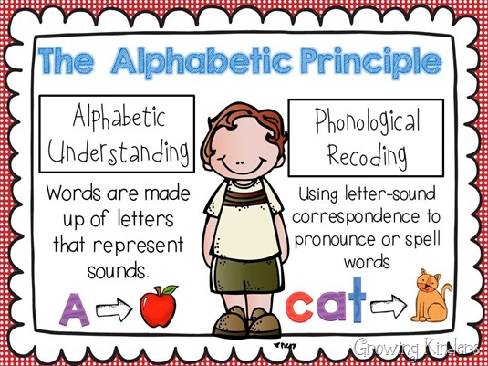

Topic 44: Introducing Alphabets
A new alphabet is introduced to a child.
- Normally, this stage of teaching alphabets is related to pre-schoolers or toddlers
- For us this is just an alphabet, but it is a whole new concept for a pre-schooler or toddler – if drawn on the whiteboard, these are new shapes for the young children.
- Whenever introducing a new letter, always relate it to a picture of an object which the child is already familiar with – it creates a context for the child and makes learning easy. The picture will make the letter stick to the mind of the child.

Three terms for teaching alphabets stage:
- Pre-school: stage before the school stage
- Toddlers: 3-4 years (have just started walking)
- Kindergarten: nursery stage (classroom is just like a playroom for the children, they learn while playing)
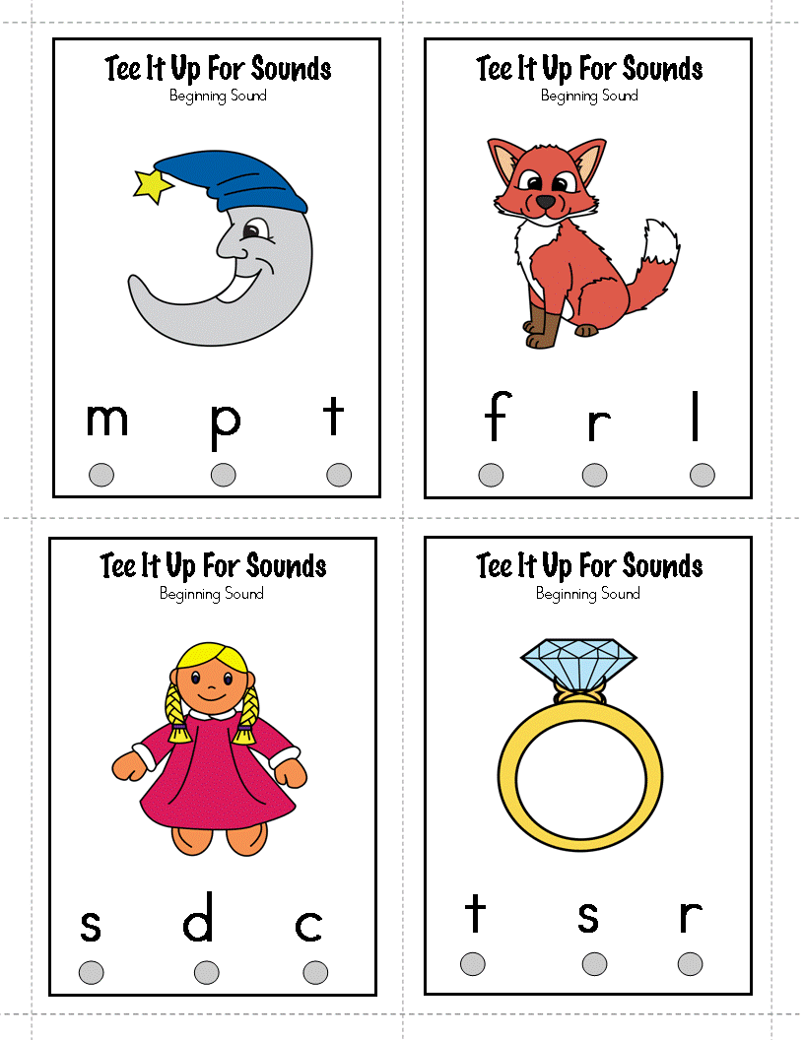

Topic 45: Alphabetic Order
- Introduce in a particular order
- Plan from easy to complex – incomplete to complete (easy concepts provide base for the next level)



The first picture above represents the natural order of English alphabets, but the second picture starts with easier sounds and proceeds to the difficult ones. ‘A’ and ‘C’ have more than one sound, while ‘B’ has only one sound, and so forth.

Extra Reading:
- Alphabetical order is a system whereby strings of characters are placed in order based on the position of the characters in the conventional ordering of an alphabet.
- To determine which of two strings comes first in alphabetical order, their first letters are compared. If they differ, then the string whose first letter comes earlier in the alphabet is the one which comes first in alphabetical order. If the first letters are the same, then the second letters are compared, and so on. If a position is reached where one string has no more letters to compare while the other does, then the first (shorter) string is deemed to come first in alphabetical order.

Topic 46: Relate with Sound
- When introducing your child to the 26 letters and each letter’s (sounds), do not simply begin with the alphabet ‘A’.
- Working in alphabetical order is not the most effective way for a child to learn the sounds made by each letter.
- Always relate a letter with a sound which is familiar to the child so that the child gets a clear concept.

Extra Reading
Phonics is a method for teaching reading and writing of the English language by developing learners' phonemic awareness—the ability to hear, identify, and manipulate phonemes—in order to teach the correspondence (association, correlation) between these sounds and the spelling patterns (graphemes) that represent them.
Phonics instruction helps children learn the relationships between the letters of written language and the sounds of spoken language. Children are taught, for example, that the letter n represents the sound /n/, and that it is the first letter in words such as nose, nice and new.
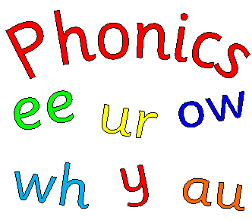

Topic 47: Practice
- To practice is to do something again and again in order to become better at it.
- It requires repeated performance or systematic exercise for the purpose of acquiring skill or proficiency.
- It involves action rather than thought or ideas.
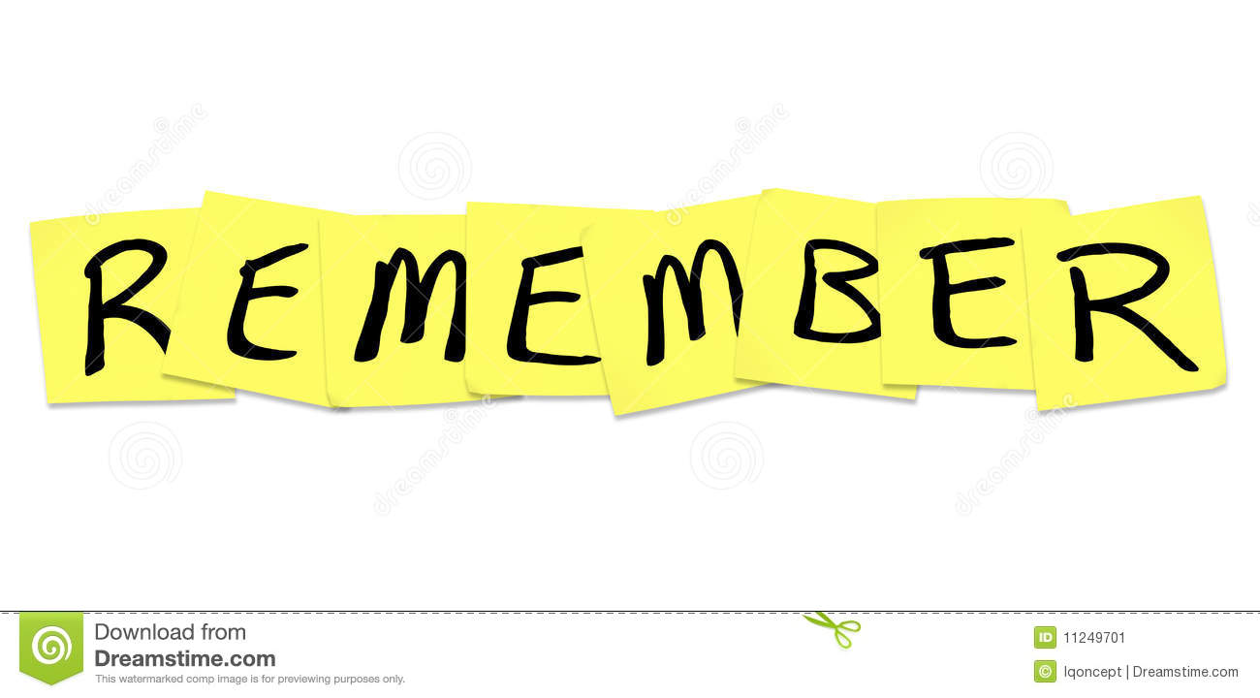

Alphabets for pre-shoolers are not easy. All alphabets are new to them.

Following three points are to be kept in mind when teaching alphabets to children:
- Components and definition of alphabetic principle
- The phonemic awareness and decoding
- Letter-sound correspondence to enhance word recognition

Lesson No. 9

Activities with Alphabets

Topic 48: Letters on String
- Select the order of the alphabets you want to teach the sounds of (e.g. one of the two orders discussed in Topic 45 earlier).
- Cut out cardboard alphabets
- Hang them on a string according to the chosen order


Letters which have to be taught are hanging on the wire. In a way, they look like something real.

Topic 49: Large Letters
- Besides being almost as tall as the child, these letters can be decorated with pictures of objects beginning with that letter.
- Any material can be used for making these big letters.




Making these letters will involve several other activities, engaging all students and enabling active learning.

Topic 50: Alphabet Cookies
Letters in the form of cookies can also serve as an effective source of teaching letters.




Topic 51: Letter Cards
Print out the letter cards, and have the young student colour the letters with crayons or paint markers.
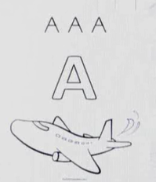
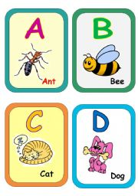
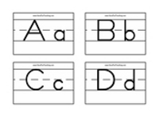

Many activities can be carried out with above material.

Topic 52: Letter Boxes
- Take small containers.
- Take letter stickers.
- Fix one letter yourself and tell the child to fix the same letter by picking from the sticker sheet.




This creates a student-centered classroom involving all students in performing the required skill.

Topic 53: Letter Pounding
This activity also helps the students in identifying and recognizing the letters, and placing them as required.
- Take boards printed with letters (or paste a sheet printed with letters on the board)
- Take letter shapes
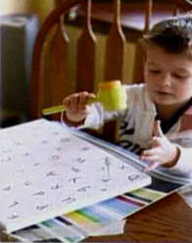
- Tell children to fix the letter shape on its place on the board.
- This is essentially a matching activity
- It is better to conduct this activity in pairs or groups.

Lesson No. 10

Alphabetic Principle

Topic 54: Lack of Alphabetic Understanding
Children who lack alphabetic understanding cannot:
- understand that words are composed of letters
- associate (connect, relate) an alphabetic character (i.e. letter) with its corresponding phoneme or sound
When we go on reducing the bigger chunks of language and start moving towards the minimum part of the word, sentences are reduced in to words and words are reduced in to letters (letters have sounds). The problem with children who lack alphabetic understanding is that:
- they do not understand that words are made of letters,
- and that these letters represent sounds (which we call phonemes).
As a result, concepts get intermingled in their minds, confusing them, and they are unable to distinguish letters.
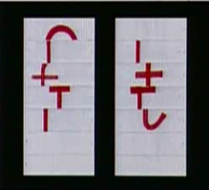

- They are also unable to identify a word based on a sequence of letter-sound correspondences (e.g. that “mat” is made up of three letter-sound correspondences: /m/ /a/ /t/).
- As a result, they cannot blend letter-sound correspondences to identify decidable words.
- Such children also cannot use knowledge of letter-sound correspondences to identify words in which letters represent their most common sound
- As such, the fail to identify and manipulate letter-sound correspondences within words.

Topic 55: Alphabetic Principle Skills
To develop alphabetic principle across nursery/ kindergarten to grades K-3, students need to learn two essential skills:
- Letter-sound correspondence
Comprises initially of individual letter sounds, and progresses to more complex letter combinations.
- Word reading
Comprises initially of reading simple words, and progresses to compound words, multisyllabic words, and sight words.
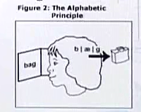

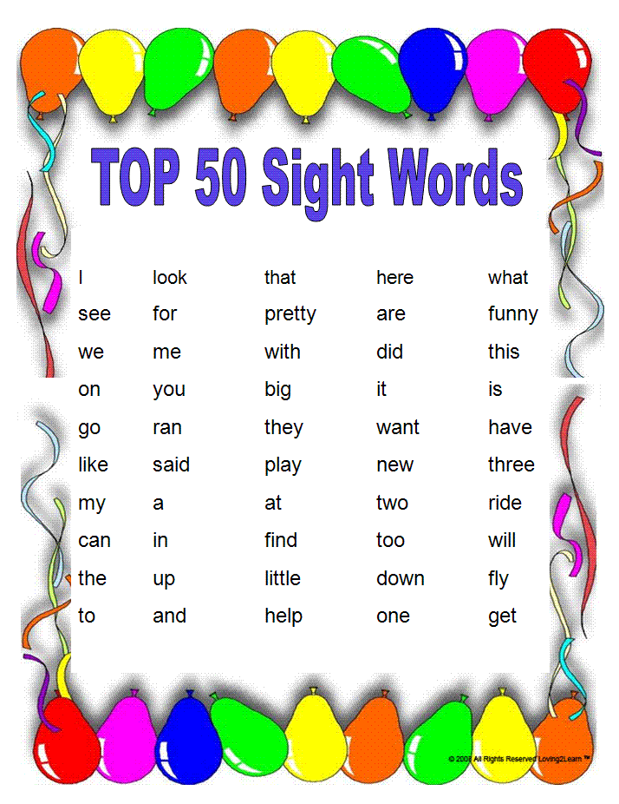

Extra Reading
Sight words are commonly used words that young children are encouraged to memorize as a whole by sight, so that they can automatically recognize these words in print without having to use any strategies to decode

Topic 56: Kindergarten Skills
1. Letter-sound correspondence: identifies and produces the most common sound associated with individual letter (letters giving more than one sound are normally not used at this stage).


2. Decoding blends the sounds of individual letters to read one-syllable words – when presented with the word “fan“, the student will say: “/fffaaannn/, fan“.

Topic 57: First Grade Skills
1. Letter-sound combination produces the sounds of the most common letter sounds and combinations (e.g. th, sh, ch, ing)
2. Decoding sounds out and reads words with increasing automaticity, including words with consonant blends (e.g. mask, slip play), letter combinations (e.g. fish, chin, bath), monosyllabic words (e.g. cat, sun, moon), and common word parts (e.g. ing, all, ike).
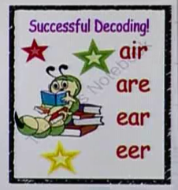

3. Sight words reads the most common sight words automatically (e.g. very, some, even, there)

Lesson No. 11

Lowercase Letters

Topic 58: Importance of Lowercases
English alphabets have both upper and lower case forms. Both forms of each letter are considered to be the same letter; that is, they have the same name and the same pronunciation and they are treated (virtually) identically when sorting in alphabetical order.
Importance of Lowercases Upper case (capital letter) is used only at the start of a sentence when the first word of the sentence is capitalized. We also capitalize the pronoun, and the proper nouns as well as most adjectives formed from proper noun. This is a very limited usage; lowercase (small letter) is used extensively.
- Lowercase is faster to write,
- easier to read,
- and saves space on the printing material.
- It is also easier on the eyes,
- and do not burden coding-decoding systems.
- It provides fluency in writing.
The invention and application of lowercase letters have been highly beneficial to the reading and writing of text.

Topic 59: When to Teach Lowercase Letters
Uppercases first, for two reasons 1. Uppercase letters are easier to visually distinguish than lowercase letters – take for example the uppercase ‘B’ and ‘D’ versus. the lowercase ‘b’ and ‘d’.
2. Uppercase letters are easier for beginning writers (e.g. ‘E’ versus ‘e’). Even when instructed with lowercase letters, it is often noticed that young children naturally prefer uppercase.
It is important to expose young children to all kinds of letters, even different kinds of fonts.
So they should be introduced and exposed to small letters soon after the upper cases.
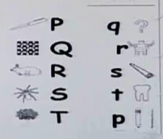



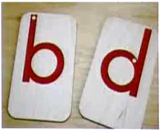
Topic 60: Letter Confusion



There are certain small letters which might create confusion for learners, e.g. ‘b’ and ‘d’.

e

It should be noted that some lowercase letters very closely mimic their capital letter partners, e.g. Cc, Kk, Oo, Vv, Ww.
So there should be more practice for the letters that might be confusing for learners.
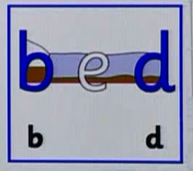

This picture helps to clarify the confusion. It relates the letters with a picture.


This picture is also helpful in clearing up the concept.

Teacher can use similar material.

Topic 61: Lowercase Letters - Some Activities
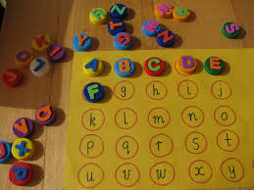
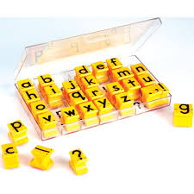
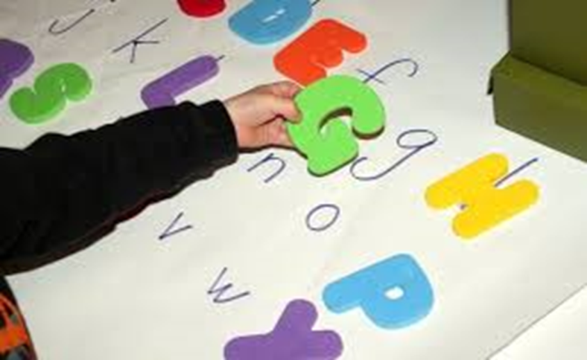
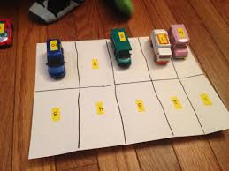
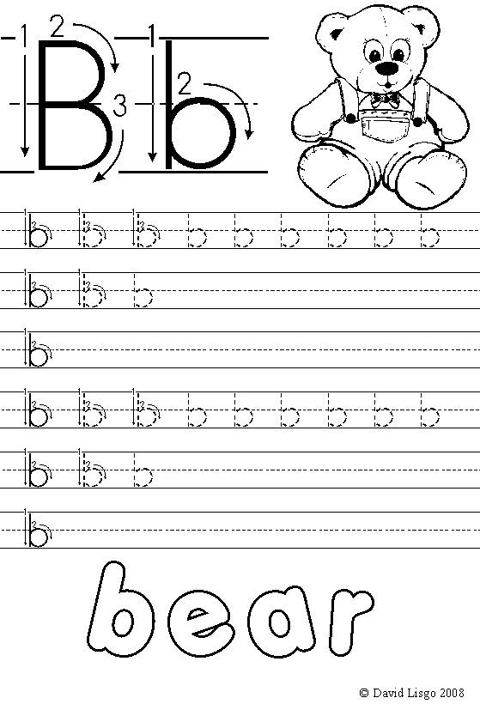

- Skill is activity based; it develops and improves with practice
- Teaching literacy skills should be activity based
- Activity provides practice
- Every classroom should be activity based
- Activities should be interesting
- Teacher should know which activity should be introduced at what time – timing is important

Lesson No. 12

Introducing Sounds

Topic 62: Phonemic Code
The phonemic code is the specific print=sound relationships written English is based on. For instance: cat /c+a+t/.The English phonemic code of phonograms (distinct written letter or letters that represent specific sound(s)) is complex.


It is related to the letters and the sounds associated with them. A standardized set of symbols used in phonetic transcription.

Topic 63: Importance of Phonemic Code
Students need to learn the phonemic code because this phonemic code is the basis for written English and the foundation for proficient reading. The linguistic fact IS English is a phonetic based system. learnt and decoded if taught effectively.
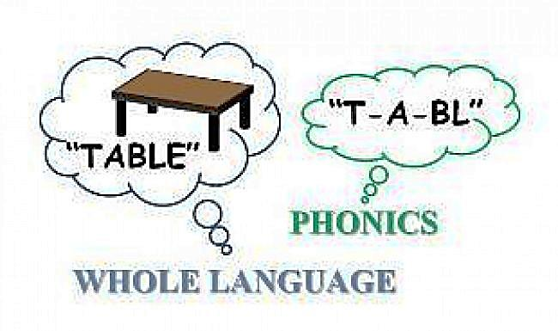
Learning the phonemic code (sound the print represents) is an essential sub skill for developing these proficient reader pathways.
This knowledge provides essential building blocks for developing the foundation of proficient phonologic processing.

Topic 64: Problem with Phonemic Code
The English phonemic code of phonograms (distinct written letter or letters that represent specific sound(s)) is complex. Letters and sounds do not have a one-to-one correspondence. There are 26 letters and 44 sounds.
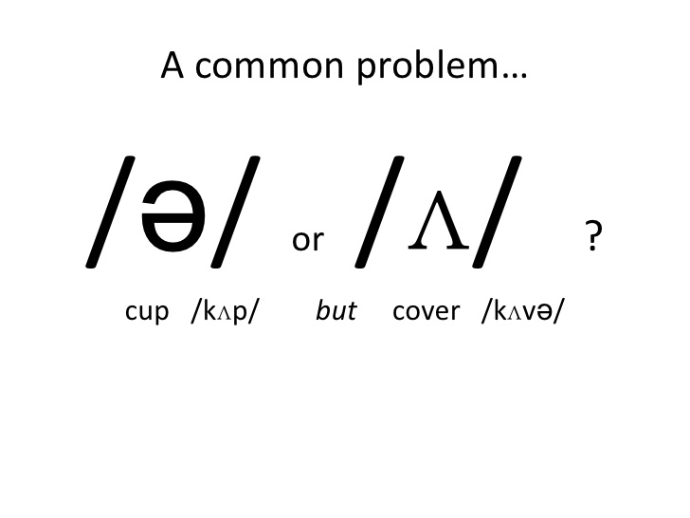
Some letters represent more than one sound. Many sounds are made from a combination of letters. For instance: the letter ‘c’ in ‘car’ and in ‘cigar’.
Combination of letters: ‘sh’ or ‘th’.
There is overlap where one sound can be written several ways: /k/ from ‘k’ for kite as well as from ‘c’ for car.

Although it is difficult, even then English language is learnt and decoded if taught effectively. Most patterns are predictable and decoded easily.

Topic 65: Keep in Mind
Assembling word parts - The most common type of reading strategy in 3rd grade. The child breaks the word into small pieces. Often these are not real words and letters are used in several word parts. "plank" is read as "plan-ant" or "literature” is read as "lite-rat-ture'even
Common phonetic errors - These are accurate and phonetically correct decoding of irregularly spelled words. "honey' is read as 'hone-ee' or 'prank' is read as 'prahnk'

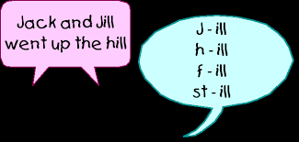

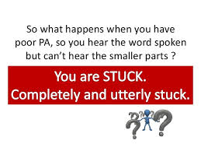
Limited code knowledge - The child has an incomplete knowledge of the spelling code. As a result, they will write the correct number of sounds, but the incorrect spelling. "made" is written as "mad" or "pout' is written as 'pot'

Letter naming - The child reads the word by saying the letter names. "punch" is read as "peeuhenseeaetch"
While teaching, one must keep these things in mind and must try to look for the effective solution to these issues.

Lesson No. 13
Some Terms
Phonology and Phonetics: Topic 66

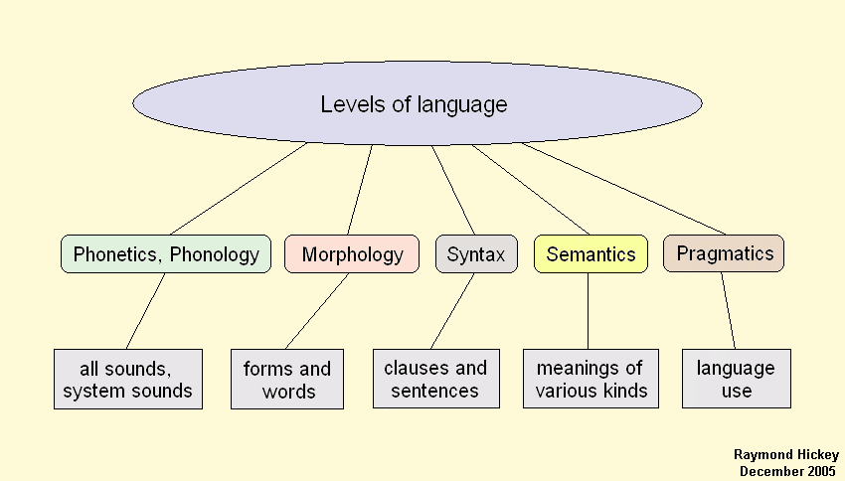

Phonology is a branch of linguistics concerned with the systematic organization of sounds in languages. It is the first level of language also.
Phonology is about the patterns of sounds, especially different patterns of sounds in different languages (Arabic, Urdu, English), or within each language, different patterns of sounds in different positions in words etc.
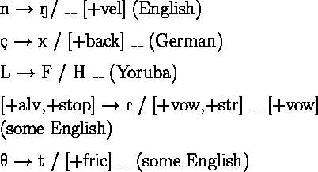

Phonetics
Phonetics deals with the production of speech sounds by humans, often without prior knowledge of the language being spoken. For instance, /k/ or /b/sound and different origins of these sounds.

Phonemes: Topic 67
Phonemes are the smallest units of sounds in a language. If a phoneme is changed, the word may change, e.g. change the l sound in 'lack' to a b and the word changes to 'back'.
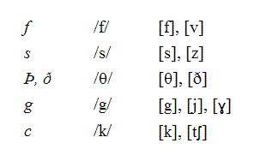

In English, the sound e in 'pet' and i in 'bit' are examples of vowel phonemes, the sounds j in 'judge' and sh in 'ship' are consonant phonemes.

Phonics; Topic 68
Phonics is a method for teaching reading and writing of the English language by developing learners' phonemic awareness—the ability to hear, identifies, and manipulates phonemes.
The purpose is to teach the correspondence between these sounds and the spelling patterns (graphemes) that represent them.
Importance of phonics
Learning phonics will help you to learn to read and spell. Written language can be compared to a code, so knowing the sounds of letters and letter combinations will help you to decode words as you read.

Phonemic Awareness: Topic 69
Phonemic awareness is the ability to hear and manipulate individual phonemes. Phonological awareness includes this ability, but it also includes the ability to hear and manipulate larger units of sound.
Conscious awareness that words is composed of separate sounds and the ability to identify and manipulate those sounds. Phonemic awareness can be developed by:
1. Recognizing beginning and ending sounds
2. Isolating sounds
3. Combining sounds
4. Breaking or segmenting words into its separate sounds

Lesson No. 14
Consonant Sounds
What are these? : Topic 70

A consonant is a letter that represents a speech sound produced by a partial or complete obstruction of the air stream by a constriction of the speech organs.
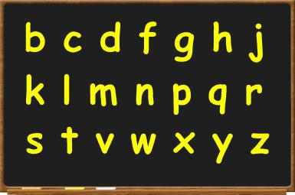

There are 21 consonant letters in the written alphabet (B, C, D, F, G, H, J, K, L, M, N, P, Q, R, S, T, V, W, X, Y, Z), and there are 24 consonant sounds in most English accents.

Consonant Phonemes: Topic 71
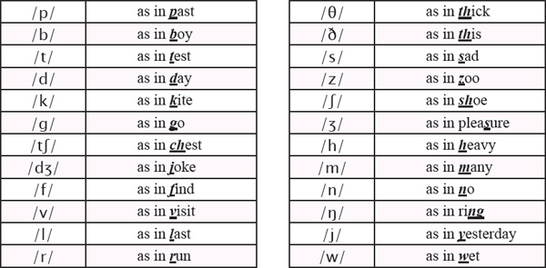
A consonant phoneme is a speech sound that is articulated with complete or partial closure of the vocal track.

Manner of Articulation: Topic 72
The manner of articulation is the configuration and interaction of the articulators (speech organs such as the tongue, lips, and palate) wh en making a speech sound.
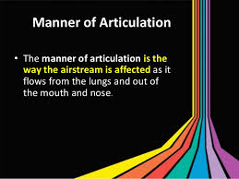

One parameter of manner is that how much air passage is blocked while producing some sound.
Different sounds are produced due to different positions of speech organs.

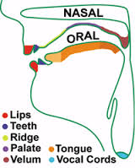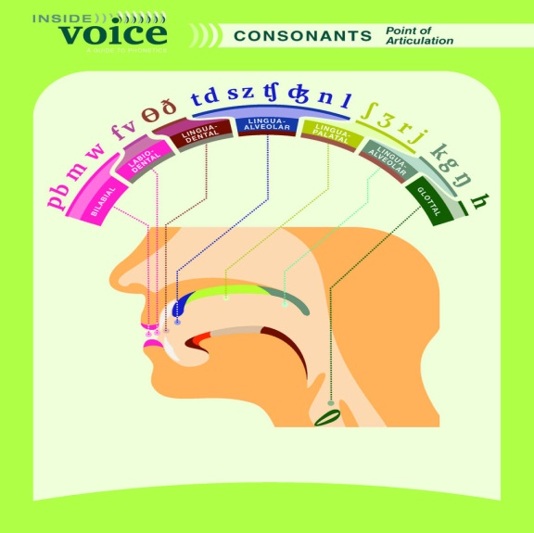

Lesson No. 15
Different Consonant Sounds

Different Types : Topic 73
A consonant sound is produced by a partial or complete obstruction of the air stream by a constriction of the speech organs. This is related to manner of articulation also.
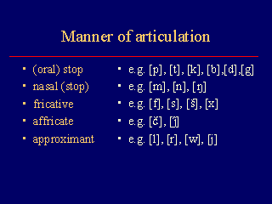
It means different positions of speech organs and the resultant air passage produce all these type of sounds. Example: flute

Stop: Topic 74
The definition of a stop consonant has three parts. First, either the tongue or the lips close off the air flow entirely. Second, this closure causes a build up of pressure, and third, there is a release of this built up air.
There are 6 different stop consonants. /p/, /b/, where the pressure is built up by the lips being closed; / t/, / d/, where the pressure is built up by the tongue raising and closing off the air flow; and /k/, /g/, where the pressure is built up by the back of the tongue reaching up an touching the back of the throat, causing the pressure to build up there.

Nasals: Topic 75
Nasals are consonants that are formed by blocking the oral passage and allowing the air to escape through the nose. The examples of a nasals are /m/, /n/ and /ŋ/.The air stops at the lips and goes through the nose instead.

Fricatives: Topic 76
A fricative is a consonant sound that is created by constricting the vocal tract, causing friction as the air passes through it The examples of English fricative sounds (the v sound, f sound, th sound, z sound, s sound, sh sound, and h sound).

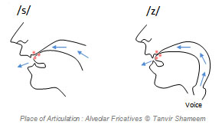

Affricates: Topic 77
A complex speech sound consisting of a stop consonant followed by a fricative; it is a combination of stops and fricatives. It is often difficult to decide if a stop and fricative form a single phoneme or a consonant pair. Examples: /t͡ʃ/ (catch) and /d͡ʒ/ (jury).

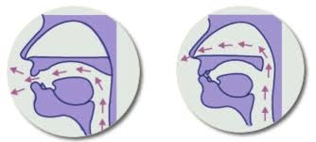

Approximant: Topic 78
An approximant, in phonetics, a sound that is produced by bringing one articulator in the vocal tract close to another without, however, causing audible friction. Approximants include semivowels, such as the y sound in “yes” or the w sound in “war.” /r/ and /l/ are also approximants.
